Scale Factors & 3-D Objects [8.6]

$$surface area of similar object= k^{2}(surface area of original object)$$
$$volume of similar object= k^{3}(volume of original object)$$

Example 1:
A Victorian train engine called “Vicky” was brought from England to Canada to “star” in the play The Railway Children. The engine was built in the 1890s and is about 16.5m long. Toy replicas of Vicky are sold at the play. The replicas fit into boxes about 16.5cm long, 2.5 cm wide, and 4.0cm high. Determine the surface area of a shipping container that could hold Vicky.

Example 2:
Determine the volume of a shipping container that could hold Vicky.

Example 3:
The smaller tank in the photograph has a capacity of 1400 m³, and the larger tank has a capacity of 4725 m³.
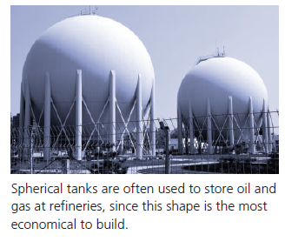
- During the refining process, both tanks are filled with oil from a pumping station at the same rate. How many times longer will it take to fill the larger tank than it will take to fill the smaller tank?
- How many times greater is the radius of the larger tank than the radius of the smaller tank?

