Career Project Roen Yap
Aerospace engineer:

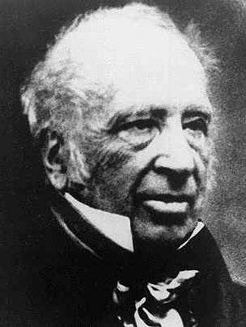
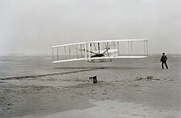
General Description: Aerospace Engineers take scientific principles and theories and use them in more practical use. They design, create, and test aircraft, spacecraft, and missiles. They also supervise the production of these products. The lowest degree one would need is a bachelor.
History: The start of this field can be traced back to the 19th and 20th century. George Cayley is one of the most important people in the field and is a pioneer in aerospace engineering.
Working Condition: Most engineers work for engineering consultant firms, government agencies, or for industries in research and development. They work 40 hours a week (full time). Aerospace engineers are not in a union. They get medical, dental, and vision coverage.
Future Outlook: Aerospace Engineers are considered lucky because the unemployment rate is only 1.5% with a 10.2% growth within the next decade.
I have good chances of getting into this field as the rate of employment in males is 51.9% and 42.7% in people who are between 25-44 years of age
Related Careers:
-Avonics tech
-Pilot
-Electrical Engineer
-Civil Engineer
Post Secondary Institutions:
-Ryerson University in Ontario (Undergraduate, Masters, and Doctoral)
-École Polytechinque de Montréal in Quebec (Certificate, Undergraduate, and Master)
-Carleton University in Ontario (Undergraduate, Masters, and Doctoral)
-Concordia in Quebec (Masters)

Sample Program of study (Ryerson University)
Year 1: Introduction to Engineering, General Chemistry, Calculus 1, and Physics: mechanics.
Year 2: Engineering Design and Graphical Comm, Materials Science Fundamentals, Principles of Engineering Economics, and Calculus 2
Year 3: Basic Thermodynamics, Fluid Mechanics, Differential Equations and Vector Calculus, and Dynamics
Year 4: Flight Mechanics, Introduction to Aerospace Engineering Design, Electric Circuits.

