
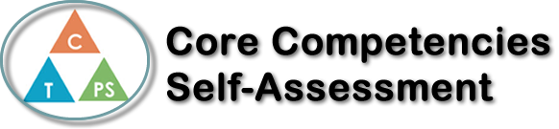
Name: Riley Manning | Date: March 28 2022

  How does the artifact you selected demonstrate strengths & growth in the communication competency?  In what ways might you further develop your communication competency? | Self-Reflection  I think my reflection demonstrates growth in the personal growth and awareness competency. The artifact (my reflection) is a document where I reflected upon the difference competencies, and how they relate to employment. I think this helped me understand myself and my goals better, and where and how I want to pursue the future. My reflection made me realize the importance of reflection and developing myself and my skill set to grow as a person, and hopefully into a successful worker one day. I also gained awareness of the responsibilities I should set for myself to develop my competencies and attain my goals. I really think this reflection demonstrates a growth in this sense, and now I have a clearer understanding of my goals for the future.


How does the artifact you selected demonstrate strengths & growth in the thinking competencies?

In what ways might you further develop your thinking competencies?


How does the artifact you selected demonstrate strengths & growth in the personal & social competencies?

In what ways might you further develop your personal & social competencies?

Publish Your Self Assessment
You will now attach and/or embed your self-assessment to the bottom of the blog post with the artifact you have chosen. You may choose to make this post private or public. After placing your artifact on a blog post, follow the instructions below.
- Categories - Self-Assessment
- Tags - Now tag your post using the tag that corresponds to the competency that you have written about. You can choose more than one. Please use lower case letters and be exact.
  - #creativethinkingcc
  - #communicationcc
  - #criticalthinkingcc
  - #socialresponsibilitycc
  - #personalidentitycc
  - #personalawarenesscc
- Use the Add Document button located at the top of your post page and embed your self-assessment at the bottom of your blog post.
- Publish

