
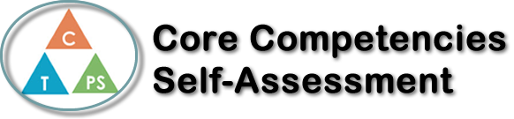
Name: Renchie De Castro | Date: January 6, 2020

  0  How does the artifact you selected demonstrate strengths & growth in the communication competency?  In what ways might you further develop your communication competency? | Self-Reflection  The artifact demonstrates my strengths on communication is that I can talk to my comrades if I need something I can ask them, one thing that I’m good at for communication skills in groups is if I’m away or want to work on it I’ll let them know or let them know in advance. If a person in the group or if I need help with something ill help them. I can develop my communication competency by talking more in groups work, and I can try to communicate more towards future group projects.


How does the artifact you selected demonstrate strengths & growth in the thinking competencies?

In what ways might you further develop your thinking competencies?


How does the artifact you selected demonstrate strengths & growth in the personal & social competencies?

In what ways might you further develop your personal & social competencies?

Publish Your Self Assessment
You will now attach and/or embed your self-assessment to the bottom of the blog post with the artifact you have chosen. You may choose to make this post private or public. After placing your artifact on a blog post, follow the instructions below.
- Categories - Self-Assessment
- Tags - Now tag your post using the tag that corresponds to the competency that you have written about. You can choose more than one. Please use lower case letters and be exact.
  - #creativethinkingcc
  - #communicationcc
  - #criticalthinkingcc
  - #socialresponsibilitycc
  - #personalidentitycc
  - #personalawarenesscc
- Use the Add Document button located at the top of your post page and embed your self-assessment at the bottom of your blog post.
- Publish

