
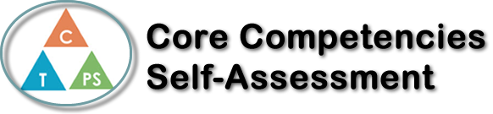
Name: Rachel Smid | Date: Tuesday April 20th 2021

  How does the artifact you selected demonstrate strengths & growth in the communication competency?  In what ways might you further develop your communication competency? | Self-Reflection  Describe how the artifact you selected shows your strengths & growth in specific core competencies. The prompt questions on the left - or other self-assessment activities you may have done - may guide your reflection process.  In the middle of the quarter, we did a self-reflection. My goal throughout the class was to improve my typing speed and accuracy and there has been an impressive jump in both over the course of the class. This class was centered around personal regulation, it was up to the individual to ensure that they were getting their work done and improving. My typing speed at the time of that self assessment was around 45-55 words per minute and I have noticed an increase on my typing speed. Referring to fastfingers, I had a 36% typing increase compared to the beginning of the quarter, I see 36% (50 wpm to 68 wpm) as a big jump and my other work all shows an increase in speed with the same or fewer mistakes.  My goal during the mid-quarter assessment was to improve my typing speed and I am happy to see that I have evidently achieved that goal. There is still room for improvement in regard to my typing speed and accuracy, but I am not done typing yet and I see improving typing speed as something that can always be better, there isn’t exactly a limit to how fast one can learn to type.


How does the artifact you selected demonstrate strengths & growth in the thinking competencies?

In what ways might you further develop your thinking competencies?

xs

How does the artifact you selected demonstrate strengths & growth in the personal & social competencies?

In what ways might you further develop your personal & social competencies?

Publish Your Self Assessment
You will now attach and/or embed your self-assessment to the bottom of the blog post with the artifact you have chosen. You may choose to make this post private or public. After placing your artifact on a blog post, follow the instructions below.
- Categories - Self-Assessment
- Tags - Now tag your post using the tag that corresponds to the competency that you have written about. You can choose more than one. Please use lower case letters and be exact.
  - #creativethinkingcc
  - #communicationcc
  - #criticalthinkingcc
  - #socialresponsibilitycc
  - #personalidentitycc
  - #personalawarenesscc
- Use the Add Document button located at the top of your post page and embed your self-assessment at the bottom of your blog post.
- Publish

