
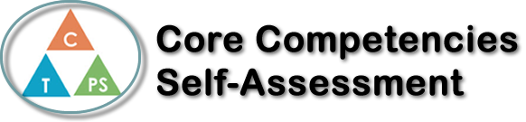
Name: | Date:

  How does the artifact you selected demonstrate strengths & growth in the communication competency?  In what ways might you further develop your communication competency? | Self-Reflection  Describe how the artifact you selected shows your strengths & growth in specific core competencies. The prompt questions on the left - or other self-assessment activities you may have done - may guide your reflection process.  The artifact I have chosen to show my social responsibilities in guitar class was helping my peers around me. In guitar class I had a peer who couldn’t speak much English and was having trouble in the class due to it. Lucky for him, I spoke his second language and I was able to help him out in class. I helped this student with guitar and some of the paper assignments we were given and due to this they not only got better in class and at guitar, but they got better at English too. It felt good to help someone else social and this also built my social responsibilities skills more too. Along with helping this certain student I also helped my other peers as well. in guitar class people always have questions and whe the teacher is not around its always helpful to ask someone else. I am happy to say that I was able to answer many questions and I ended building an fun relationship with some of my peers too. In the end I am really happy that in was both able to help people out and also get help from them instead when I needed it. In conclusion, that is why this artifact represents my social responsibility skills in guitar class.


How does the artifact you selected demonstrate strengths & growth in the thinking competencies?

In what ways might you further develop your thinking competencies?

x

How does the artifact you selected demonstrate strengths & growth in the personal & social competencies?

In what ways might you further develop your personal & social competencies?

Publish Your Self Assessment
You will now attach and/or embed your self-assessment to the bottom of the blog post with the artifact you have chosen. You may choose to make this post private or public. After placing your artifact on a blog post, follow the instructions below.
- Categories - Self-Assessment
- Tags - Now tag your post using the tag that corresponds to the competency that you have written about. You can choose more than one. Please use lower case letters and be exact.
  - #creativethinkingcc
  - #communicationcc
  - #criticalthinkingcc
  - #socialresponsibilitycc
  - #personalidentitycc
  - #personalawarenesscc
- Use the Add Document button located at the top of your post page and embed your self-assessment at the bottom of your blog post.
- Publish

