English Studies 12
Radio/Voice Over Play Assignment
Plays, movies and TV help us to explore a different perspective from our own. These visual story-telling forms can be informative (the news, documentary film), or they can mirror our society (Modern Family), they can help us to imagine extraordinary experiences (Stranger Things), and sometimes, they detail a world we would not want to live in, but we can visit safely through this creative media (Squid Game).
What about before TV and movies existed, though? There were books, for the literate, and there was RADIO.
You will have the opportunity to use language to shape ideas and influence others through the words or dialogue that you create: You will develop a short story and some unique characters with a RADIO PLAY.
Your goal is to create a one act play that is a dramatized acoustic performance.
Your play should be 3 to 5 scenes.
There will be no visuals so your play will rely heavily on dialogue, music and sound effects to help the audience imagine the characters and the story.
You will get to select up to two actors (from the Drama Department) to do the voice over work for your characters, if you wish, working through a casting process.
You will include at least three different sound effects in your play.
At two different junctions in your play, music should be included to heighten the ambience of your play.
These are some tips to consider while writing your play:
Grab the audience.
Radio drama thrives on strong narratives. Whether you are writing a tragedy, a comedy, or a play about a social or political message, a great storyline will keep your audience listening. However, do not make the story too complicated with too many themes, characters and plotlines, or the listener will get confused. Think about how your radio play will start, with characters talking on the edge of or even in the middle of the action.

Example:
(ELEVATOR BING SOUND EFFECT; ELEVATOR DOOR CLOSING. JOHN RUSHING IN.)
Sharon: “Good morning John!”
John: “Good morning…hey…Sharon can we talk?”
Sharon: “John, are you okay, you look like you haven’t slept…”
Purpose!
Ask yourself, why does this story matter? What is your goal with it?
Keep the audience engaged.
Think about the beginning, middle and end of your play. Think about how the conflict in your play will develop and change through the play and whether the ending will be resolved or unresolved. Check that your play is not too predictable. Try not to rely on cliche.
Stay character driven.
Aim to have up to three key characters in your play. You can also have some small ‘doubling’ parts that only have a few lines each and can be played by the same actor who ‘doubles’ roles.
Focus on Dialogue and Interactions.
Remember, we can’t SEE your characters!
Avoid writing this - Matt shakes his head.
Instead write this - Matt: “No!”
Think about how to explain visual elements of your play to allow the audience to imagine the story you are telling. Plan accordingly: if a butterfly appears in your story, and starts talking, how is the audience going to understand that it’s a butterfly? It can work, but you will need to find a way to establish this clearly. What sound effect does a butterfly make? Can another character say, “Hey a butterfly! Wait…is it trying to say something?!!”
Format for ease.
Type all the instructions to actors, and the sound effects, in capital letters.
For example - SHARON RUNS IN TO THE OFFICE, OUT OF BREATH.
Dialogue is formatted typically.
Leave a space each time a different character speaks.
Be sure to include a cast of characters at the beginning (listed in order of appearance),
You could include a narrator if needed, who will provide important background information.
Referenced from https://www.bbc.co.uk/programmes/profiles/tnkQgSgPJVWM4ZpZ3hHbjv/ten-tips-for-writing-a-play-for-radio
(Accessed on October 5, 2021)
A Few More Tips:
Choose your partner carefully. You will want to choose someone who you can collaborate with and who will divide the work equally with you. You will both receive the same grade. If behavior is an issue, I will split you up and assign new partners.
To help you write your Radio Play, here is a website that can help you format your play. The link is https://writerduet.com/
Radio Play Examples:
Animal Farm Radio Version- George Orwell- Audio Performance
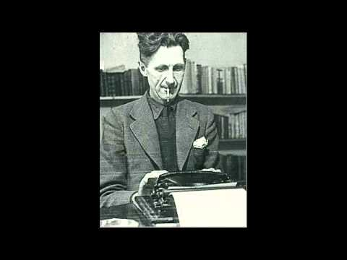

Hunchback of Norte Dame Full 2008 Radio Programme
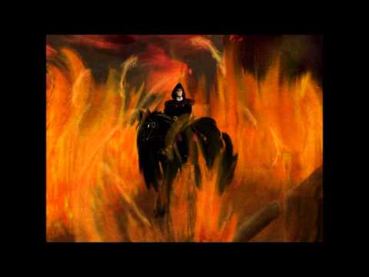
The Lost World A BBC Radio Classic Drama
Dave Goes Babysitting
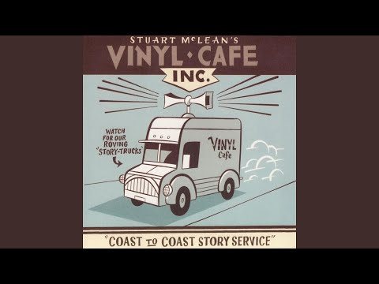

Charles Dickens- A Christmas Carol- Audio Drama
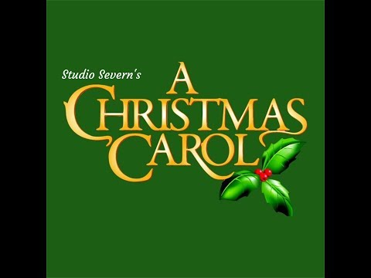

TIMELINE
Monday November 29th, 2021, and Wednesday December 1st 2021 | Pitch session- You will sit down with Ms. Roberge and pitch your play idea.
Thursday December 9th 2021 | First draft of your play is due.
Wednesday December 15th 2021 | First draft of your play is returned to you with notes from Mr. Barrington
Tuesday January 4th 2021 | Final Draft is due
Tuesday January 4^{th,} 2021, to Thursday January 6th 2021 | Students go through casting for voice over actors (who will provide voice recordings).
Thursday January 6^{th,} 2021, to Monday January 17th, 2021 | Recording (Outside of class)
Monday January 17^{th,} 2021 | Editing Process- In class
Tuesday January 18th 2021 | Submit your Radio/Voice Over Play
Thursday January 20th 2021 | Listen to Radio/Voice Over Play in class

- You will be doing a self-evaluation that will be part of your mark.
- The dates will be finalized based on our Unit Schedule in class.
Total Mark: 35 marks

English Studies 12
Radio/Voice Over Play Project
Student Evaluation

Your Name:_________________________________________________________________________

Your group members:
_______________________________________________________________________________________________________________________________________________________________________________________________________________________________________________________________
Please answer the following questions and then give yourself a mark that you think you deserve for this project.

- Did you fully involve all the members on your team in terms of brainstorming and writing your One Act Play script?
__________________________________________________________________________________________________________________________________________________________________________________________________________________________________________________________________________________________________________________________________________________________________________________________________________________________________________________________________________________________________________________________________________________________________

- What was the most enjoyable part of this collaboration project?
__________________________________________________________________________________________________________________________________________________________________________________________________________________________________________________________________________________________________________________________________________________________________________________________________________________________________________________________________________________________________________________________________________________________________

- What was the most challenging part of this collaboration project?
__________________________________________________________________________________________________________________________________________________________________________________________________________________________________________________________________________________________________________________________________________________________________________________________________________________________________________________________________________________________________________________________________________________________________

- If you had an opportunity to do this project again, what would you do differently?
__________________________________________________________________________________________________________________________________________________________________________________________________________________________________________________________________________________________________________________________________________________________________________________________________________________________________________________________________________________________________________________________________________________________________

- What letter grade do you think you and your partner deserve for this project?
________________________________________________________________________________________________________________________________________________________________________________________________________________________________________________________________________________________________________________________________________________________________________________________________________________________________________________________________________________________________________________________________________________________________________________________________________________________________________________

Please circle the mark that you think you deserve for this One Act Collaboration Play project.

A+ A A- B+ B- B- C+ C C- Pass

Your Self-Assessment Mark:___________

Overall Mark: ____________

RADIO/VOICE OVER ACT PLAY RUBRIC

 | Extension | Proficient | Developing | Emerging
Theme  Use writing and design processes to plan, develop, and create engaging and meaningful texts for a variety of purposes and audiences | Though-provoking, relevant and timely. The story provided some thoughtful commentary to a topic that people would find relevant today. | Good premise. Explored a relevant topic and the story provided some insight into a topic that people would find relevant today. | Has potential but requires development. Explored a topic and touched on a topic that people would find relevant today. | Unclear, or implies a harmful message. Has an idea but did not explore or touch on the topic so that people could relate to the topic today.
Plot  Use writing and design processes to plan, develop, and create engaging and meaningful texts for a variety of purposes and audiences | Complex and moving plot that had all the elements of a dramatic story. | Just complicated enough and paced well to reach a dramatic climax. | Intriguing and fully realized. Some holes within the plot that if they were cleared up would have made the story further engaging. | Too simple, or too complicated, or just doesn’t make sense. Too many holes to clear up that would have made the story further engaging.
Characters  Respond to text in personal, creative, and critical ways | Story contained intriguing and relatable characters. The protagonist’s conflict is relatable and helps the audience relate to the story. Protagonist changes in a significant way. | Features intriguing relatable characters. The protagonist confronts a conflict and as a result is changed in some small or large way. | Original, sympathetic characters need more development. Protagonist does not change in a way that is relatable or relevant. | Flat, vague or cliché characters. Protagonist is not changing in some way.
Dialogue  Respond to text in personal, creative, and critical ways | The dialogue is complex, engaging and relatable. Flows in a way that we feel we are watching a play. | Economic. Witty. Each character’s voice is distinctive. Follows in a way that you can picture the story and characters in your mind. | Serviceable. Gets the point across with occasional flashes of humor or cleverness. | Unintentionally stiff and contrived. Sounds like the TV.
Staging  Respond to text in personal, creative, and critical ways | Staging is on point and seemingly an essential part of the play. | Staging, though minimalist, creatively enhances the drama. | Mostly practical and effective but may need simplification or clarification. | Staging is not described, or too difficult to stage.
Creativity  Transform ideas and information to create original texts, using various genres, forms, structures, and styles | The whole story was creative and enjoyable. The author’s story was interesting and engaging which furthered the audience’s imagination. | The story contains many creative details that contribute to the reader’s enjoyment. The authors have really used their imagination. | The story contains a few creative details that contribute to the reader’s enjoyment. The authors have used their imagination. | The story contains a few creative details, but they distract from the story. The authors have tried to use their imagination.
Writing Process  Assess and refine texts to improve their clarity, effectiveness, and impact | Students went above and beyond in time and effort to the writing process. | Students devoted a lot of time and effort to the writing process. | Students devoted sufficient time and effort to the writing process. | Students devote some time and effort to the writing process.
Collaboration  Demonstrate appropriate speaking and listening skills in a variety of formal and informal contexts for a range of purposes | Students went about and beyond with their collaborators. | Students worked extremely well with their collaborators | Students generally were good with their collaborators but there were some issues during the collaboration process | Students did not work well with their collaborators during the collaboration process.
Entertainment Value for a Family Show  The exploration of text and story deepens our understanding of diverse, complex ideas about identity, others, and the world.  Language shapes ideas and influences others. | Four thumbs up! Went above and beyond for a radio play. | Thumbs up! Captured the essence of a radio play. | The playwright’s intended effect is achieved for a radio play. | All in all, the play, though skillful in ways, was a good attempt as a radio play.

STEPS TO FOLLOW
Step 1
Begin with an idea by picking one of the short stories that we have read. Inspiration can come from anywhere and at any time. Get inspired by an interesting person, a meaningful event, an interesting place or an important point that needs to be expressed. Plays are a great medium for expressing a concern or issue.
Step 2
Develop the story before turning it into a play. Remember the same conventions for writing a story. Plot is extremely important, ending in a dramatic climax just like other stories. Character motivation will drive the plot.
Step 3
Create interesting characters. Good character development is essential to playwriting. Your characters should have thoughts, feelings, passion, wants and needs. It is important in stage plays not to create too many characters, which would be confusing to an audience. Consider how many characters are needed to effectively tell the story.
Step 4
Create the world carefully. When performing the play with little or no set or costumes, the audience only knows what the world is by what the characters say. It is important for the audience to understand the play’s context.
Step 5
Write believable dialogue. Dialogue is generally the only way for playwrights to portray setting, character, feelings, thoughts, what is happening, and what has happened before. It is important
that the dialogue being spoken by the character is believable and makes sense at the time it is being spoken.
Step 6
Have a lot of action. In most cases, it is interesting for the audience to see the actors moving around on stage. Some of this is the work of the directors and actor later, but the play needs to allow for it.
Step 7
Keep it simple. Remember that this is not a motion picture. Put the emphasis on good character development, a well thought out plot, and a meaningful theme for the most successful play.

