Hello have you ever been interested in the theory of the continental drift? Maybe you got into an debate whether it makes sense or not, maybe you’re doing a paper and you need some help to understand the wonders of the continental drift theory, well whatever your reasoning, this article on 4 reasons why continents are moving should help you with whatever you’re doing.
Here are the 4 reasons why our continents are MOVING!!
- Continental Puzzle Pieces
By the research of Alfred Wegener one of his theories is that about how each of the continents can be re arraigned and put together like puzzle pieces, the main pieces of evidence of this theory are the connections between South America and Eastern Africa.
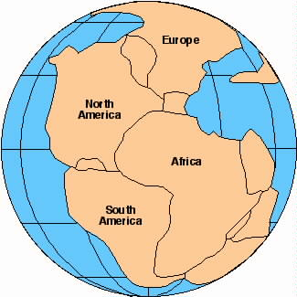
- Plants, Animals and Mountains
Here is another set of evidence by the great Alfred Wegener, however with this one it includes Plants, Animals and mountains. 1. Mountains: to prove his theory Alfred Wagner traveled between countries to study the mountains age and structural make up, after a long time of study Mr. Wagner found 2 mountain ranges with both the same age and minerals split between Africa, and north America. 2. Plants and Animals: not only did Mr. Wegener discover mountains, but he also found the same type of plant and animal fossils. But the most interesting was the discovery of the Meosaraus. The Meosaraus was a shallow, fresh water dinosaur that would have died trying to swim between continents and yet they this dinosaur was discovered in south America and southern Africa.
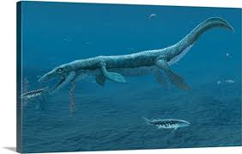
- Tectonic Plate Theory
Now I know that we all have heard of these at least once in our lives, so it should be easy enough to say that the causes of earth quakes are the moving of these plates right? Well this a clear showing of that the earth does in fact move, so it should not be so hard to believe that the continents where once connected then split apart from a lot of moving plates.
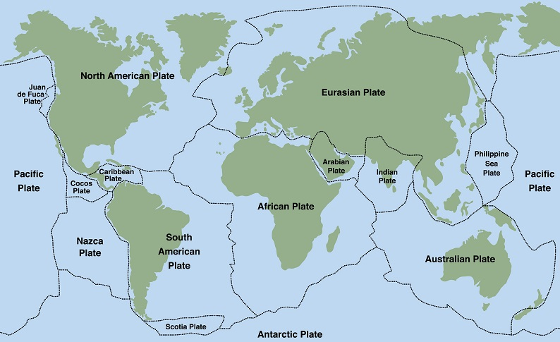
- The paleo climate
Once again a Alfred Wegener theory was that certain types of minerals were commonly found in areas which when you made the world into Pangea the minerals would sort of clump together. Take today’s northern Europe and Applacleant, these are both places that are rich in coal, however they are now a days split apart, but for “ideal coal production” by the earth it would have to be stationed in a hot wet equatorial climate. This would only make sense if at one point these place where together and lower on the map (Pangea)

