Alliteration
The commencement of two or more stressed syllables of a word group either with the same consonant sound or sound group.

Bobby’s bouncing beagle barked and barked, becoming bothersome for Billy

Personification
Figure of speech in which a thing, an idea or an animal is given human attributes. The non-human objects are portrayed in such a way that we feel they have the ability to act like human beings.
Lightning danced across the sky.

Simile

figure of speech involving the comparison of one thing with another thing of a different kind, used to make a description more emphatic or vivid
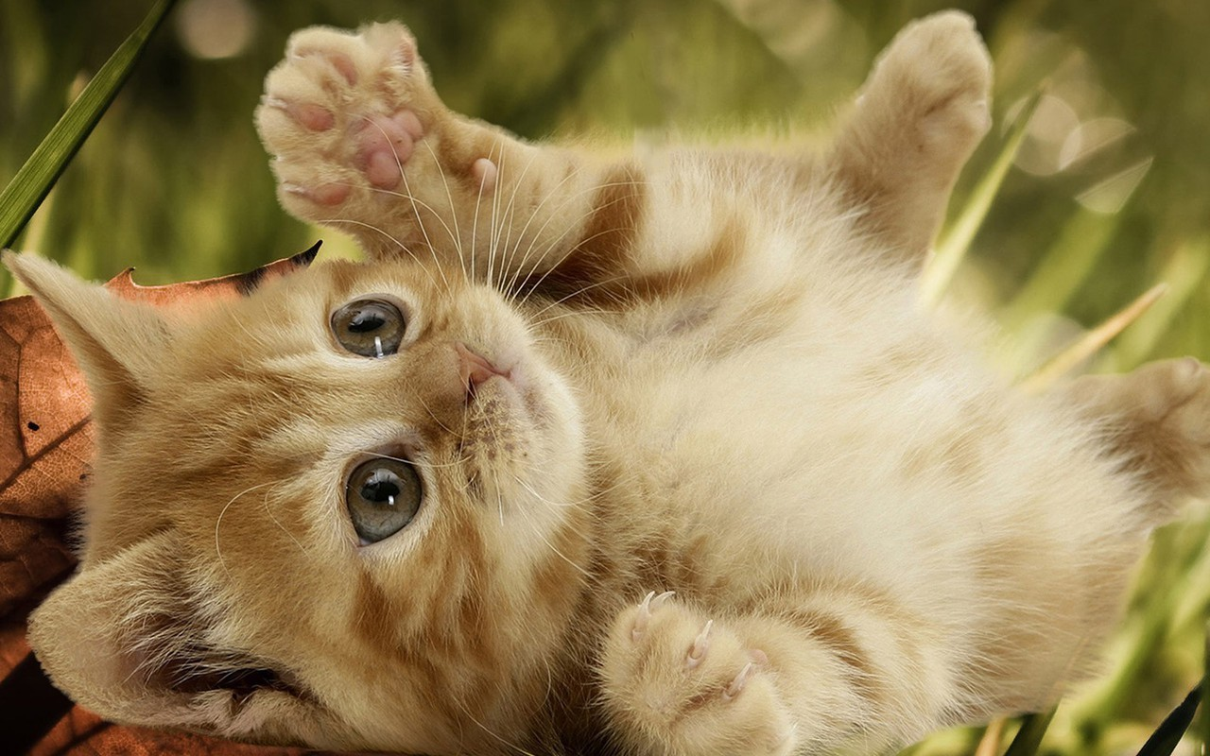
She was as cute as a kitten

Onomatopoeia
the formation of a word from a sound associated with what is named
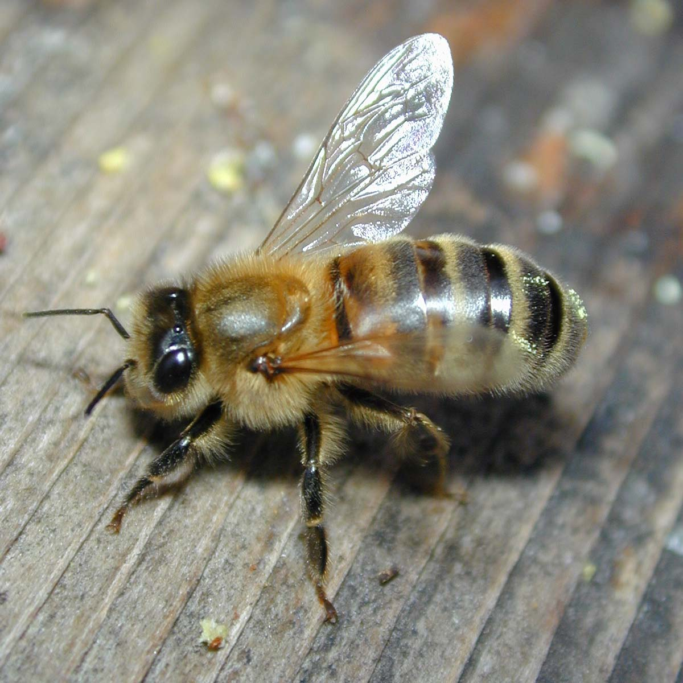
Both bees and buzzers buzz.

Metaphor
figure of speech in which a word or phrase is applied to an object or action to which it is not literally applicable:
He drowned in a sea of grief

Hyperbole
Exaggerated statements or claims not meant to be taken literally.
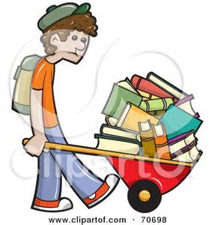
He had a ton of homework

