Canada Expands West Political
Part 3:
- Define and state the significance of each of the following (Horizons – Chapter 4 – pages 156-160):

Term | Definition/Background | Significance
Rupert’s Land | land that was given to the Hudson’s bay company for trade reasons but becomes too much to handle for them. | gets sold to Canada, the metis were never consulted.
Louis Riel | He was once the leader of the red river resistance. | He made a group of metis to fight for their rights which creates one side of the war.
Land surveyors | They are chosen to map out the land and to see where everything should go. | They would plan where everything should go.
Canada Party (page 155) | They made the act for Canada | Canada might have been different
Fort Garry | It was a fort the metis took over | If they didn’t take over the fort Canada wouldn’t care for them and give them rights
William McDougall | he was trying to take away rights from people | People wouldn’t have rights if he succeeds
John Schultz | He was a pro Canada and expand into where the metis were | He wanted to expand into where the metis were
Thomas Scott | He was anti metis and didn’t like louis riel he went to prison after being a part of a raiding group | His death would have been profound implications for the metis and Luis real
John A MacDonald | He was prime minister | If he was never alive we wouldn’t have Canada

Part 3:
- Define and state the significance of each of the following (Horizons – Chapter 4 – pages 156-160):

Part 4:
- List the articles from the Manitoba Act that match what the Metis were asking for in the Metis List of Rights:
Article #: | Translation:

- Based on your findings in #1 above, would the Metis be satisfied with the Manitoba Act? Explain why or why not (think about quality and quantity of rights given):

- What is scrip? How was the process of attaining scrip made difficult? (Horizons – Chapter 5 – pages 167-168 and Collections Canada)
It was difficult because the metis could not read or write so they asked lawers to help them write it out but they bribed the metis with around 100 dollars there and they would say it might take yours for them to get their land.

- What were the Laws of St Laurent? What happened to these laws and how was Lawrence Clarke involved? (Horizons – Chapter 5 – pages 169-172)
the buffalo would only be allowed to be hunted once in a while because their numbers were decreasing. Lawrence Clark arrested two metis hunters that were hunting bison

- How would you characterize Canada’s treatment of the Metis after the Red River Rebellion (explain by considering the Manitoba Act, and what happened with scrip and the Laws of St Laurent)?
Canada treated them like slaves but was slightly better than slaves because It was difficult because the metis could not read or write so they asked lawyers to help them write it out but they bribed the metis with around 100 dollars there and they would say it might take yours for them to get their land.

- Sketch a fictitious scene that illustrates #5 above (what could each character or concept be symbolized as?).

Part 5:
- Explain why whiskey was a growing problem for First Nations people in the Plains. (CBC.ca)
The white traders were getting the natives drunk then making deals but after they tasted the whisky they got addicted to it and the white traders would take advantage of their addiction and get better deals for the traders.

- What are the reasons for the creation of the Northwest Mounted Police? (Horizons – Chapter 5 – pages 174-175)
Made as a police force to protect the parries and stop American traders from passing into Canada and stop the American traders and their liquor intake.

- Sketch 3 different book covers for the Whiskey Peddler based on 3 different perspectives: Aboriginals, Americans, Canadians:
Provide sketches here

Part 6:
- What are the reasons for the Aboriginals and Canada to enter into treaty negotiations?
Aboriginal Reasons | Canada’s Reasons
They were starving and need help and this was their chance | So then they sign the paper that’s says all the land is owned by canada

- What did the Aboriginals receive in Treaties 1-7 in exchange for giving up their rights to the land?
They would be given 600+ meters of reserve land for their tribe to live in with peace and harmony, 5+ dollars per person every year even today, 20$+ per year for the chief and a suit of clothes every 3 years. A one-time gift of farming tools, schools on reserve land, a censes, promise they would police themselves and no liquor to be sold to them at any time. But it varies on the place.
We got their land by striking deals with the natives for things they need.

- Make a questionnaire/poll with 3 questions about fairness that are analogies of the Aboriginal’s situation and the treaty agreements. You should not mention treaties or Aboriginals at all.
Provide your questions and explain the analogy’s connection to the Aboriginal situation with treaties:
Questions: | Explain the Analogy:

Part 7:
- View the political cartoons in the image gallery and complete the following:
Title | Describe | Document | Interpret

Part 8:
- Why did MacDonald develop the National Policy? (Horizons – Chapter 5 – pg 197)
Raise tariffs 15% to 17.5% to 30%. He did it to keep jobs in Canada and grows business in Canada. It helps create new industry. We also get new technology it keeps Canadians in the country. It raises revenue for government helps create national economy

- Define each of the three parts of the National policy. For each case, state why MacDonald thought it would benefit Canada:
 | Definition & how to get it done | Benefits
Impose High Tariffs | raised taxes from 15% to 17.5 – 35%!! | Protects small industries.  Protects jobs in Canada.  Helps create ne industry’s  Transfers technology in the county.  Keeps Canadians in the country  Raises revenue for government  HELPS CREATE EAST- WEST/NATIONAL ECONOMY.
Settle the West | The east makes food and they sell it to the west. | Keeps economy in Canada and helps each other
Build a Transcontinental Railway | A rail way built to BC to connect BC to the rest of Canada | Canada is connected to every province now.

- What problems did the construction of the CPR encounter? How were these problems solved? (Route change? William Van Horne? Budget 1883?) (Horizons – Chapter 5 – 198-201)
People ran out of money, it was harder to make the rail way in the mountains than the prairies

- Pick one of the following children’s stories to create an analogy for John A Macdonald’s National Policy. Sketch the analogy and explain what parts of your sketch represent the different parts of the John A MacDonald’s National Policy.
  - Three Little Pigs
  - Little Red Riding Hood
  - Jack and the Bean Stalk
  - Goldilocks and the Three Bears
Provide explanation here

Provide sketch here
Part 9:
- Read about the Northwest Rebellion here (http://www.thecanadianencyclopedia.ca/en/article/north-west-rebellion/). What were the causes of the Northwest Rebellion?
Aboriginals | Metis
The bison herds where depleted, pushing people to near starvation, their land was being signed away in treaties, and they were now seeing towns, farm fences and railways appearing on the once wild and expansive prairies. | Their old life style as fur traders and carriers for the Hudson's Bay Company was disappearing, they were losing bison on which they also where depended on. They were also waiting, without much help from Ottawa, for reassurance that title to their river-lot homesteads and farms would be guaranteed.

- Using the same article from above, complete the following:
Historical Figure | Role in the Northwest Rebellion | What happened to them after the Northwest Rebellion?
Gabriel Dumont | he was a military commander, | Gabriel Dumont, among others, eventually returned from the US under the terms of a general amnesty.
Big Bear | Cree chief Big Bear, and Crowfoot, leading chief of the Blackfoot, founded an Aboriginal confederacy to try to solve their people's grievances.  warriors of Big Bear's band took several Métis and non-Métis settlers prisoner. A war chief Wandering Spirit kills a federal Indian agent. Chief Big Bear then tried to stop the violence, but the warriors took their own initiative from their war chief and killed two priests, the government farming instructor, an independent trader, a miller and three other men. Several people were spared, including the widows of two of the dead men.  Big Bear had been the last Plains chief to sign a treaty with Ottawa, and in 1885  Basically they from what I am getting from this is they are the peaceful ones
Poundmaker | Chief Poundmaker perswaded the aboriginal worriors not to attack the governments troops | Chief Poundmaker and a number of Battleford area tribes had surrendered to General Middleton on 26 May at Battleford.
Louis Riel | The Métis of Saskatchewan brought Louis Riel, the Red River Resistance leader, back to Canada from exile in the United States. Riel urged all dissatisfied people in the North-West to unite and press their case on Prime Minister John A. Macdonald's Conservative government, which had failed to address their grievances. | Louis riel was been hung by a noose.

- Why do you think Canada’s response to the Metis was different during the Red River Rebellion and the Northwest Rebellion?
the first time they tried to do it peacefully and give them land but they did not want the land so they chose to fight.

- Analyze the following painting of the Battle of Fish Creek by comparing it to the written description:
Question | Response
How did the Battle of Fish Creek start
How does the painting reveal the start of battle?
How many soldiers did the Canadians and Metis have at this battle?
Does the painting show the number of soldiers correctly? How do you know?
Who won the battle?
Who looks like they’re winning in the painting? How do you know?
Who’s perspective does this painting show? How do you know?

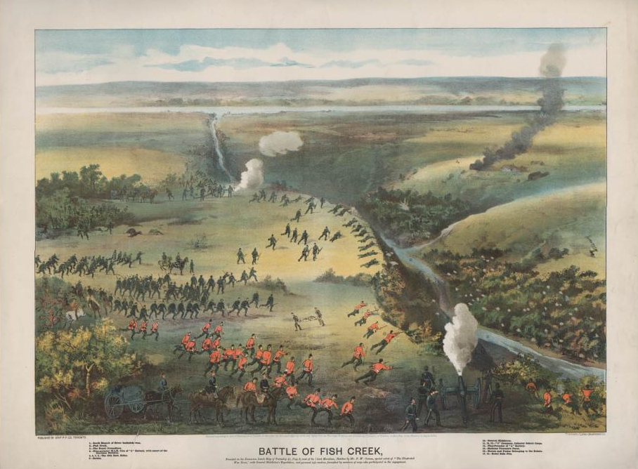
- Create a sketch of the above painting from the opposing perspective:
Insert sketch here

Video Discussion
- Which of the following factor affects ownership of land more: who was there first, who originated there, or who made use of the land? Explain with examples from the past and present.
- Choose one of your analogy questions from Part 6 above, explain the analogy you were creating and explain what the results of your questionnaire says about the fairness of the treaties. Explain whether or not you agree with the questionnaire results.
- Is Canada guilty of genocide when it implemented the Residential School program with Aboriginals? Refer to the definition of genocide provided by the UN.
- Are the names “Red River Rebellion” and “Northwest Rebellion” proper labels for these two events? Explain why or why not. If not, explain what a better label would be.

Cartoon Planning:
- How would you characterize Canada’s treatment of the Aboriginals and the Metis between 1867 and 1885? Come up with an analogy for your characterization – “Canada’s treatment of the Aboriginals and the Metis is like ___(what situation?)___________________”
In your analogy:
- How would John A MacDonald be depicted? Is there an appropriate symbol that could represent him and fit your analogy above?
  - Summarize what MacDonald did in the Red River Rebellion in one statement. How can that fit your analogy?
  - Summarize MacDonald’s intentions with the Treaties and Residential Schools in one statement. How can that fit your analogy?
  - How could the National Policy fit the analogy?
  - Summarize MacDonald’s response in the Northwest Rebellion in one statement. How can that fit your analogy?
- How would the Metis be depicted in your analogy? Is there an appropriate symbol that could represent them?
- How would the Aboriginals be depicted in your analogy? Is there an appropriate symbol that could represent them?
*If you get stuck on one of the steps above, you may have to restart your analogy idea.

- SKETCH your political cartoon. Find someone to explain your sketch to.

- Redo your sketch if necessary.

