
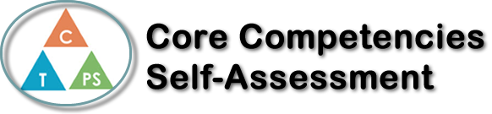
Name: Olivia Lukasiewicz | Date: February 28, 2022

  X  How does the artifact you selected demonstrate strengths & growth in the communication competency?  In what ways might you further develop your communication competency? | Self-Reflection  Describe how the artifact you selected shows your strengths & growth in specific core competencies. The prompt questions on the left - or other self-assessment activities you may have done - may guide your reflection process.  While making my mind map, I had to be very creative with my communication and how I represented my findings. I wrote a lot about different aspects of the story, and with this writing I had to be precise and use many different words to represent what I wanted to say. I used descriptive language and made sure to explain thoroughly, so that if someone read my mind map, they would be able to understand “A Private Experience” fully. When looking at the visual aspects of my mind map, I tried very hard with symbolism and making my presentation have a double meaning. I used archetypal colors such as red and blue, to have meanings that related to the deeper theme of the story. The red represents courage, sacrifice and danger and the blue represents calmness, trust, and wisdom. I also used wavy patterns in my project, which are meant to represent change, as the women both go through a lot of change throughout the story. I used a lot of images to visualize the story more, and I made sure all the images added to one’s understanding of the story. In the end, I put a lot of thought into my project, and I genuinely believe that I tied the best that I could to complete it. It thoroughly represents my understanding of the story and definitely helped my skills of communication and creativity.


How does the artifact you selected demonstrate strengths & growth in the thinking competencies?

In what ways might you further develop your thinking competencies?


How does the artifact you selected demonstrate strengths & growth in the personal & social competencies?

In what ways might you further develop your personal & social competencies?

Publish Your Self Assessment
You will now attach and/or embed your self-assessment to the bottom of the blog post with the artifact you have chosen. You may choose to make this post private or public. After placing your artifact on a blog post, follow the instructions below.
- Categories - Self-Assessment
- Tags - Now tag your post using the tag that corresponds to the competency that you have written about. You can choose more than one. Please use lower case letters and be exact.
  - #creativethinkingcc
  - #communicationcc
  - #criticalthinkingcc
  - #socialresponsibilitycc
  - #personalidentitycc
  - #personalawarenesscc
- Use the Add Document button located at the top of your post page and embed your self-assessment at the bottom of your blog post.
- Publish

