
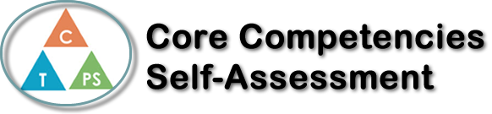
Name: Olivia Lukasiewicz | Date: January 24, 2022

  How does the artifact you selected demonstrate strengths & growth in the communication competency?  In what ways might you further develop your communication competency? | Self-Reflection  Describe how the artifact you selected shows your strengths & growth in specific core competencies. The prompt questions on the left - or other self-assessment activities you may have done - may guide your reflection process.  This work experience class has taught me a lot of important lessons that I will never forget. One thing that it gave me a sneak peek of was adult life.  There are so many adults that work long hours every day at a job that they don’t even like, just because they need the money and/or because they paid for the schooling and now feel stuck in this career for the rest of their lives. This is a sad reality that affects many people around us. Before this work experience, I was thinking about becoming a lawyer. I spent a lot of time thinking about it and I always had my friends and family saying that I should go into that career. The experiences I had while volunteering under Cadman Law taught me to really think critically about my future job. I got a bit of a taste of how a lawyers career life is, and it taught me that I really don’t want to become a lawyer. An experience like this is very valuable to me as now I won’t waste more time trying to take part in a career that I am not interested in.  I really feel that my thinking competency grew from this experience as now I am clearer on the things I like in a job, and the things I don’t like.

X

How does the artifact you selected demonstrate strengths & growth in the thinking competencies?

In what ways might you further develop your thinking competencies?


How does the artifact you selected demonstrate strengths & growth in the personal & social competencies?

In what ways might you further develop your personal & social competencies?

Publish Your Self Assessment
You will now attach and/or embed your self-assessment to the bottom of the blog post with the artifact you have chosen. You may choose to make this post private or public. After placing your artifact on a blog post, follow the instructions below.
- Categories - Self-Assessment
- Tags - Now tag your post using the tag that corresponds to the competency that you have written about. You can choose more than one. Please use lower case letters and be exact.
  - #creativethinkingcc
  - #communicationcc
  - #criticalthinkingcc
  - #socialresponsibilitycc
  - #personalidentitycc
  - #personalawarenesscc
- Use the Add Document button located at the top of your post page and embed your self-assessment at the bottom of your blog post.
- Publish

