
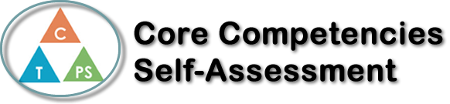
Name: Noah Marusenko | Date: November 16, 2020

  How does the artifact you selected demonstrate strengths & growth in the communication competency?  In what ways might you further develop your communication competency? | Self-Reflection  Describe how the artifact you selected shows your strengths & growth in specific core competencies. The prompt questions on the left - or other self-assessment activities you may have done - may guide your reflection process.  This project helped me develop a better understanding of culture and how it shapes our identity through questions and research. For this project, I chose to do my research on Morocco because it is a country that I have visited before when I was younger but didn’t have the chance to learn about the culture of this country yet. I have greatly grown my understanding of the culture of this country by doing research about the French language, the history of the country and general facts about it.  This artefact proves my growth in the personal identity competency because now I am more aware of a different culture in the world and am capable of knowing how to learn about other cultures and how they affect everyone in the world.  One interesting aspect I found during my research was that on the Canadian government’s website, they talked about being allies with Morocco and how they are fighting for social justice together in the world. This is an aspect that I did not know about that directly relates to all of us because a country in the world that we were unaware of (Morocco) has direct correlation with Canada.  Overall, I am very confident with how my project turned out and am happy for others to see the Prezi I made so they can also get informed about the interesting culture of Morocco. I really enjoyed this project, and I am going to continue to learn about the culture of different countries in the world and how they affect us here in Canada.


How does the artifact you selected demonstrate strengths & growth in the thinking competencies?

In what ways might you further develop your thinking competencies?

X

How does the artifact you selected demonstrate strengths & growth in the personal & social competencies?

In what ways might you further develop your personal & social competencies?

Publish Your Self Assessment
You will now attach and/or embed your self-assessment to the bottom of the blog post with the artifact you have chosen. You may choose to make this post private or public. After placing your artifact on a blog post, follow the instructions below.
- Categories - Self-Assessment
- Tags - Now tag your post using the tag that corresponds to the competency that you have written about. You can choose more than one. Please use lower case letters and be exact.
  - #creativethinkingcc
  - #communicationcc
  - #criticalthinkingcc
  - #socialresponsibilitycc
  - #personalidentitycc
  - #personalawarenesscc
- Use the Add Document button located at the top of your post page and embed your self-assessment at the bottom of your blog post.
- Publish

