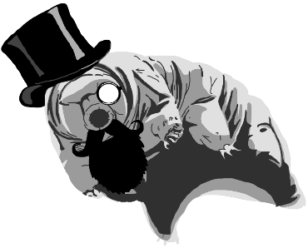
Tardigrades
Noah H

Taxonomy:
- Domain: eukaryote
- Kingdom: Animalia
- Phylum: tardigrada
- Class: Eutardigrada
- Order: Parachela
- Family: hypsibiidae
- Genus: hypsibius
- Species: hypsibius dujardini

The sexual reproduction could happen externally and internally. A female will lay her eggs on the outer layer of the moult and a male will come along and begin to fertilize the eggs. They can also have sex for up to an hour. The male curls up with the female and she will stimulate the male while semen is ejaculated several times.
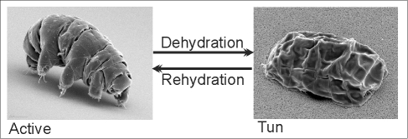They are known to live only from 3 to 30 months without being in a tun state. A tun is when they curl up into a ball almost like a pill bug that produces glycerol (antifreeze) and Trehalose (a sugar) that has remarkable preservation properties. In this state the tardigrade can live for up to centuries and when revived (rehydrated), it’s able to reproduce and move without difficulty.

Reproduction/Lifestyle
Evolution
Water bears are dioecious and can reproduce asexually and sexually. The asexual way of reproducing happens when there are sometimes no male tardigrades in a species of tardigrades. A female tardigrade will undergo parthenogenesis when she will lay her eggs and they will develop without the need of fertilization.

the evolution of tardigrades is a rough subject. There have been many assumptions as to how the tardigrade became to be. A sixth of their genome came from horizontal gene transfer. Some say that they are related to arthropods from their moulting cycles and nematodes from their piercing style of feeding and similar body plan. In 1702 Anton Van Leeuwenboek discovered cryptobiosis (adaptations of being able to withstand harsh conditions) with nematodes and rotifers which could indicate that they descended from roundworms. PLos One Biology published a paper when they tried to find what type of proteins their genomes contain that stops cell death, but in the end the data was inconclusive.

What is it?

The hookah-smoking caterpillars in “Alice in Wonderland” resemble a unique creature called the tardigrade (often called water bears or moss piglets). It’s an invertebrate belonging to the Tardigrada phylum. There’s over a thousand-different species worldwide in terrestrial, freshwater and marine habitats. They are long, plump bodied, eight legged microscopic organisms that are almost indestructible.

Video of sexual reproduction
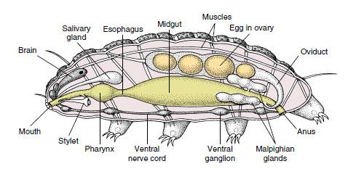

Bilateral symmetry
Tardigrades are said to survive every possible mass extinction, so if they were to become extinct, humans can possibly be endangered. Possible ways that the tardigrade could become extinct are if a nearby star goes supernova and sends deadly radiation toward earth, a gamma ray burst fries earth or an asteroid impact. All these possibilities are related to earth and mankind so if tardigrades become extinct, we become extinct.
An ecological benefit of tardigrades is that they are a pioneer species, inhabiting new environments to attract other invertebrates and predators to a space. They are known to be bioindicators for environments air quality to see how a species was affected by pollution like abnormal levels of sulfur dioxide. Like the spotted moths affected by industrial pollution. 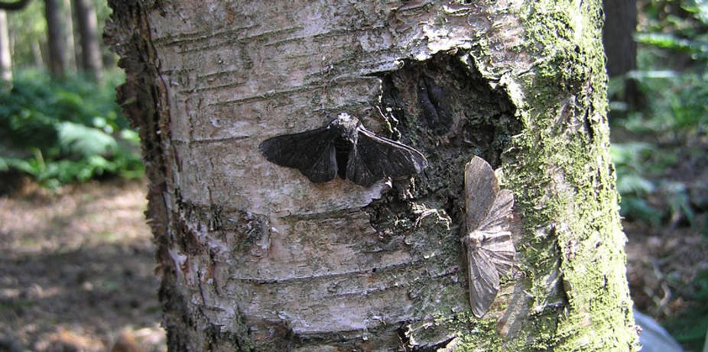

Tardigrades were a part of pop culture in the TV show Star trek: discovery as a giant version of a tardigrade that was incredibly strong and could travel anywhere in the universe. In the movie ant-man and the wasp the main character rode a tardigrade to show another perspective of how small ant man was. Tardigrades are 0.5mm long so how could an ant-sized man fit on top of a tardigrade? 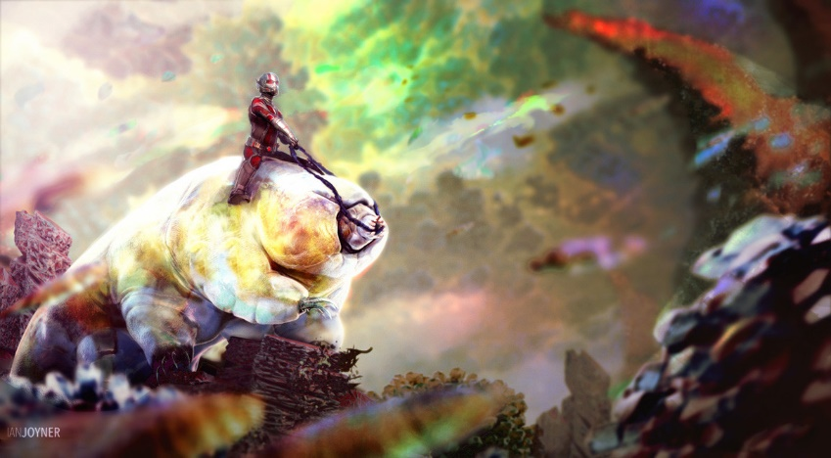 There have been many other appearances like in South Park, Family Guy, Harbinger Down and Adventure Game Studio.
They also took part in an experiment with NASA. In 2007, they launched a tardigrade in space with the Nasa shuttle endeavour along with other microscopic animals. After 10 days of exposure to airless conditions, ultraviolet rays and cosmic rays they were rehydrated. The space vacuum had little effect on them. The only thing that affect their cellular material and DNA was the ultraviolet radiation, but 68% of the tardigrades recovered and went on to lay eggs that hatched.

The tardigrade isn’t the type of animal people would want to represent or be spiritual about since it’s smaller than a grain of rice and isn’t exactly well known. Although some characteristics of the tardigrade you can find in spiritual animals like the bat which represents the unknown longevity of the tardigrade species or the bear and its immune-like strength to be able to withstand much hotter and colder temperatures. 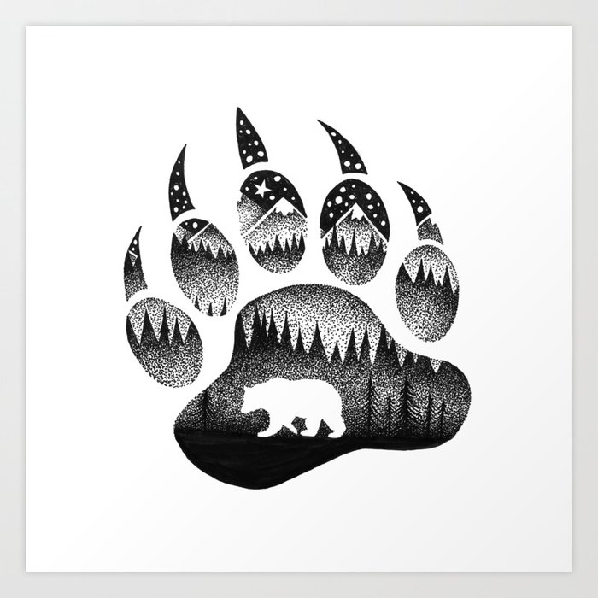 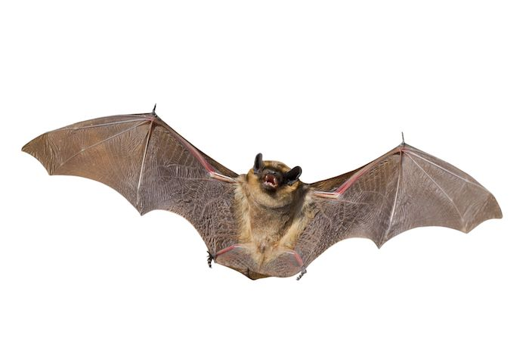
Tardigrades may one day help humans be immune to harsh elements like radiation. A molecular biologist Takekazu Kunieda from the university of Tokyo discovered by sequencing a tardigrades genome and inserting it into mammalian cells that the tardigrade-tinged human cells were able to reduce the radiation damage by 40%. If we could solve the mystery to what makes these creatures immune to almost everything it will be a new stepping stone for humans.

Pop/Science Culture
First Nations
Extinction

Since tardigrades are invincible to the human eye, I was curious to know what these creatures looked like. I decided to find a tardigrade myself. I started by taking a piece of moss (usually tardigrades live in moist areas like moss) and added water to it in a small container. After 50 minutes I took a sample of the moss water and placed it in a glass piece on a microscope. To be honest the chances of me finding a tardigrade were slim, but I think I managed to find one.
I cannot tell if it is another microscopic organism (a very good chance it is), but the process of trying to find one was very interesting. It didn’t have the long, slim body of a worm. It looks like there’s small legs and a head with body segments. It had a few longer limbs and a few shorter ones which is something I haven’t seen on tardigrades. It looks a lot longer than I expected which is another thing I didn’t except. It doesn’t look like it’s in a tun state, but when I was observing it through the microscope there was no sign of movement. Maybe tardigrades don’t need to be in a smaller form to be dormant. In my opinion`, I believe that this is a tardigrade because of its segmented body, small limbs, and from the environment it was found in.
`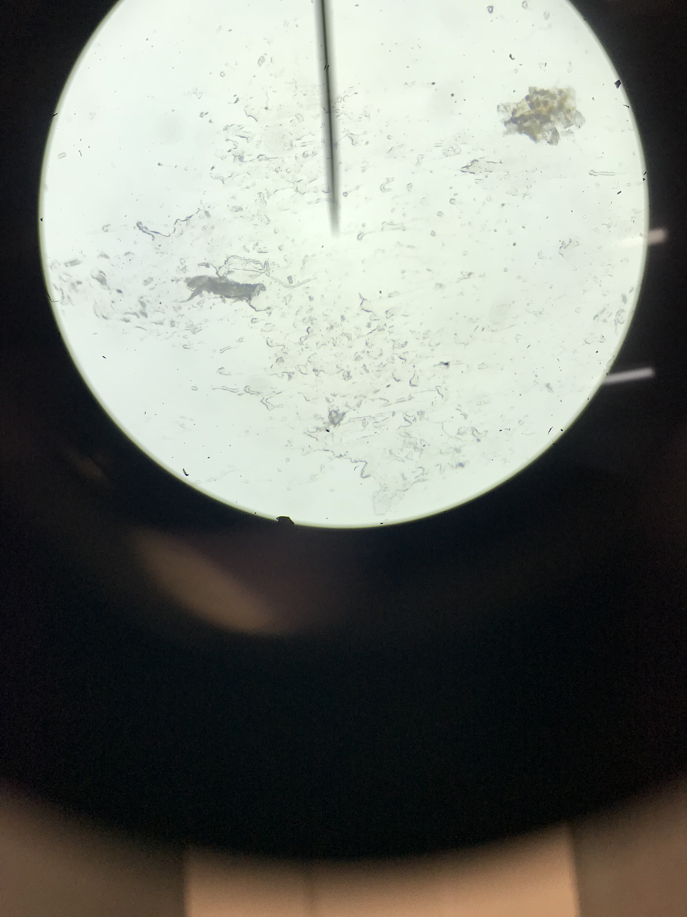
Tardigrade lab
Sources:
- Borenstein, Sarah. “Tardigrades.” Examples, Marine Biological Laboratory, 7 June 2017, serc.carleton.edu/microbelife/topics/tardigrade/index.html.

- Courtland, Rachel. “'Water Bears' Are First Animal to Survive Space Vacuum.” New Scientist, New Scientist, 8 Sept. 2008, www.newscientist.com/article/dn14690-water-bears-are-first-animal-to-survive-space-vacuum.

- Mandelbaum, Ryan F. “Tardigrades Are Still a Complete Evolutionary Mystery.” Gizmodo, Gizmodo.com, 28 July 2017, gizmodo.com/tardigrades-are-still-a-complete-evolutionary-mystery-1797336080.

- Thorp, David H., and Alan P. Covich, eds. Ecology and Classification of North American Freshwater Invertebrates. Third ed. N.p.: Elsevier Inc., 2010. 455-84. Print.

- Wright, J. 2014. "Tardigrada" (On-line), Animal Diversity Web. Accessed December 13, 2018 at https://animaldiversity.org/accounts/Tardigrada/

- Weiser, Kathy. “Native American Totem Animals & Their Meanings.” Legends of America, Legends of America, 2017, www.legendsofamerica.com/na-totems/.

- Stanford Tardigrade Project. “How to Find Tardigrades (Water Bears) in Your Own Backyard.” Microcosmos, 10 Aug. 2016, microcosmos.foldscope.com/?p=17901.

