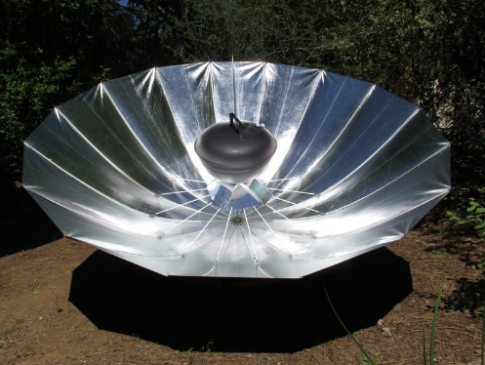  Parabolic solar cooker: |  | 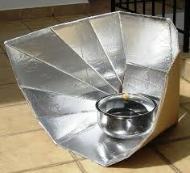  Panel cooker: |  | 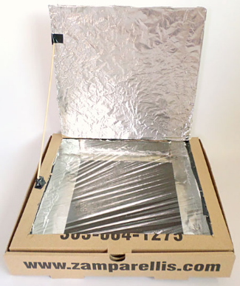  Box cooker (pizza box):
Pros: | Cons: | Pros: | Cons: | Pros: | Cons:
insulate heat very well | Wider than most solar cookers | Can be used for high moisture foods in pots (soup, stews, braising) | Takes longer to cook to produce tender and succulent products. | Capable of baking things on trays | Run out of space depending on how big and deep it is.
Can be used for high temperature cooking like grilling and frying. | Must adjust the angle and direction of the cooker for maximum cooking efficiency | Never needs to be adjusted. | It can not reach a temperature more than 250 degrees Fahrenheit from the lack of insulation of a glass sheet. | Can reach high enough temperatures for baking needs and high moisture contents (250-350 Fahrenheit) | The cooker is often homemade and not very professional so maintaining the oven will be necessary.
Time of cooking is reduced from the high temperature | The design is more complex and takes more practice to use. | Very difficult to burn or overcook things since its low temperature. | High wind can affect the cooking process since it will knock the panels out of place. | Very safe and does not need much surveillance
 | Cost more to produce and buy |  |  | The simplest and cost-effective design.

3 common types of solar cookers and their pros and cons

Why did we pick the box solar oven?
We picked the box oven for various reasons. First, it was the most cost effective since we didn’t need to buy any of the materials to construct it since all we needed were household items like a cardboard box, plastic wrap, tin foil etc. Secondly, it was very simple to build. There were many tutorials online about how to make it and how you could improve it. Lastly, it’s compact and portable. Mot solar ovens like the parabolic are wide and hard to transport. The box oven is simply a box that could be stored, transported and dissembled easily.

How does thermal energy affect our solar oven?
Green house gas – The green house effect is when sunlight enters a transparent material such as glass or plastic enters a room and the rays are reflected by materials like tin foil within the room or oven. The cold energy is absorbed by the energy absorber and because its radiant energy, most of it cannot escape. It is absorbed by the object being cooked, a pot or other materials. A dark absorber plays a critical role in a solar oven since it conducts heat that cooks the food.
Conduction – Conduction happens when heat is transferred from object to object. If we put the solar oven outside without any sort of conductor it will be very difficult to cook anything since all the heat is entering the oven materials and simply leaving. An absorber plate is needed to insulate all the heat, we used black paper. When the solar rays enter the oven, it needs an conductor (tin foil) of heat to spread throughout the oven. See picture F.1.
Convection – heat circulates due to convection. Conduction occurs when heated air molecules within the solar oven escape, see picture F.2. This happens when little spaces, holes or the door of the oven escape through imperfections of the oven. Natural convection also occurs from the natural sunlight that enters and evenly distributes heat through the object being cooked.

Radiation - Radiation occurs mostly on the object being cooked since the glass or plastic traps most of the radiant heat see picture F.3. It radiates heat on the food or pot and reflects off the insulation (aluminum sheets) and plastic sheet and generates heat back to the food or pot.

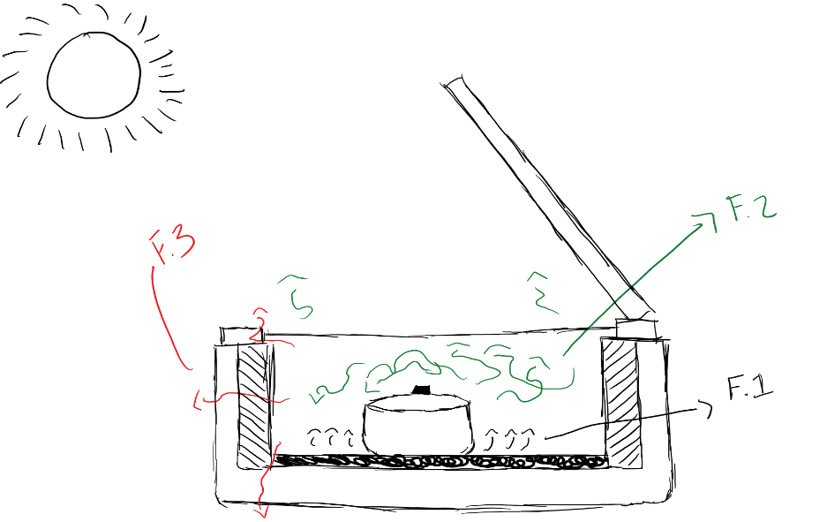

How we improved our solar oven
Our solar oven worked I was pleased with the results, but I wanted to know of there was a way to cook things faster or if the oven could get hotter. Since the box cooker is a very common oven, there have been many different modifications people have made that helped. The first improvement I made was to the conductor (black sheet). If the heat came in and the black sheet was laying flat on the cardboard, the heat would go straight through the cardboard out of the oven. If you elevated the conductor, then the heat waves should flow throughout without escaping. The second adjustment I made was to the reflector. One reflector did the job, but it made sense putting more in to concentrate the sunlight and to direct the heat. I glued two more reflectors to the sides of the original reflector at an angle so the sunlight can reflect off those and the main reflector to conserve the sunlight.

The experiment
smores
Time | 15 minutes
Temperature (start and end) | Start: 30 degrees Celsius  End: 50 degrees Celsius

Sources:
- Fulmer, Nora. “The Relationship Between Heat Transfer and Cooking.” WebstaurantStore, - WebstaurantStore, 5 Oct. 2016, www.webstaurantstore.com/blog/postdetails.cfm?post=976.
- parry, nathan. “Solar Cookers: Pros and Cons of the Different Types.” Solar Cooker - Solar Cooking, www.solarcooker-at-cantinawest.com/solarcookers-prosandcons.html.
- “Principles of Solar Box Cooker Design.” Solar Cooking, 13 Mar. 2018, solarcooking.wikia.com/wiki/Principles_of_Solar_Box_Cooker_Design.

