Earthquakes and Impacts

Part 1:
The region I have chosen is Southside Port Coquitlam. Port Coquitlam is built on till. Till is a soil made up of clay, silt, sand, and stones. Till is deposited by glacial ice. This means that till is basically materials left over by moving glacier ice. Port Coquitlam was formed by the Fraser Glaciation, which allowed us to have the beautiful scenery, soils, and ecosystems, we have here today. Port Coquitlam can be considered to have a suburban population, only about 52, 342 people living here, specifically just in Port Coquitlam. Even though Southside Port Coquitlam is a smaller community, we are all connected in the activities we do and places we do them in. For example, I work at a local bakery. It has been here for many years, and every day I see almost all the same customers. I like this because it helps me see the types of people that live in my community, and get to know them better. Since we are a smaller town, we have great opportunities for smaller, specialized businesses. None of which interfere with the amazing assortment of ecosystems that we have. Southside PoCo does not have a retail centre like a mall, we consist of fast food places (Dairy Queen, McDonalds, Subway, Donair…), barber shops, Drugstores/ stores (Shoppers Drug Mart, Pharmasave, Super Value), and smaller personally owned businesses, like the bakery I work at (Inno Bakery). PoCo is made up of forests, managed parks, marshes, and rivers. Therefore, we have many trees, different animals, and man made things that we combine with the environments. For example, Gates Park or Lions Park. These parks are built in the forests and along the rivers. The people of Port Coquitlam enjoy the available ecosystems to do environmentally friendly activities. Like rafting, sports, fishing, picnics… Since I live on Southside, I have had many personal experiences with the region. The obvious ones being: going to school and working. Which gives me the opportunity to interact with the people here. On a more interesting level, the environments here have given me the chance to interact with some of the animals, such as bears and coyotes around my house.
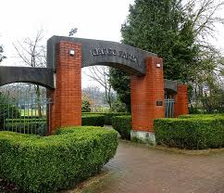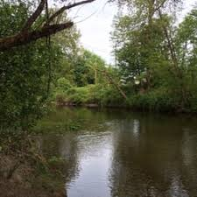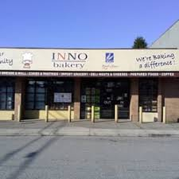
Part 2:
If Port Coquitlam was ever to experience seismic activity, it would be caused by the Juan de Fuca plate and Continental North American Plate. For an earthquake to hit Southside Port Coquitlam and even the Greater Vancouver area, the Juan de Fuca plate would have to move towards and under the North American plate in the boundary called Cascadia Subduction zone, which is the boundary along the British Columbian Coast. This type of plate movement is called convergent boundary. P and S waves will liquefy the soil (till) in some parts of Southside Port Coquitlam. Some areas like Citadel Heights are located on a higher elevation and therefore will be saved from the liquefaction of their grounds. The local ecosystems would be damaged due to fallen trees, covered rivers, and the liquefaction. Many animals that live in the water would die, due to the falling of tree’s, buildings, and branches even. Although, a good portion of our forest/river ecosystems would basically become a large pile of mud mixed with trees and leaves/grass, mother nature would eventually grow back. The houses of Port Coquitlam are mostly made of wood, which is good, because wood withholds earthquakes stronger. Many people might say that Southside Port Coquitlam is a small populated space, but that is only if you compare it to the GVA’s. We may have fewer people than Vancouver, but that doesn’t mean 50,000 people is not a lot. The risk factors still exist for us suburban people. For example, the liquefaction of our soil will cause roads, and houses to be destroyed, tall buildings and trees to collapse. Many neighborhoods in Southside Poco are townhouses. Townhouses are connected, which can cause many damages to the surrounding townhouses. For example, if a certain unit was to set on fire, it would spread to the other unit’s, or while the ground is undergoing liquefaction the entire complex would move as one, potentially creating more hazards. All the personally owned, local businesses would no longer exist. Whereas, the more company based businesses would be alright, such as Dairy Queen. Because they have their stores all over Canada. Port Coquitlam in general, but especially Southside would be isolated from everything. All the bridges would collapse, and all the roads would be destroyed. Making our access to good’s extremely difficult. At this time, we would depend more on the rescue teams that come and give us food and other resources rather than the big shops. 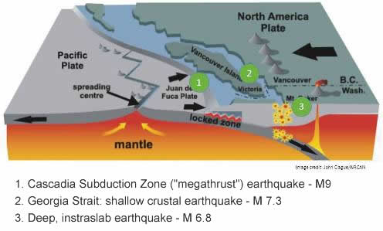 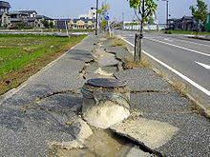
Part 3:
Introduction:
I actually live on Southside Port Coquitlam, in an apartment. I believe it is made of either concrete or plywood, but honestly I wouldn’t know for sure. My usual transportation consists of walking or driving. Using this transportation, I either drive to fast food places for food with my friends or Walmart for groceries. I eat everywhere. I eat at school, work, home, the car… My days are quite busy. Wake up, go to school, go to work, go home, do homework, finish whatever I need to do to be ready for the next day and go to sleep. In between all that I somehow find time for my friends. I honestly don’t even know what we do with our time. Watch Netflix, go to McDonald’s, parties… My life is very “small”, I guess you can call it, because I live in a small community.
Assessment:
If an earthquake was to ever occur here in my town, obviously it would affect my life greatly. Especially since the earthquake we are expecting is supposed to be around a 9.0. My everyday activities would be compromised for sure. Students will not be attending school, because everything will be gone or destroyed. Work will no longer be a responsibility, because people won’t be out shopping. The roads will be damaged so I won’t be able to drive anywhere either or walk really. Most importantly, needs I have in my everyday life such as electricity, sewage, water, would no longer be available. Whenever we have a little storm the electricity goes out, imagine an earthquake. For me no electricity is an issue because I hate the cold, and I am always cold. Without electricity I’ll have to depend on whatever clothes I have left. Or hope it is summer time. I couldn’t even imagine having to use the bathroom outside in front of people because there is no sewage, and probably no bathroom. So many people, including me, would probably hold it, which is so unhealthy for you. Every person need’s water to live, but also to wash themselves. People who will be stuck living this way for a few days will start to turn darker due to the dirt. Hopefully the rescue charities get to us fast because we will have no water, because all the pipes will burst. My life would change before my very eyes. Thing’s everyone takes for granted will be gone. I couldn’t even begin to put myself in the shoes of earthquake experienced Nicole, because it is one of those things you need to have happen to you, to understand the seriousness of the consequences like no water. Something people say they don’t even like, but will realize they need. My life would change drastically, the things I knew to be normal would no longer be normal and that is scary.
