Wegener’s Shoes Writing Assignment

Continental Drift – Its Real!

For as long as we knew it, in history, scientist’s believed the Earth was always the way it is today. Split into the continents and nothing else. A historical scientist named Alfred Wegener suggested an idea that created controversy in the people’s minds. The idea was that the Earth hasn’t always been this way. In fact, he suggested it was once a “Super Continent” otherwise known as “Pangaea”. If you are not a believer in the “Super Continent” then you are about to enjoy a roller coaster of facts that could change your mind. Being comfortable with the theories you’ve always known seems like the safer route to go, but do you dare question what you already think you know?
The facts I have for you are simple. The first one is the fit of the continents. All the continents fit like puzzle pieces if you connect them. This fact recognizes that “Pangaea” split apart and the continents have been moving away from each other ever since. It is not just a coincidence that if you were to connect all the land on Earth it would fit perfectly.
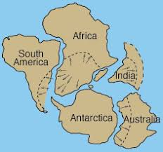My second fact is that Wegener found rocks of the same type on both sides of the Atlantic Ocean. Including mountain ranges that he found to be matching across the Atlantic as well. The Appalachian Mountains were just like mountain ranges in Eastern Europe. From this, Wegener concluded that these mountain ranges formed one big one. Which then broke apart as the continent split. How else can one explain how the same rock or mountain ended up on the other side of the world? It must’ve travelled from somewhere and since mountains and rocks aren’t living and cannot move themselves it makes sense that the ground beneath them is what caused these changes. Now you can argue that the ground beneath isn’t living either, therefore cannot move, but there is proof that plates can make the ground move and that it has. There is no proof of mountain ranges moving (to different continents). My third fact is simply earthquakes. Which can be caused when tectonic plates move. The proof that plate movement can cause earthquakes is proof of continental drift. Because it is how it occurs. This is valid because everything needs a way to move. This is how continents move. Maybe if our tectonic plates stayed put we would all be connected in the “Super Continent” and earthquakes wouldn’t occur along with other natural disasters. My fourth and final fact is a concept called “faults”. 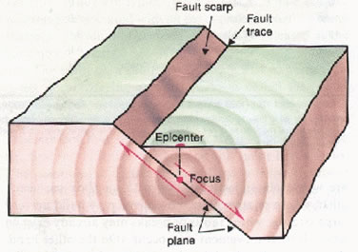Faults are cracks in the Earth’s crust that form boundaries between tectonic plates. These faults can be another reason continental drift occurs. These faults can also cause earthquakes, which can alter the surface of the Earth. Faults and earthquakes are proven fact’s which is why believing the outcome of these facts (continental drift) is valid.

History has stated that the Earth has always been the same. However, these new facts we now have acknowledged show us that maybe we were wrong in the past. Wegener and his theory on continental drift was shot down, simply because he didn’t have the evidence to back up his facts. Now we do as we progress in society. It is easier to stick to your old ways, but given this evidence do you dare believe that Wegener was right? There is more evidence proving continental drift rather than the Earth just being the way it is. So question history, and decide for yourself what you believe given this information.

