
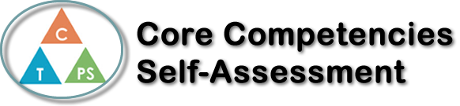
Name: Narissa Gillani | Date: February 27 2020

  How does the artifact you selected demonstrate strengths & growth in the communication competency?  In what ways might you further develop your communication competency? | Self-Reflection  Describe how the artifact you selected shows your strengths & growth in specific core competencies. The prompt questions on the left - or other self-assessment activities you may have done - may guide your reflection process.  During the 2nd PE health unit, I used the skill of personal awareness and responsibility. This relates to this unit heavily because when learning about things like addiction or resilience we needed to be responsible enough to learn in deep detail about it. This unit taught me how to better my well-being if I had something like an addiction and needed to stop that addiction. A person’s well-being can mean a series of things, for example, being physically or mentally healthy so in order to be the highest standard within those things you need to use the skill of responsibility. Personal awareness can also include sub-topics such as self-determination and/or self-regulation. Self-determination can be very important to living a healthy life and being able to manage your own life and make your own choices. That is the same case with self-regulation, when being able to self-regulate you can make your learning even more effective just by being able to manage both your emotions and behaviors. This relates to the substance use unit because the use of addictive substances could be a result of lack of responsibility and can also cause a bigger problem with personal awareness and responsibility.


How does the artifact you selected demonstrate strengths & growth in the thinking competencies?

In what ways might you further develop your thinking competencies?


How does the artifact you selected demonstrate strengths & growth in the personal & social competencies?

In what ways might you further develop your personal & social competencies?

Publish Your Self Assessment
You will now attach and/or embed your self-assessment to the bottom of the blog post with the artifact you have chosen. You may choose to make this post private or public. After placing your artifact on a blog post, follow the instructions below.
- Categories - Self-Assessment
- Tags - Now tag your post using the tag that corresponds to the competency that you have written about. You can choose more than one. Please use lower case letters and be exact.
  - #creativethinkingcc
  - #communicationcc
  - #criticalthinkingcc
  - #socialresponsibilitycc
  - #personalidentitycc
  - #personalawarenesscc
- Use the Add Document button located at the top of your post page and embed your self-assessment at the bottom of your blog post.
- Publish

