Adding polynomials
is our equation. The x is a variable which is an unknown number of the equation. That’s what we are looking to find. A coefficient is the number in front of the variable which tells us what we must multiply it by. The last thing is a term, a term is -3x^2, x, and -5 in this there are 3 terms. Last but not least is a constant term which is the 5, a constant term is a term with no variable.

For the adding if we have (instead of and I meant plus) if we take the -3x^2 and the -4x^2 they cancel out and become 7x^2. The x and 3x become 4x because x on its self means you add a one in front of it. The -5 and 6 make it into 1 so the answer is .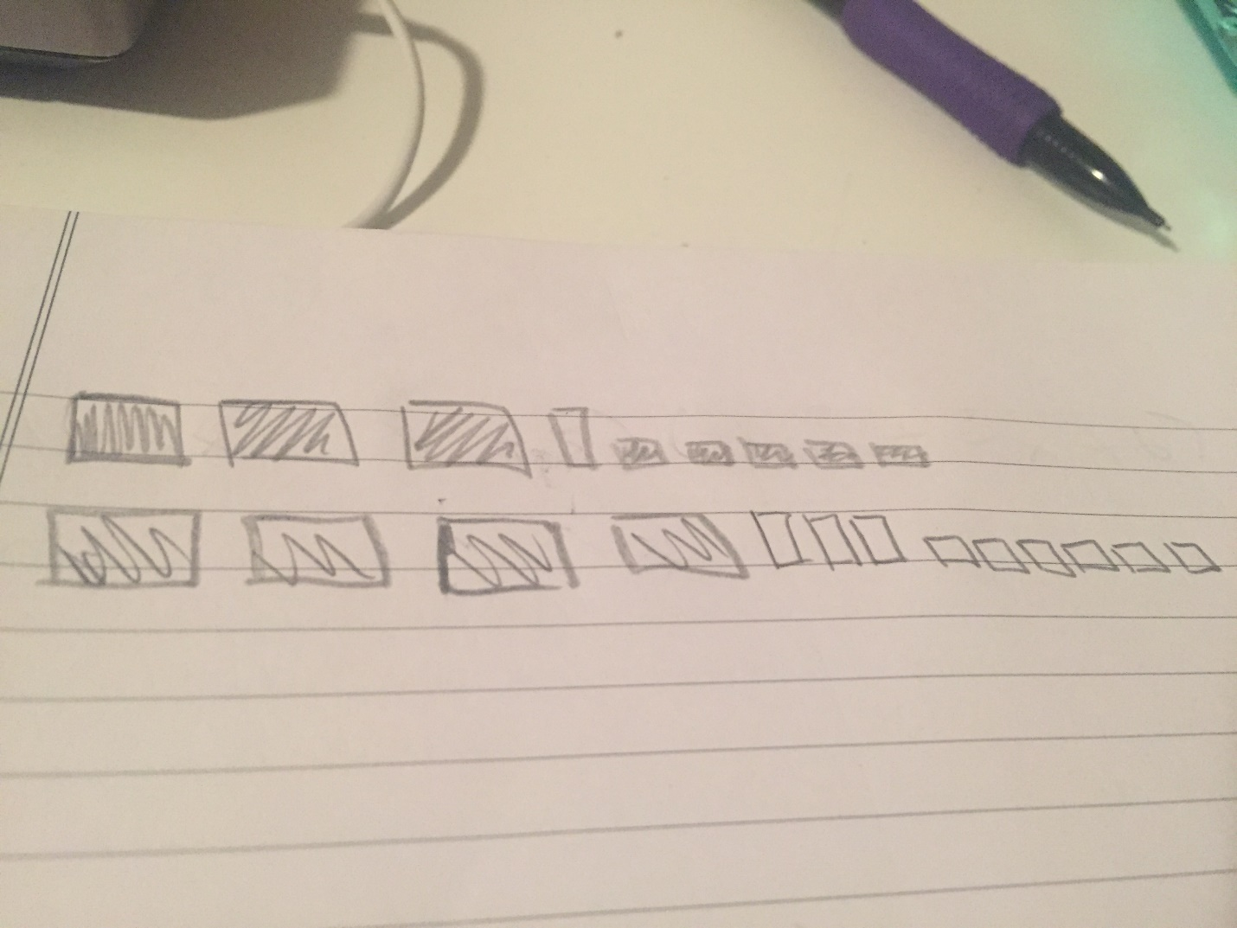

Subtracting polynomials
So we took the same equation and switched the signs .
which gave us this so we then do the same steps as adding we take the -3x^2 and the 4x^2 they cancel out and become 1x^2. The x and 3x become 2x because x on its
self means you add a one in front of it. The -5 and -6 make it into -11 so the answer is

Multiplying polynomials
For multiplication we multiply the coefficients in the brackets by the coefficient outside of the brackets, and add the powers.
-3x^2 (+ x – 5) -4x^2 (+ 3x +6) = -15^3 -9x^2

Dividing polynomials
during division we divide the coefficients and subtract the exponents. So the question would be 12x/2 which would be 6x.

