Name: Morgan K. | Date: 05/10/2023

How does the artifact you selected demonstrate strengths & growth in the communication competency?  In what ways might you further develop your communication competency? | Self-Reflection  Two years ago, in grade 10, I took Automotive Life Skills 11. During this time, the Covid-19 pandemic was at its peak and the school switched to the quarter system in which each class only had 1/2 the amount of time in the school year that it would normally have. As such, learning the skills that were supposed to assist me through my life, was rushed. Most of the information didn't end up sticking and when entering Automotive 12 after years had passed, I was very hesitant in my abilities and knowledge. Despite my uncertainty, I kickstarted my brain and although slowly, most of it came back to me.  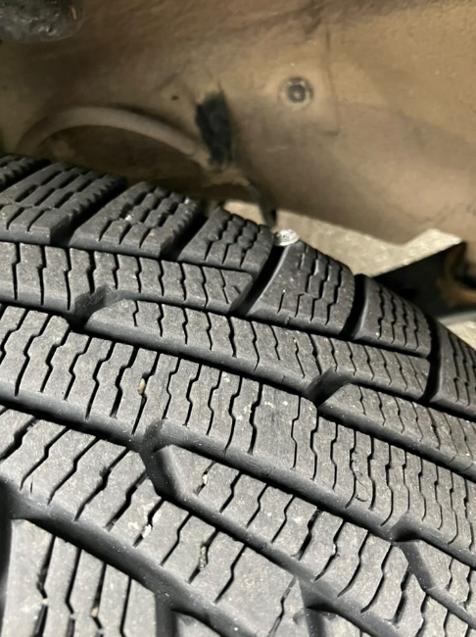  This year, I learned plenty that I previously had missed. I believe these skills will actually stick this time, so I can keep up with maintenance with my own car, and hopefully not get scammed by auto shops!  One such example of my knowledge could be when I repaired my own flat tire. I had driven through a puddle from a flooded store on my way home. One piece of debris had stuck its way into my tire near the side wall, which is a dangerous place to repair the tire. Despite the risk, I lifted my car with wheel chocks, a floor jack, and jack stands to gain access to the front left wheel. I removed the lug nuts, then the wheel, and located the puncture. Using a tire repair kit, I removed the screw, reamed the hole to make it larger, then plugged it up with rubber cement and a repair plug.  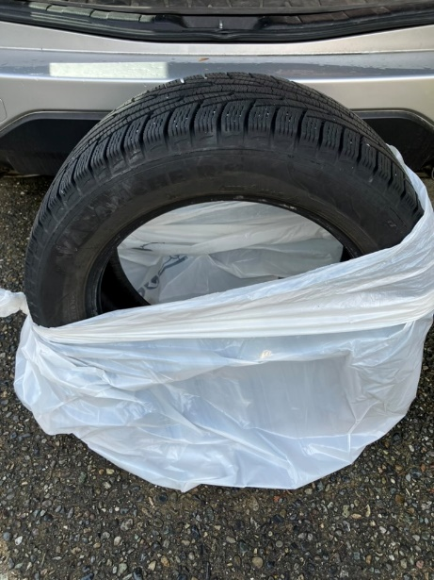  Knowing the repair would be unstable due to the location of the compromise, I bought a new set of tires around a week later, as my old ones were coming up on 9 years old anyway. Luckily, everything turned out okay, and I knew after this, that I really would have the skills to do such a repair in an emergency.  Although I learned plenty about cars and maintenance, I believe this repair best shows my education as the experience reflected a real-life scenario. This example demonstrates my growth in my personal awareness and responsibility through self-determination.  I hope with the knowledge I gained through this course I will continue to stand up for myself and fix problems on my own. I will self-advocate for my wellbeing and finances so as not be another victim to the automotive industry preying on unsuspecting girls in society.

How does the artifact you selected demonstrate strengths & growth in the thinking competencies?

In what ways might you further develop your thinking competencies?
x

How does the artifact you selected demonstrate strengths & growth in the personal & social competencies?

In what ways might you further develop your personal & social competencies?

