
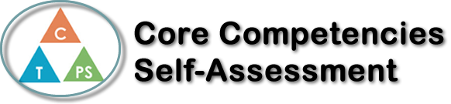
Name: Morgan Kosola | Date: 05/11/2020

  How does the artifact you selected demonstrate strengths & growth in the communication competency?  In what ways might you further develop your communication competency? | Self-Reflection  Describe how the artifact you selected shows your strengths & growth in specific core competencies. The prompt questions on the left - or other self-assessment activities you may have done - may guide your reflection process.  I can persevere with challenging tasks:  This was my first time using coggle.it to create a mind map. I found it fairly easy to use, except I wish had more access to all of the different colors and shapes within the free trial. When I first began this assignment, I was quite frustrated because I had trouble recognizing the different core competencies the main character of The Lovely Bones portrayed. Because of the unique perspective in the book, it was not clear to me on how I can find these characteristics. I find that, within the first 50 pages at least, Susie Salmon focuses on highlighting the important people in her life and how they are coping with her death, rather than directly showing the reader her present point of view on her own life. I felt I had to really dig through all of her past experiences that she talked about to find her personality and character. This mind map was beneficial because although I started off a bit frustrated, I created a visual representation that I can possibly use as a resource on future assignments. Personally, I learn best when I can see everything laid out in front of me. For example, if I need to study for a test, I will write and organize all of the information I need to know on paper. Before I started this assignment, I had never even heard of a mind map but now I’ve learned that it is something that can help me in my future studies. I am literally going to use this for any note I take or test I study for.


How does the artifact you selected demonstrate strengths & growth in the thinking competencies?

In what ways might you further develop your thinking competencies?


How does the artifact you selected demonstrate strengths & growth in the personal & social competencies?

In what ways might you further develop your personal & social competencies?

Publish Your Self Assessment
You will now attach and/or embed your self-assessment to the bottom of the blog post with the artifact you have chosen. You may choose to make this post private or public. After placing your artifact on a blog post, follow the instructions below.
- Categories - Self-Assessment
- Tags - Now tag your post using the tag that corresponds to the competency that you have written about. You can choose more than one. Please use lower case letters and be exact.
  - #creativethinkingcc
  - #communicationcc
  - #criticalthinkingcc
  - #socialresponsibilitycc
  - #personalidentitycc
  - #personalawarenesscc
- Use the Add Document button located at the top of your post page and embed your self-assessment at the bottom of your blog post.
- Publish

