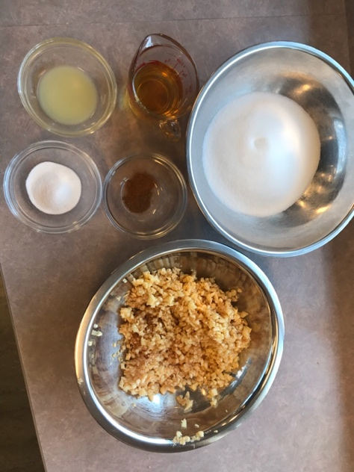
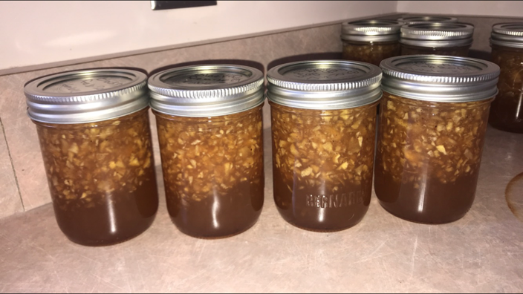
The Apple Jam lab was my favourite because I think that our final product tasted terrific, especially with our croissants. Throughout the lab, everyone worked efficiently and was very helpful to each other. Everyone was always doing something to help out, which I feel was what made the lab enjoyable and gave us a delicious outcome. I enjoyed doing this lab with my group because everything went very smoothly and we were able to work well together with some time to spare at the end of the block. I enjoyed learning about how boiling the jars created a seal with the screw tops and the snap tops, it is an easy and effective way to preserve foods at home and I will definitely use this method again in the future. When we made this lab, my grandparents were visiting so they were able to try the jam as well, we spread it on some scones with cream and they said it tasted like something you could order at a high tea restaurant. If I was to do this lab again I would maybe try to make sure the apple pieces were more of similar size because in my preference, some of them were a bit too large in the jars we made, I would also try with different fruits to experience different tastes. Overall, this lab was a lot of fun and I’m happy that I got to make and enjoy it.

