Solar Oven Procedure ____________________________________________________
Materials:
- Cleaned out cardboard pizza box
- Black construction paper
- Plastic wrap
- Newspapers
- Oven mitt dish or pie plate
- Cooking ingredients
- Thermometer (optional)

- Pencil
- Ruler
- Box cutter or scissors
- Aluminum foil
- Clear tape

Procedure:
- Use the rule and pencil to draw a square 1inch in from the edges on top of the box
- Use the knife/scissors to cut along the front and side lines, do not cut the back line
- Fold the flap of cardboard upwards, making a crease along the uncut side
- Cut out a piece of aluminum foil large enough to cover the underside of the flap
- Wrap and tape the foil around the flap on the underside tightly, insure that the shiny side is faced down
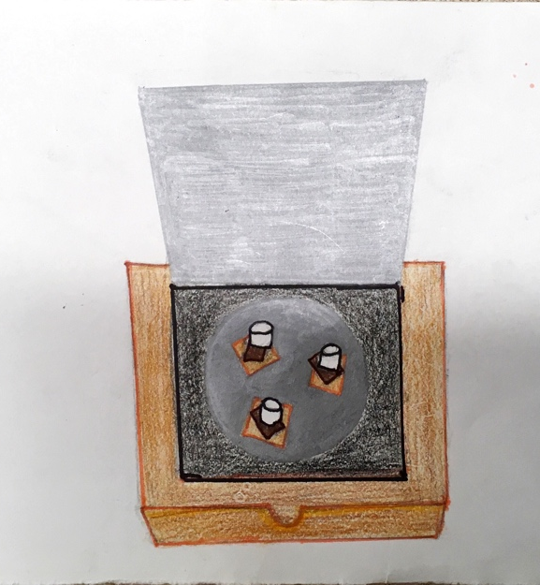
- Line the bottom of the box with black construction paper
- Cut a piece of plastic wrap the same size as the top of the pizza box, tape it on the inside edges of the square window you created. Make sure the seal is tight, you are creating an air-tight window
- Roll up some tubes of newspaper to place inside the box along the edges, make sure you are still able to close the box
- Prop the flap up on an angle, you can use the ruler to do so
- Now cook! Use the dish and slide it into your new created solar oven and watch the magic begin!

Advantages, Disadvantages and Explanations:
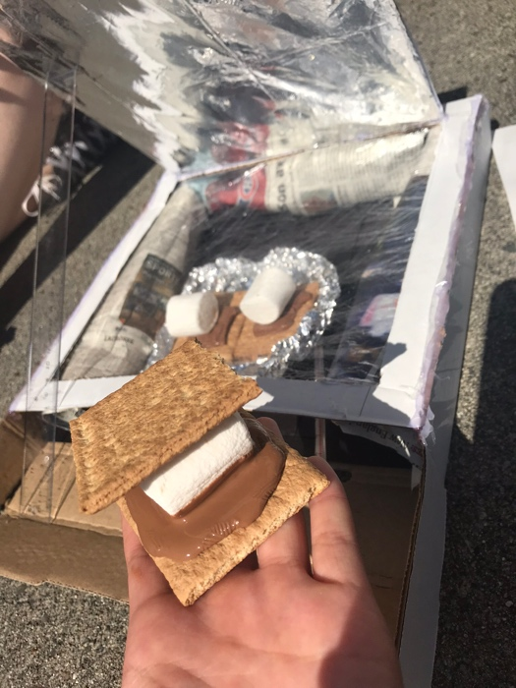
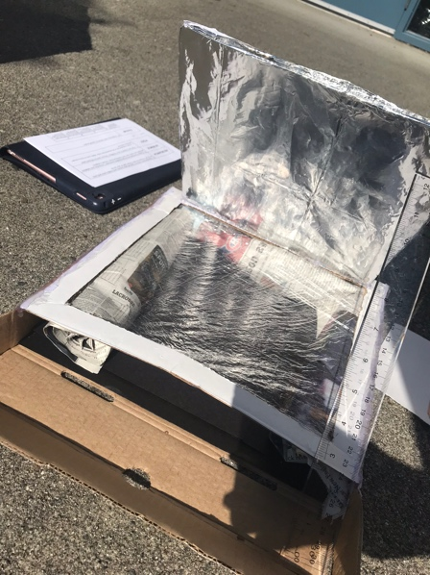
The first advantage of this project is that it is quick, easy, and cheap to make but why build it like this? What makes this build so functional? Well to start with, we used aluminum foil to cover the down-facing side of the flap, ensuring that the shiny side was visible. We did this to reflect the sun’s energy into the box. Why did we use black paper to place on the inside of the box? Why not white or something spontaneous like purple? Well black paper will absorb a lot of the sun’s hot energy and keep it inside whereas white would have reflected a lot of it back out of the box. What is the purpose of the plastic wrap? We use the plastic wrap to make the oven air-tight which helps keep the warm air inside, making sure it doesn’t leave through convection. In addition to this, we also used news paper to insulate the box which helps to prevent heat loss via radiation. In any oven there is very little heat transferred from the heat source to the food by conduction, it is mainly transferred through radiation and convection (mostly radiation). A disadvantage of a solar oven would be that it requires sunlight which is something that is not always accessible, the user of the oven must also further prepare so that food can be cooked thoroughly and to ensure that maximum use of sunlight is applied because solar ovens take longer to cook that conventional. For this homemade oven specifically, it can be very functional for the making of foods such as smores or even nachos. Another advantage is that it is easy to use! The use of a pizza box makes for easy access to your delicious treat.

Pro’s and Con’s:
Model | Description | Pros | Cons
Parabolic cooker | Parabolic solar stoves concentrate sunlight to the cookware, they generate heat by using a curved reflector to concentrate light on the bottom of the cookware. Because of their ability to heat up faster and to higher degrees, they are at great use to grill/fry/cook food. This style can withhold higher cooking temperatures than box or panel cookers | -capable of maintaining higher cooking temperatures than box or panel  -Capable of reaching high temperatures at a higher pace  -can be used for grilling, frying or boiling | -need to adjust angle and direction more frequently for maximum cooking efficiency  -higher complex design, more expensive to make/buy
Box cooker | A box cooker uses an insulated box to retain heat, along with reflective panels to concentrate the solar energy. The sun light hits the panels and reflects into the box where it gets trapped and cooks the food. This model can reach temperatures comparable to traditional gas/electric ovens but does not typically get as hot as a parabolic cooker. | -Eco-friendly, avoids dependence on electricity and gas  -can cook multiple things on trays/pots at once depending on size | -takes more time to cook than a parabolic  -cook time has to be scheduled based on sunlight  -most foods require special temperature, not always capable of maintaining 300 degrees or desired heat
Panel cooker | A panel cooker’s design incorporates elements of box and parabolic cookers. They include a flat or slightly curved reflective surface, to use you just unfold the panels and place the pot in a heat resistant container then place inside the cooker. They are the most simple and affordable model of solar cookers however they do generate heat at lower temperatures. | -Usually able to maintain temperature of 200-250 degrees  -Doesn’t require adjustment or alignment  -Easy to use  -Affordable | -Cannot cook as much food at once  -Mainly used to cook at lower temperature for longer periods of time  -Does not reach high temperatures

Experiment results: Smores’
*we recorded how the results varied based off of the temperature change and a constant time of 25 minutes, rather than the length of time each trial took to “cook” because visible browning was difficult to see. *

Observations:
Trial 1: Cooked at 38°c. Undercooked, marshmallow was slightly firm, no colour change. Tasted like a warm marshmallow with very little “ooze”
Trial 2: Cooked at 45°c. Slightly cooked, marshmallow has a somewhat runny consistency, smooth texture, warm and enjoyable. No colour changes
Trial 3: Cooked at 52°c. Most cooked out of 3 trials, very runny consistency, very warm inside. Slight colour change. Outside was a bit “crispier” that recent trials.

URL https://www.oneearthdesigns.com/blog/compare-solar-cookers/
Website Title SolSource by One Earth Designs
Article Title Compare Solar Cookers - our How To guide
Date Published November 01, 2017
Date Accessed June 18, 2018

URL http://www.solarcooker-at-cantinawest.com/solarcookers-prosandcons.html
Website Title Solar Cooker - Solar Cooking
Article Title Solar Cookers: Pros and Cons of the Different Types
Date Accessed June 18, 2018

URL https://www.homesciencetools.com/article/how-to-build-a-solar-oven-project/
Website Title Home Science Tools
Article Title Home
Date Accessed June 18, 2018

URL http://www.solarcooker-at-cantinawest.com/solarcookers-types.html
Website Title Solar Cooker - Solar Cooking
Article Title Solar Cookers: Types and Styles
Date Accessed June 18, 2018

