
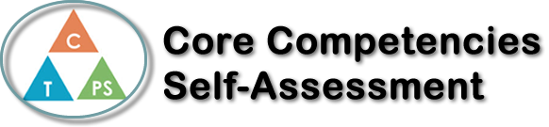
Name: Morgan Kosola | Date:

  y  How does the artifact you selected demonstrate strengths & growth in the communication competency?  In what ways might you further develop your communication competency? | Self-Reflection  Describe how the artifact you selected shows your strengths & growth in specific core competencies. The prompt questions on the left - or other self-assessment activities you may have done - may guide your reflection process.  For this project, with a partner, we were instructed to create a podcast or vlog on a debate on an “International Conflict during the 20th century” My partner Alhan and I decided to do a podcast on the first Persian Gulf War. Throughout this project we both had to make use of our communication skills, considering this was a partner task. To show that I was able to listen thoughtfully, I made sure to always confirm and connect my ideas with my partner, at to always take note of her opinions/ideas and incorporate them into my part of the making. I made sure to have my full attention on her when she was speaking to me, then respond back with my understandings and ideas as well. When we would come to a disagreement, we developed ways to incorporate both persons ideas into the assignment, the outcome of this benefited our podcast in the sense of having both creators ideas intact, and merged together.  This final project demonstrates how much we/I have learned throughout the teaching of this unit. My thinking has changed of this topic throughout the process because I was exposed to another person’s ideas, so I was then able to see multiple points of views, and how my partner understood the aspect of the topic. To decide whether to believe what information I took in was true or false, I made sure to explore multiple sites in order to see that the result/information were similar. to come up with ideas, my partner and i worked well to do this through communication, we shared each other’s ideas and used them to create our final product.

y

How does the artifact you selected demonstrate strengths & growth in the thinking competencies?

In what ways might you further develop your thinking competencies?


How does the artifact you selected demonstrate strengths & growth in the personal & social competencies?

In what ways might you further develop your personal & social competencies?

Publish Your Self Assessment
You will now attach and/or embed your self-assessment to the bottom of the blog post with the artifact you have chosen. You may choose to make this post private or public. After placing your artifact on a blog post, follow the instructions below.
- Categories - Self-Assessment
- Tags - Now tag your post using the tag that corresponds to the competency that you have written about. You can choose more than one. Please use lower case letters and be exact.
  - #creativethinkingcc
  - #communicationcc
  - #criticalthinkingcc
  - #socialresponsibilitycc
  - #personalidentitycc
  - #personalawarenesscc
- Use the Add Document button located at the top of your post page and embed your self-assessment at the bottom of your blog post.
- Publish

