**FRANCE**

# **GEORGRAPHY**

## Physical geography

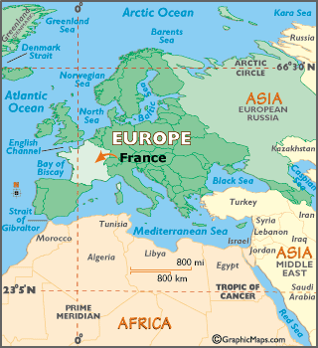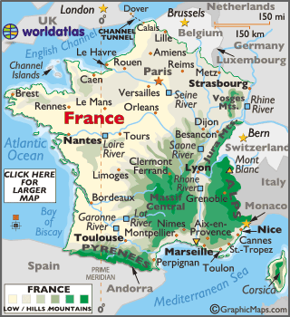

France is the second largest country in Europe, it is covered in a relatively flat plain biome with a few rolling hills. Along the coast line there are rugged cliffs along the English Channel.

## Population Information

As of June 1st, 2017, almost 67million (66,991,000) people live in France, including all overseas apartments, but not including overseas territories and collectives

## Special attributes

The physical geography of France has been shaped by past events that had taken place in the country itself. France has and still does play an important role in the art of fashion, cuisine, literature, technology, cinema, science and mathematics. The importance of French culture has risen up and down throughout the years, depending on the economic, political and military importance.

# **PEOPLE**

## Language

French is the only official language that is spoken in France, however several regional languages are also spoken in France, such as German dialects or Celtic languages.

## Religions

France is considered to be a multi confessional country because of its majority of religions. The major religions in France include Islam, Judaism, Catholicism, Protestantism< Russian Orthodoxy, Armenian Christianity, Hinduism, and Sikhism.

## Culture

When you think of France culture, you automatically think of Paris culture and traditions, so you would think France is all fancy cuisine, fashion and art. However it is not, France culture varies throughout its cities. French culture was grown on by Celtic and Gallo-Roman cultures as well as a German tribe known as the Franks. The French typically celebrate the traditional holidays following their religions, but they also mark Victory In Europe Day on May 8th, and Bastille Day on July 14th.

# **INDUSTRY**

## Key industries

One of France’s key industries would be the high rate of tourism. France comes from a rich cultural root and is a country that attracts lots and lots of tourists. The Eiffel Tower located in Paris is a tourist attraction.

## Currency exchanged

In France, currency is spent and counted as Euros. 1 Euro would equal 1.50 Canadian Dollars.

# **TOURISM HIGHLIGHTS**

Monument aux Girondins

This beautiful monument represents the Girondists who were originally a political party within the first National Convention from 1792 to 1795 of the new French Republic.

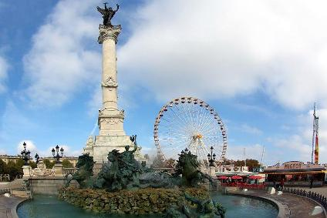

The Eifel Tower

The Eifel Tower is an iron lattice tower located on the Champ de Mars in Paris, France. It is named after an engineer names Gustave Eiffel who’s Company designed and built the tower. The beautiful tower has attracted millions of tourists from all over the world throughout the years.

[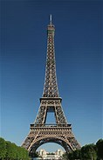](https://www.bing.com/images/search?q=eifel+tower+tourist+attraction&FORM=IARRTH&ufn=Eiffel+Tower&stid=df4609a4-71b9-990d-daf2-4257b7c86249&cbn=EntityAnswer&cbi=0&FORM=IARRTH)

Pont de Pierre

The Pont de Pierre is a beautiful stone bridge that connects the historic city over the Garonne River to La Bastide. It was commissioned by Napoleon and was the first bridge to spam the river in Bordeaux.

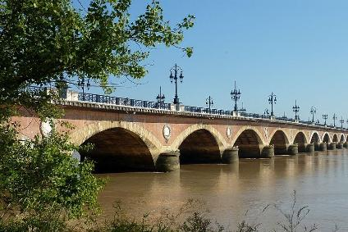

Grosse Cloche de Bordeaux

This is a famous bell that was a 15th century addition to the remains of the 13th century Porte Saint-Eloi. It was also once called Gate of St James because of the many pilgrims passing through following the St James rout to Santiago de Compostela

