TED Talk or Rant Project Organizer
Part A:
- What innovations or new systems made the Agricultural Revolution possible and what were their effects? In what ways is it still present today? How is it different today? (Crossroads – Chapter 7 – pg 231-234)
Innovation or System | Effects in the 1700s | Presence Today (similarities) | Differences Today
4 crop rotation | By rotating crops of cloves, turnips, wheat, grasses or barley from field to field they found that when they planted wheat (for example) it grew a lot better. They would plant turnips in field 1, clovers in field 2, and wheat and barley in fields 3 and 4. When they re-planted the wheat and barley where the clovers and turnips where it grew much better than when you re-planted it after wheat. | The crop rotating system allowed increased crops, and grew cheap fodder which fed the livestock and allowed people to increase their herds. The turnips and clover crops grew then released nitrogen back into the soil to replenish it so more crops could be planted and would grow better all on the same field. We try to avoid planting related crops in the same spot for more than 3 years. | Today a lot of the times we use synthetic fertilizers and other man made organic compounds to put the nutrients back into the ground/soil. This allows us to use as much space/fields as possible without leaving fallow fields.
Seed drill | The seed drill was pulled by horses and would dog a tunnel, plant the seeds, and then cover them up again. The seed drill created a faster way to plant seeds in rows of 3. The seed drill caused many more seeds to sprout instead of being eaten by birds and animals or blown away by the wind. | The seed drill makes a tunnel then spits seeds out into neat rows before burying them up and deep enough so animals/birds can’t eat them. | Now seed drills are powered by gas, larger and they are high tech. in the 18th century these drills were pulled by a horse and planted 3 rows of seeds at a time. Now they are more mechanical and driven like a car by one person.
Enclosure | Landowners would combine many small strips to make one field which was closed off with a fence. This allowed them to work more efficiently. The commons became private grounds which resulted in a difficult situation for the poor farmers. Enclosure turned farming into more of a business. People made more than enough food so they began to sell it. | Farm owners owned one big plot of land which basically consisted of many small fields surrounded by a large fence turning those fields into one large property. Farming was a business, more than enough food was being produced so people began to sell it. | Farms are a lot less needed today. The reason for this is because today the farms are much larger and more equipped with machinery used to help maintain the farms.
Selective Breeding | Selective breeding is when you separate female and male animals and then watch them for their traits and/or characteristics. You would choose a male and female who (if they were Sheep) where the biggest and had the most wool. The off spring would usually develop these traits and sometimes their wool would grow faster as well. | Sheep were bred to have thicker wool and cattle were bred for more meat. New breeds were also more resistant to diseases. | Meat/Food is being sold to company’s and stores who then sell them to citizens and that allows businesses to grow and make big profits. Wool is going to companies who produces clothing or yarn and that gets sold to stores and citizens.
Cash Crops | Cash crops allowed farmers to make enough food for themselves/their family and they had extra which they sold to earn money. The purpose of a cash crop was to sell grain for profit. | People would sell grains to make a profit for themselves/their family. Cash crops were grown and gathered more specifically for the market. | Farming today is mostly international and third-world countries are commonly the main producers for crops and produce for the larger and more populated countries.

- How did the Agricultural Revolution pave the way for the Industrial Revolution? (Crossroads – Chapter 7 – pg 235)
The Agricultural Revolution changed how the country side looked. It also helped create and support the industrial revolution along with creating more food which people had enough of so they sold or traded food with others.

- How has the Agricultural Revolution impacted us today?
Benefits | Drawbacks
Today we make much more food and there is much less poverty. We are able to make enough food so many more people have enough and are able to live a proper and healthier lifestyle. | The more food we make the more people there are because the people need food and we are now able to provide that however more people causes more pollution.

Part B:
- What are the major innovations or systems that were new to the Industrial Revolution and what were their effects? (Crossroads – Chapter 7 – pg 236-244) In what ways is it still present today? How is it different today?
Innovation or System | Effects | Presence Today (similarities) | Differences Today
Coal & Steam | Coal was burned for heat especially in winter when it was colder. It was also used to fuel the steam engine and used to make iron. The steam engine was used to pump water that would drip down out so the miners could work. | Today coal is a major use in manufacturing and factory facilities. It is used for power generation, steel production and many other things. | We use coal and steam to power some generators in some places. We use furnaces which are usually powered by electricity. Steam engines are no longer used much. Instead we use vehicles fueled by gas.
Iron | Iron was used to make pots, pans, wheels in factories iron steam engines and bridges. | Better structures/buildings can be made and if you’re able to afford it there is better quality appliances available. | Today we still use iron but not as much. For pots and pans other materials are used now such as ‘Gotham steel’ they still use cast iron but it’s not as common.
Textiles | The textile industry was mainly about designing clothing, yarn and cloth. The fibre threads would be made into fabric. When new technology was invented it could speed up the process and steps and you could finish faster. | Today we use machines to make yarn and thread. We have company’s and factories that make the clothes. | We still make clothing using thread and yarn but a lot of the time we make it a different way. Its still a very common industry
Factories | inventions of the industrial revolution resulted in the cottage system becoming no longer used in many areas. Most new machines that were invented were large and many parts of manufacturing in the factories were now in one place. | Today we have larger factories and manufactures that create many different machines, vehicles, and products in less time then it took back then. We still have many people who work in the factories and business owners try to make products as efficient as possible. | The factories are much larger and much more complex things are being made much faster. We make more things at a time and have many more manufacturing companies.
Transportation | Steam engines helped with transportation. Eventually they developed a steam engine to power railways. Railways transported goods and then later on people and progressed/improved overall and in speed. | We still use trains today however they are no longer powered by steam engines but one example of how there powered is electric locomotives. | Trains transport people, animals, goods and a few other things. They have a roof in which they didn’t when first invented. They are also much larger and able to transport more.

- Create a flow chart or mind map that shows how coal, steam power, iron, textile production, factories and new modes of transportation were all connected (hint: start with coal). Explain the connections.
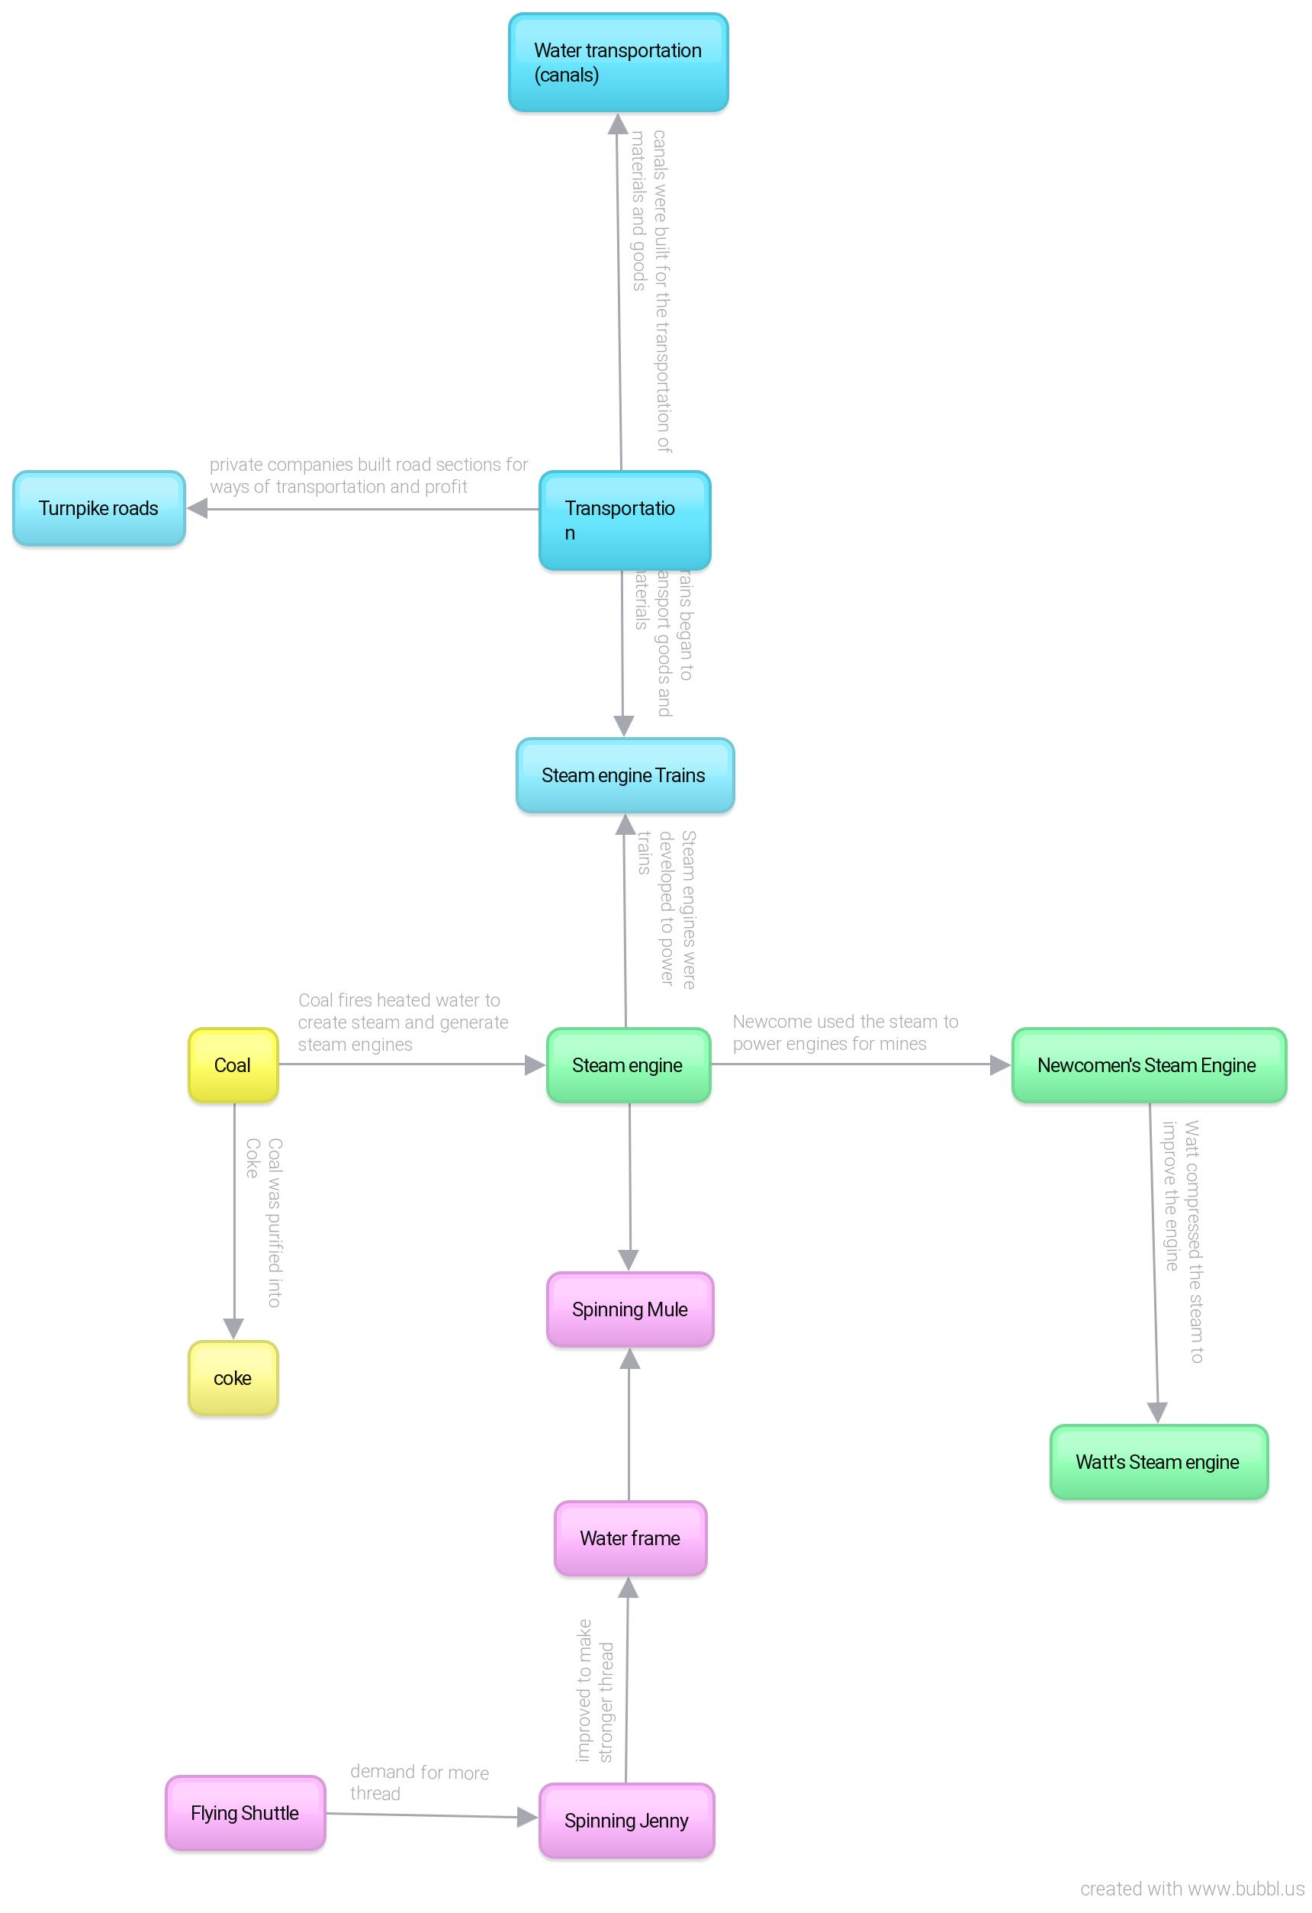

- How have the innovations of the Industrial Revolution impacted us today?
Benefits | Drawbacks
We have progressed in the products we make and now they are made faster and more efficiently. The products are much better quality and we make much more so many people are able to have them. | All of the products we make for everyone means your burning more fuels/coal making these products/machine which creates much more pollution and smoke in the air.
Sources | Sources

Part C:
- What are the major societal changes that were new to the Industrial Revolution and what were their effects/importance? (Crossroads – Chapter 7 – pg 245-254) In what ways is it still present today? How is it different today?
Innovation or System | Effects/importance | Presence Today (similarities) | Differences Today
Working Conditions | Air usually would be filled with fluff and microfibers which got into the workers lungs and could cause them to get sick. The machines noises were at times deafening. Working in mines involved many risks because there’s many toxins in the air which could cause diseases and explosions. | People still work in factories with loud machines but, the machines have been improved and so has the environment. There are still risks but they are reduced and they are not caused by toxins just floating around because the air is cleaner. | Working conditions today are much better. The air in factories is much cleaner and if it is really loud people may have ear plugs. The factory owners are required to keep safe working conditions and
Child Labor | Children suffered many risks because of child labor. They were paid very little and many were beaten. From a early age these children were exposed to toxins, dangerous work and pollutions which caused many to get sick and many to be hurt. | Children still work today but they aren’t forced. They aren’t paid as much as adults and can still get hurt but that would be if they were unsure of how to do their job. | Today we have less children working because there are many more jobs and there is more freedom and children can get a free education. The children who do work usually have much better suroundings.
Class | Lower class people were considered to be people who work in a factory or in the trades and within this class there are different rankings including: skilled labor, unskilled labor and casual labor. The population of the lower class grew and they had almost no chance of education.  The middle class people worked in stores or offices or may have worked as a doctor, engineer or lawyer. They could also be business men with property and money.  The upper class people separated themselves from the other classes. They were known and knew each other personally or by reputations. | The wealthier people didn’t need to work as much or at all and could hire the lower class people which is similar to today because the wealthier people may work but they may not need to much and they can hire others to be assistants. People can also now get a job almost anywhere. it may not be a job they wanted but they could still enjoy it because they had a choice. | There aren’t labelled classes now. People still have more or less money than others but that doesn’t make them upper class or lower class. The wealthier people still may be treated better and can definitely get more things but the people with less money can get an education and a decent job.
Laissez Faire | This was the policy which made a market as free as possible from the governments interference. An example of this is, that a business owner would not have to pay tarrifs to the government. The government had previously interfered with trade and prices so the business owners didn’t have much of a profit. This allowed for them to actually make a profit but for the workers that meant little protection. Workers were now easily fired and had to find a new job to support themselves and their families. Basically this was the idea that if the government stayed out of it it would work itself out. | Business owners still are able to fire their workers but not as easily. The government also doesn’t control their pricings. The businesses make a good income (usually) and are able to afford more workers and properly pay them. | When a business owner or manager wants to fire a worker they are not allowed to just fire them they have to explain what’s wrong and try to fix it first. Workers are treated better now and payed better.

- How have the societal changes of the Industrial Revolution impacted us today?
Benefits | Drawbacks
Working conditions are much safer and you need to actually get checks on the work space. Child labor in many places is banned and now children get a healthier and free education. We now have better transportation such as: trains, cars, public transit, airplanes, fairy’s etc. | There is more pollution with all the products being produced and the transportation also causes pollution. Most cards need gas to function and when gas escapes the smoke/steam goes into the air. When people travel over water in a boat (for example) things may spill or be dumped into the water causing pollution.
http://www.preservearticles.com/201107159157/what-were-the-advantages-and-disadvantages-of-industrialization.html | http://www.preservearticles.com/201107159157/what-were-the-advantages-and-disadvantages-of-industrialization.html

Part D:
- How did Britain react to the new changes of the Industrial Revolution?
Reaction | Importance | Presence Today (similarities) | Differences Today
Poor Law | The poor laws relate to the support of the poor. In Britain in the 17th century they tried to address poverty with poor laws. Even when they were altered in 1834 the poor laws were not effectively reducing poverty and unemployment. The poor laws made charity the local authorities responsibilities. Many poor people still were left without relief. | We are still trying to help reduce and end poverty and looking for different ways to do so. | We don’t have as much poverty now. The unemployment rate isn’t too bad in a lot of places. In the places where we have poverty we try to help them by sending resources when we can.
Social Reformers | Social reformers were trying to improve the lifestyle of the lower class. Some were mainly concerned with helping children, and addressing child labor, education and housing. Free schooling was not available for all children at that point in time but it was supported. With support from donors there were ragged schools which would offer free lessons to needy children. | Today we have social workers who are very similar to social reformers. They try to help improve people’s life and help with what is possible. | The difference is that today they don’t just help the poorer people they help out whoever needs it. For example, if someone was in a tight situation financially they could help them figure out a way to make it better whether that’s loans or something else. Social workers can also help out with other problems as well.
Factory Acts | Factory acts were the new laws that were written when people became disturbed by the extreme effects the industrial revolution was causing. It became illegal to have children work more than 12 hours straight in cotton mills. In 1819 it became illegal to hire a child under nine years of age for work in the textile industry. This law however was not applied to children in other industries. Over time positive changes helped children eventually go to school and entertainment (like sporting events) became popular. | We have laws that state the rules for when children of certain ages are working. You can no longer force children to work such long hours for almost nothing in return. | Today if you want to work in certain businesses you have to first go through a few years of courses to get there. You also usually have to be older for certain jobs. In fast food restaurants they hire form 14 up usually.
Abolition of slavery | People were being bought and sold as slaves and there was an idea that ‘all men are created equal’. That idea made people question the idea of slavery. Slaves, social reformers, workers, politicians, religious leaders and many others all worked together to try and put and to slavery. They began a petition against slavery.in 1807 the slave trade became illegal but did not free the people already in slavery. People were also asked to stop buying products made by slaves because that could raise awareness to stop it. | We still have petition to end certain things and people work together to do that. People also try to raise awareness for certain things in different ways. | Today we don’t have slavery in most places and people have much more freedom.

- How have Britain’s reactions to the Industrial Revolution impacted us today?
Benefits | Drawbacks
In the past people were worked way to hard and in very harsh conditions. Laws between the upper, middle and lower class were not equal and slavery was a normal thing. Eventually people began to recognize what they saw happening was wrong and began to put a stop to it. once it got through to many more people new laws were laid down and without those laws, we wouldn’t be as fortunate as we are now. Today we still have different classes but people now try to help each other out more. | Some families were no longer able to afford some things because eventually younger children could not work and hours were also reduced which means they are bringing home less pay. We still have classes today and in some cases the upper class acts negatively towards the low or middle class while, the middle class may act negatively to the low/upper class.

