Transcription

- How is mRNA different from DNA?

mRNA is different form DNA due to the following reasons. DNA is made up of deoxyribose sugars, whereas mRNA is made up of ribose sugars. DNA has thymine as one of the two Pyrimidines, while mRNA has Uracil as its Pyrimidine base. They are in different spots, as DNA is present in the Nucleus, while mRNA diffuses into the cytoplasm after synthesis. Lastly, DNA is double-stranded and mRNA is single-stranded.

- Describe the process of transcription.

The process of transcription starts with the information from one gene is then copied onto a strand of mRNA. DNA helicase breaks the hydrogen bonds between the pairs throughout the chain.
Next, complimentary base pairs of the RNA join onto what is called the sense strand, which is the strand with the enzyme “polymerase”.
Lastly, when the whole gene has been transcribed, the RNA strands parts from the DNA and exits the nucleus to deliver the message derived from the DNA. The DNA then reconnects the two strands.

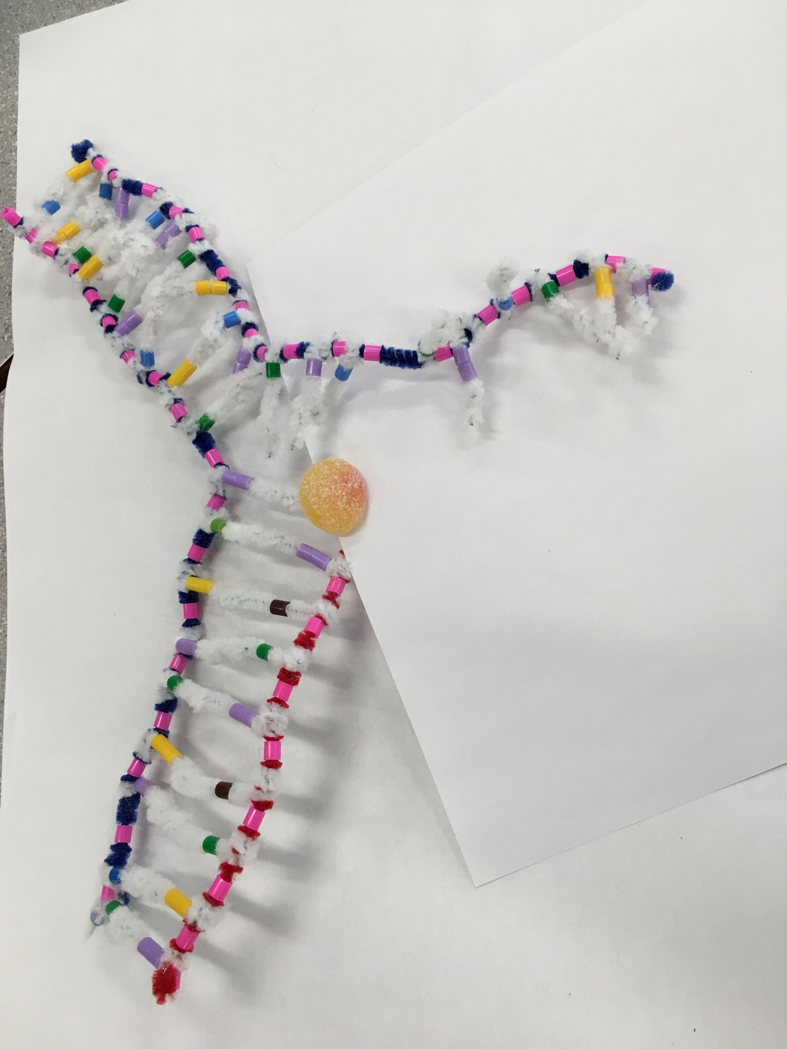

RNA polymerase is copying the DNA onto the mRNA

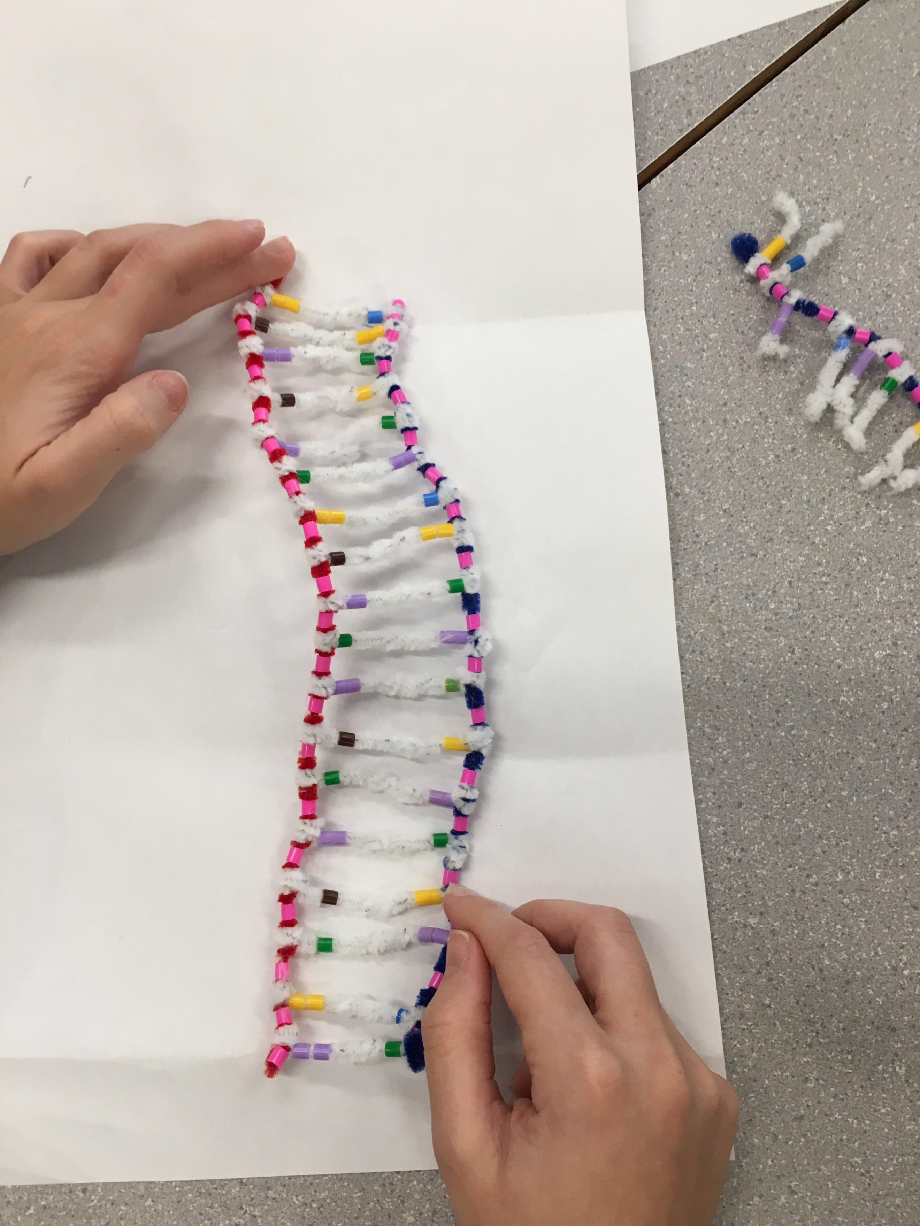

mRNA strand

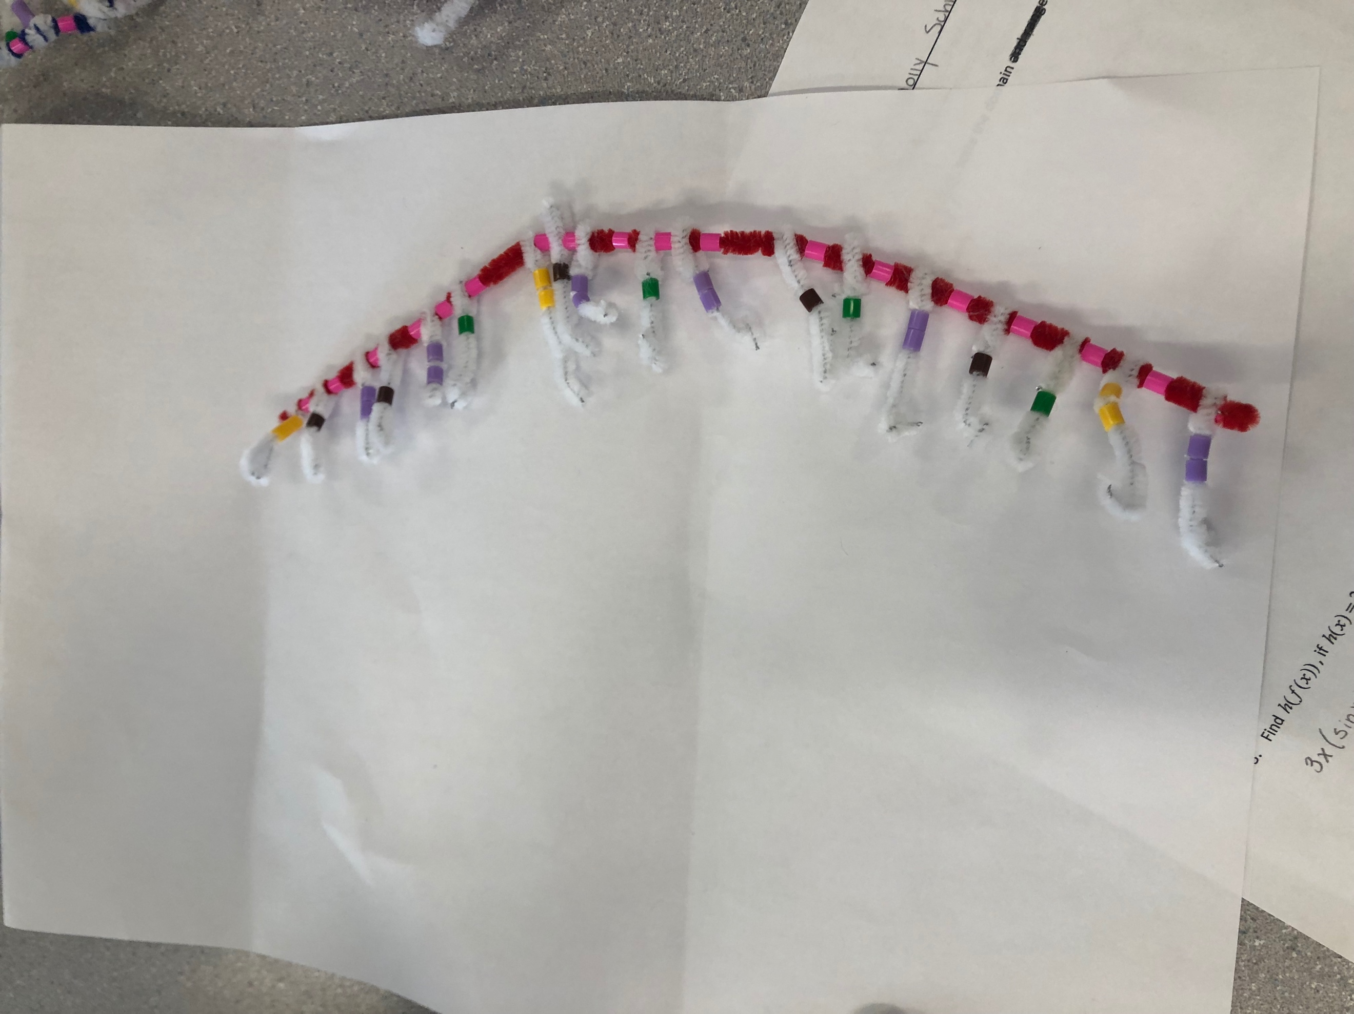

RNA strand parted from the DNA to deliver the message from the DNA.

- How did today’s activity do a good job of modelling the process of RNA transcription? In what way was our model inaccurate?

This activity did a good job of modelling the process of RNA transcription as it used different coloured beads to show uracil from thymine. It also used a different coloured pipe cleaner (red) to represent the RNA strand. A way this model was inaccurate was that this DNA strand only represented a very small portion, as a real gene strand is 1000 nucleotides long while the one we modeled was only 18.

Translation

- Describe the process of translation: Initiation, elongation, and termination.

The process of translation first starts with “initiation”. This is where a ribosome looks for the start codon “AUG”, from the mRNA. A ribosomal subunit then binds together (red paper) and starts to read the mRNA. The first one starts with the “AUG”, which is placed on the “P” site. Next is elongation where the “A” site on the ribosomal subunit, is now ready for the next tRNA (Green paper). The tRNA with the anticodon which matches to the mRNA. The tRNA is holding the matching amino acid (Blue paper) to the codon. When one tRNA binds to the codon on the “P” site, there is another codon which binds on the “A” site. Once the “A” site grabs its corresponding amino acid, the codon in the “P” spot will release, and the amino acids on the “P” codon will join onto the “A” codon. The codon in the “A” site will now shift to the “P” site, and the process then repeats. The final step is termination. The elongation process ends when the ribosome reads a “Stop” codon. A “stop” codon has no matching tRNA amino acids. Once you receive this codon, no amino acid is added and the polypeptide is released and the ribosomes detach from the mRNA.

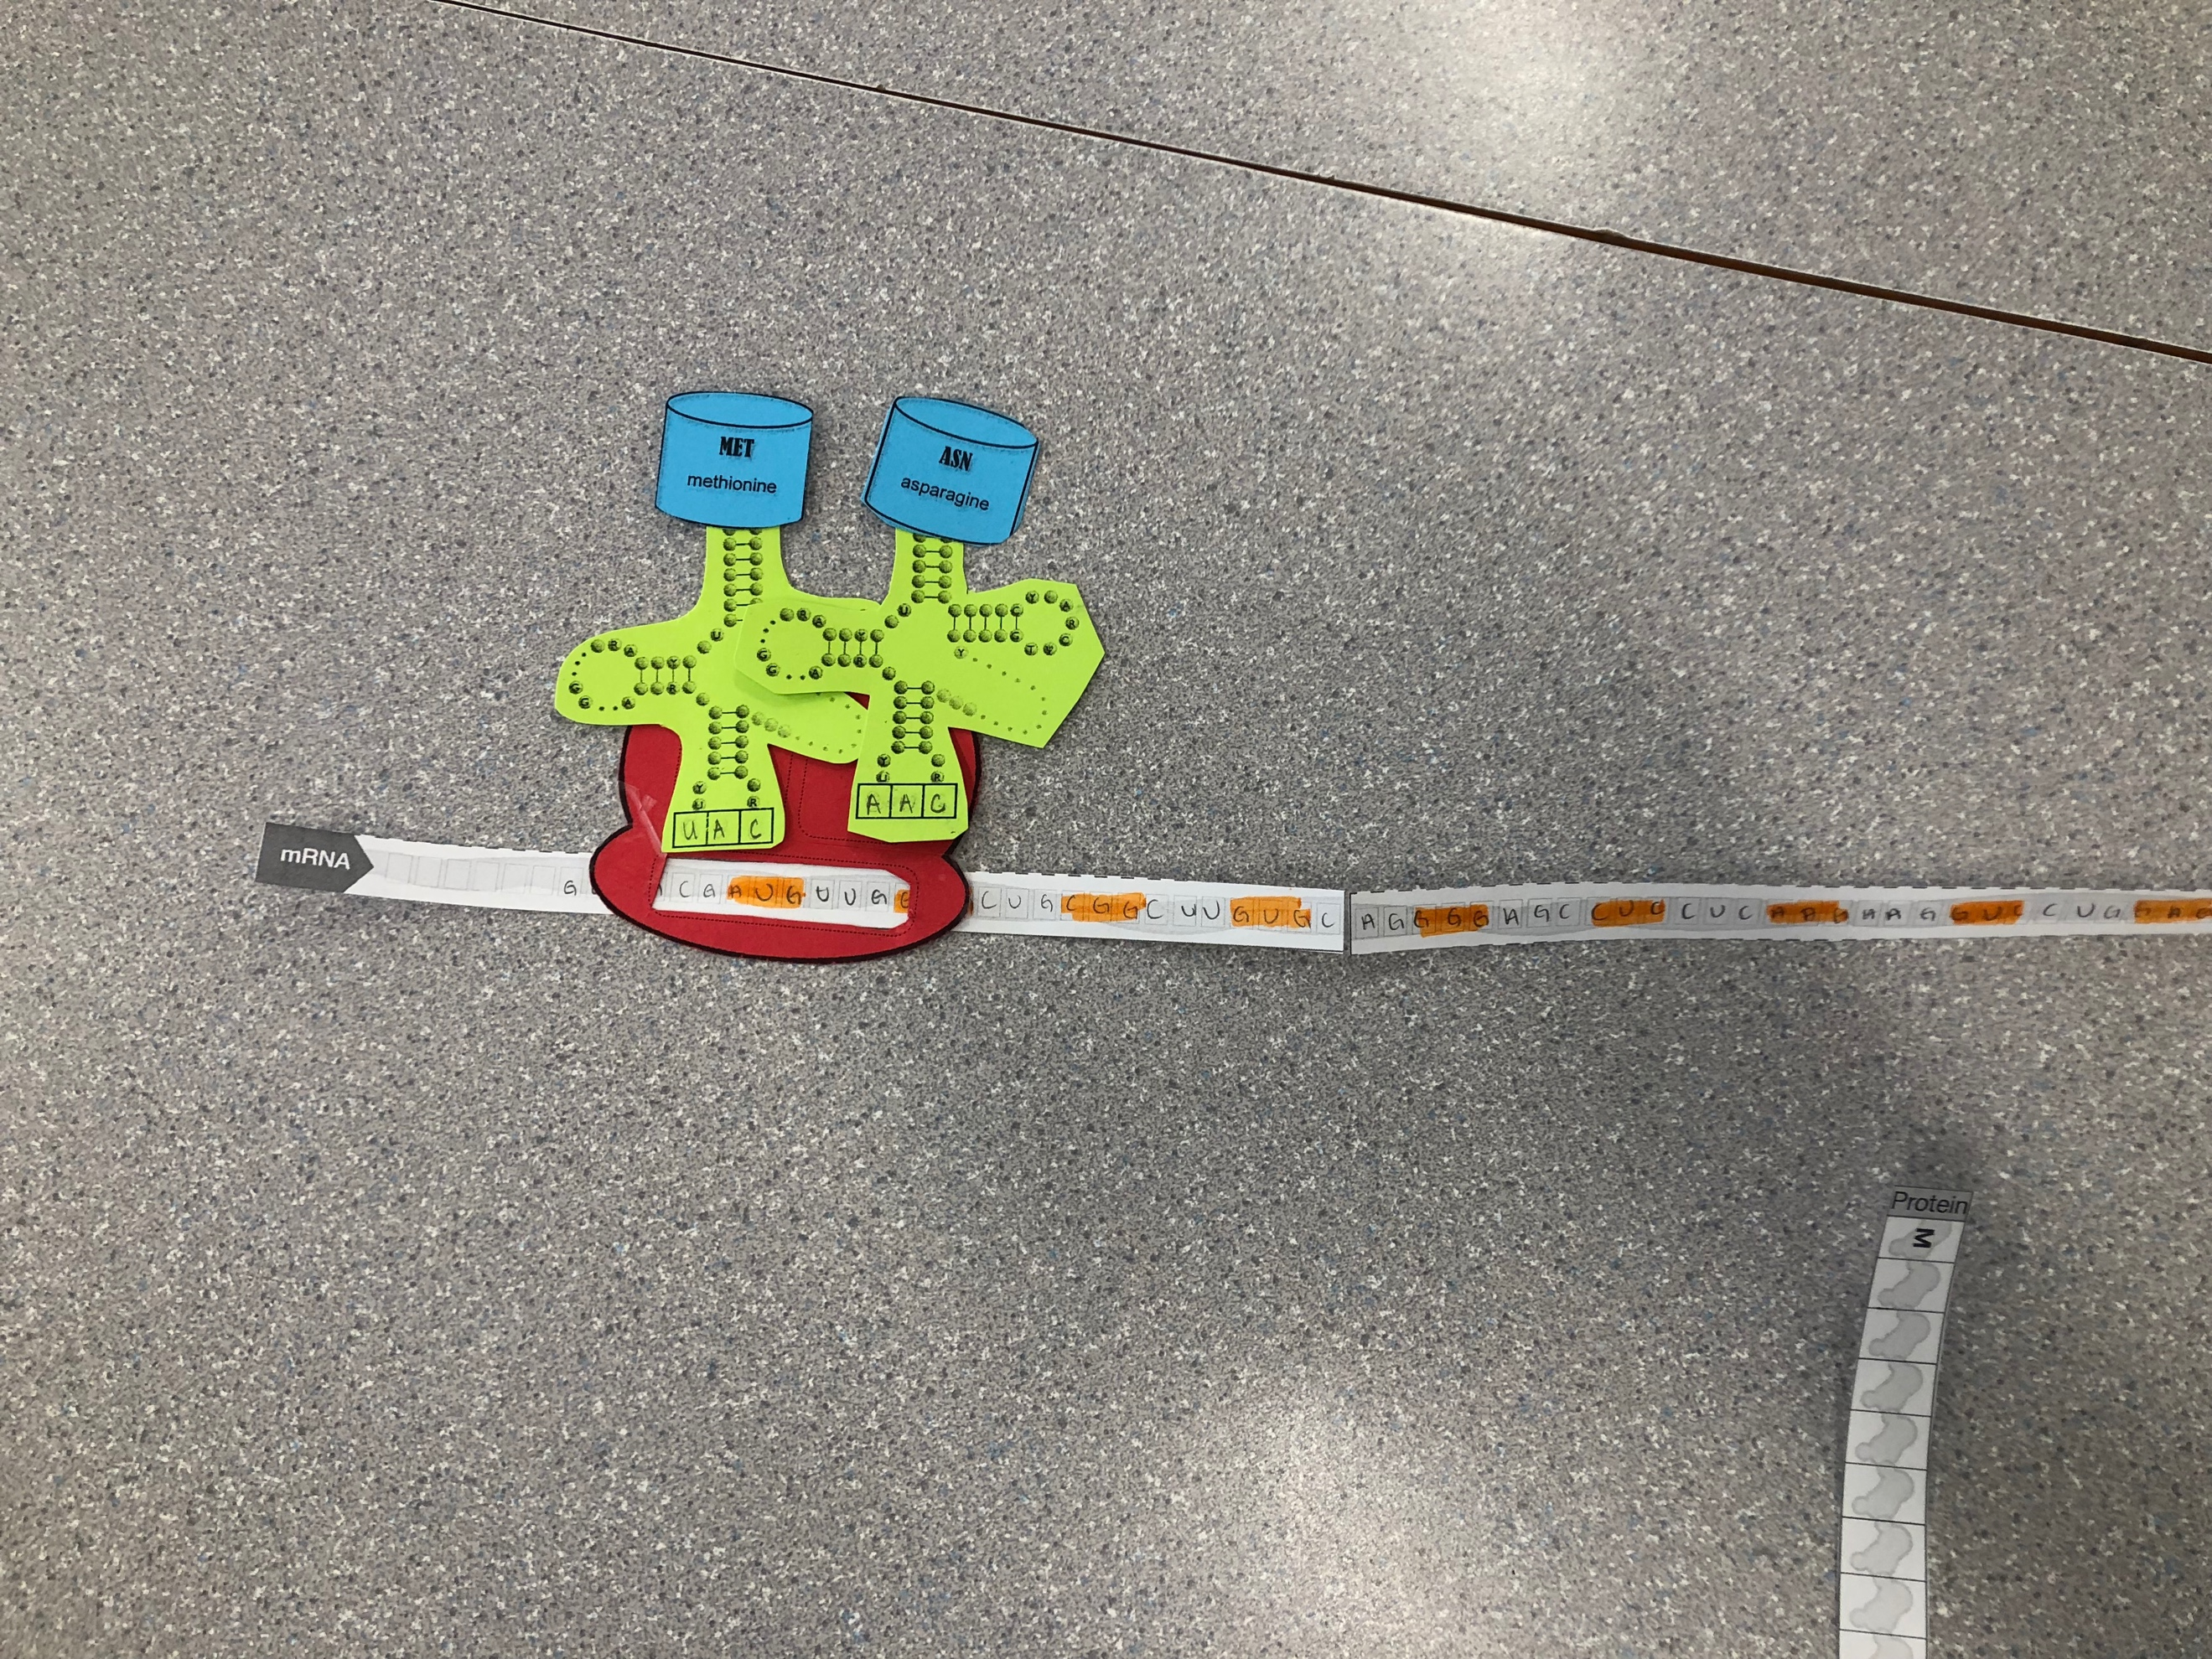

The Ribosome on the start codon “AUG” which attaches
To its first tRNA amino acid.

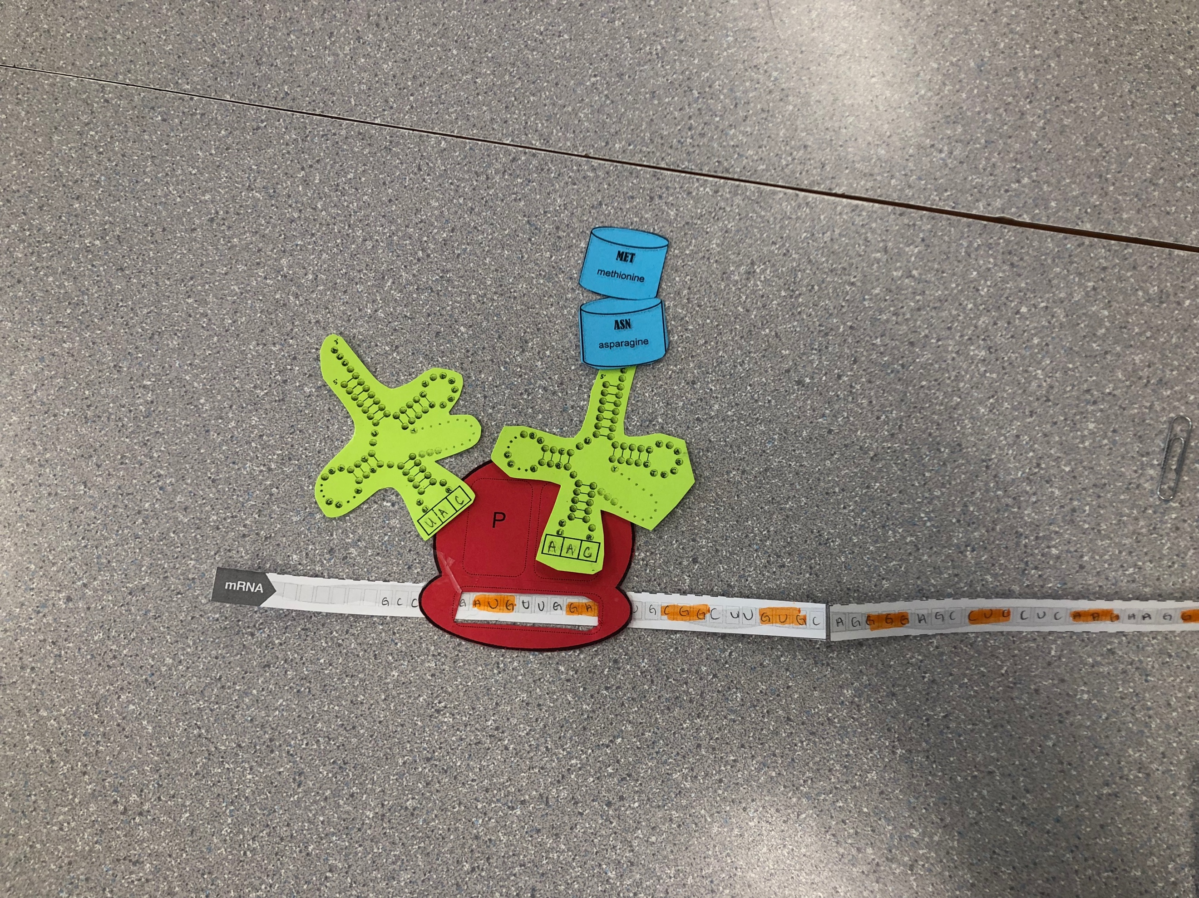
The tRNA on the “P” site leaves and its amino
Acids join onto the “A” site tRNA.

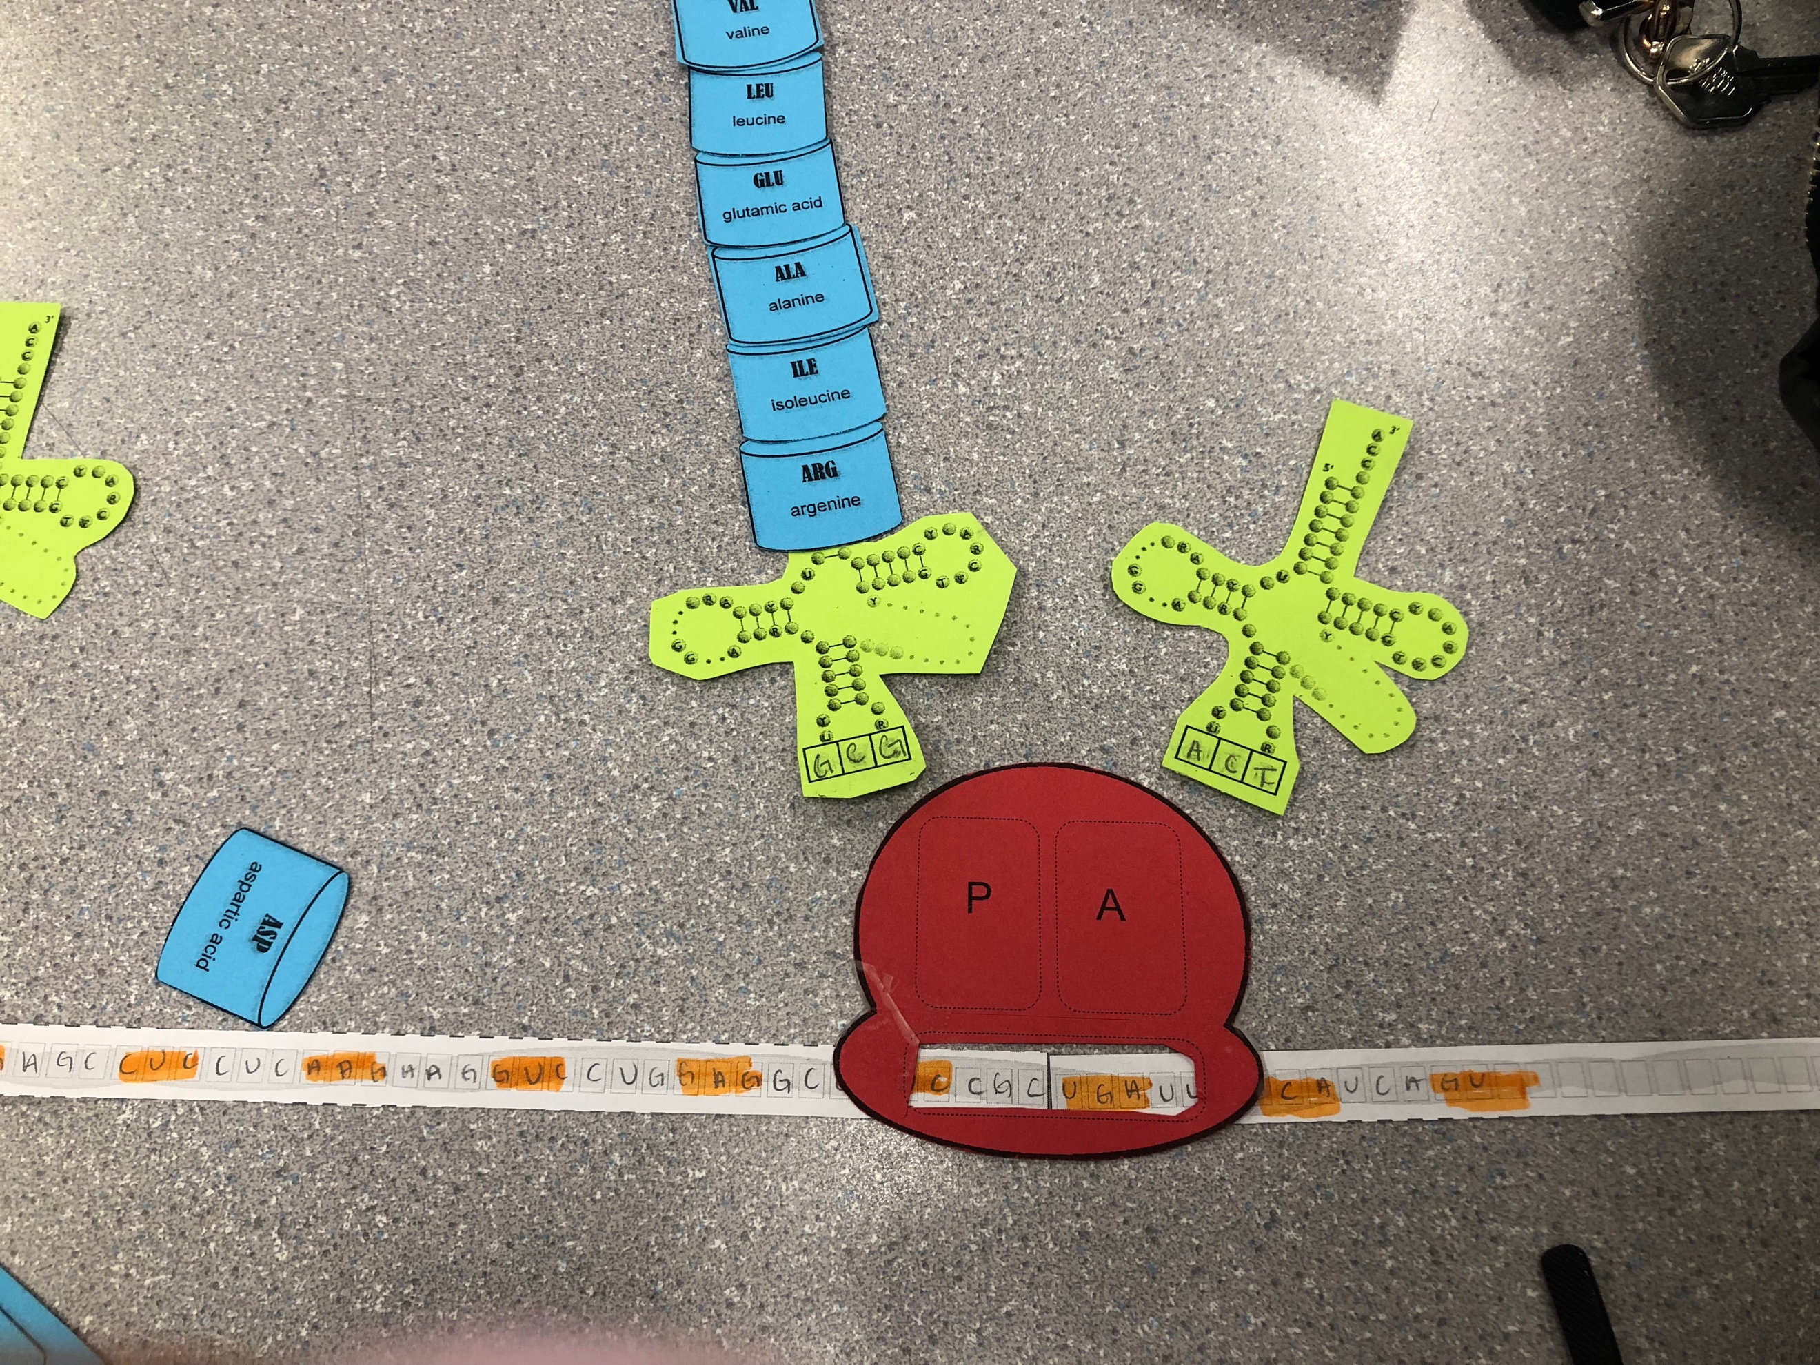

final step, Termination takes place and both tRNA
detach from the mRNA.

- How did today’s activity do a good of modelling the process of translation? In what ways was our model inaccurate?

The activity did a good job modelling this process because it clearly showed the process of how tRNA bind with each codon, by using the pieces of different coloured paper. It made it very visual to understand the process of translation. One way this model was inaccurate was the RNA was missing the phosphate-sugar strand. It only showed bases. Also, the shapes of the amino acids were not accurate.

