Molly Schmidt

Diffusion in Agar Cubes

Calculations:

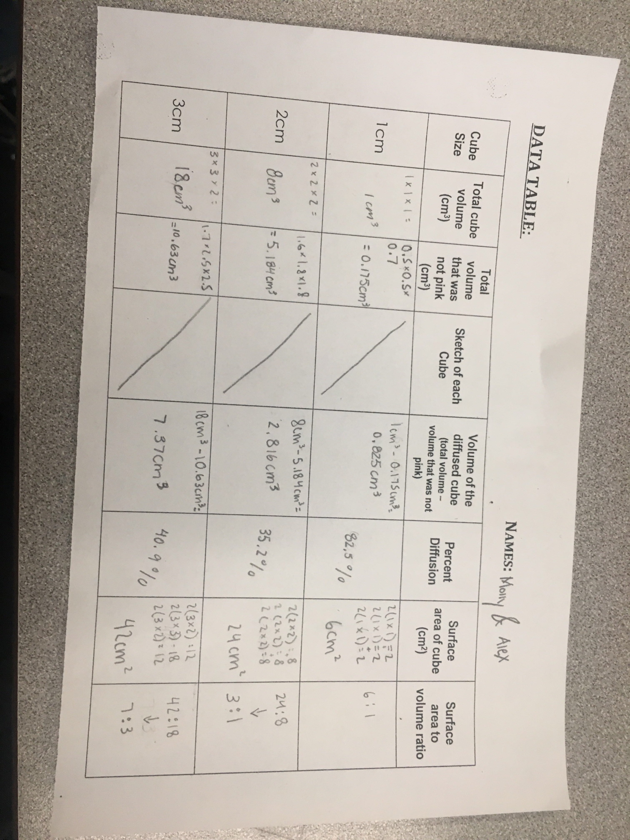

Observations:

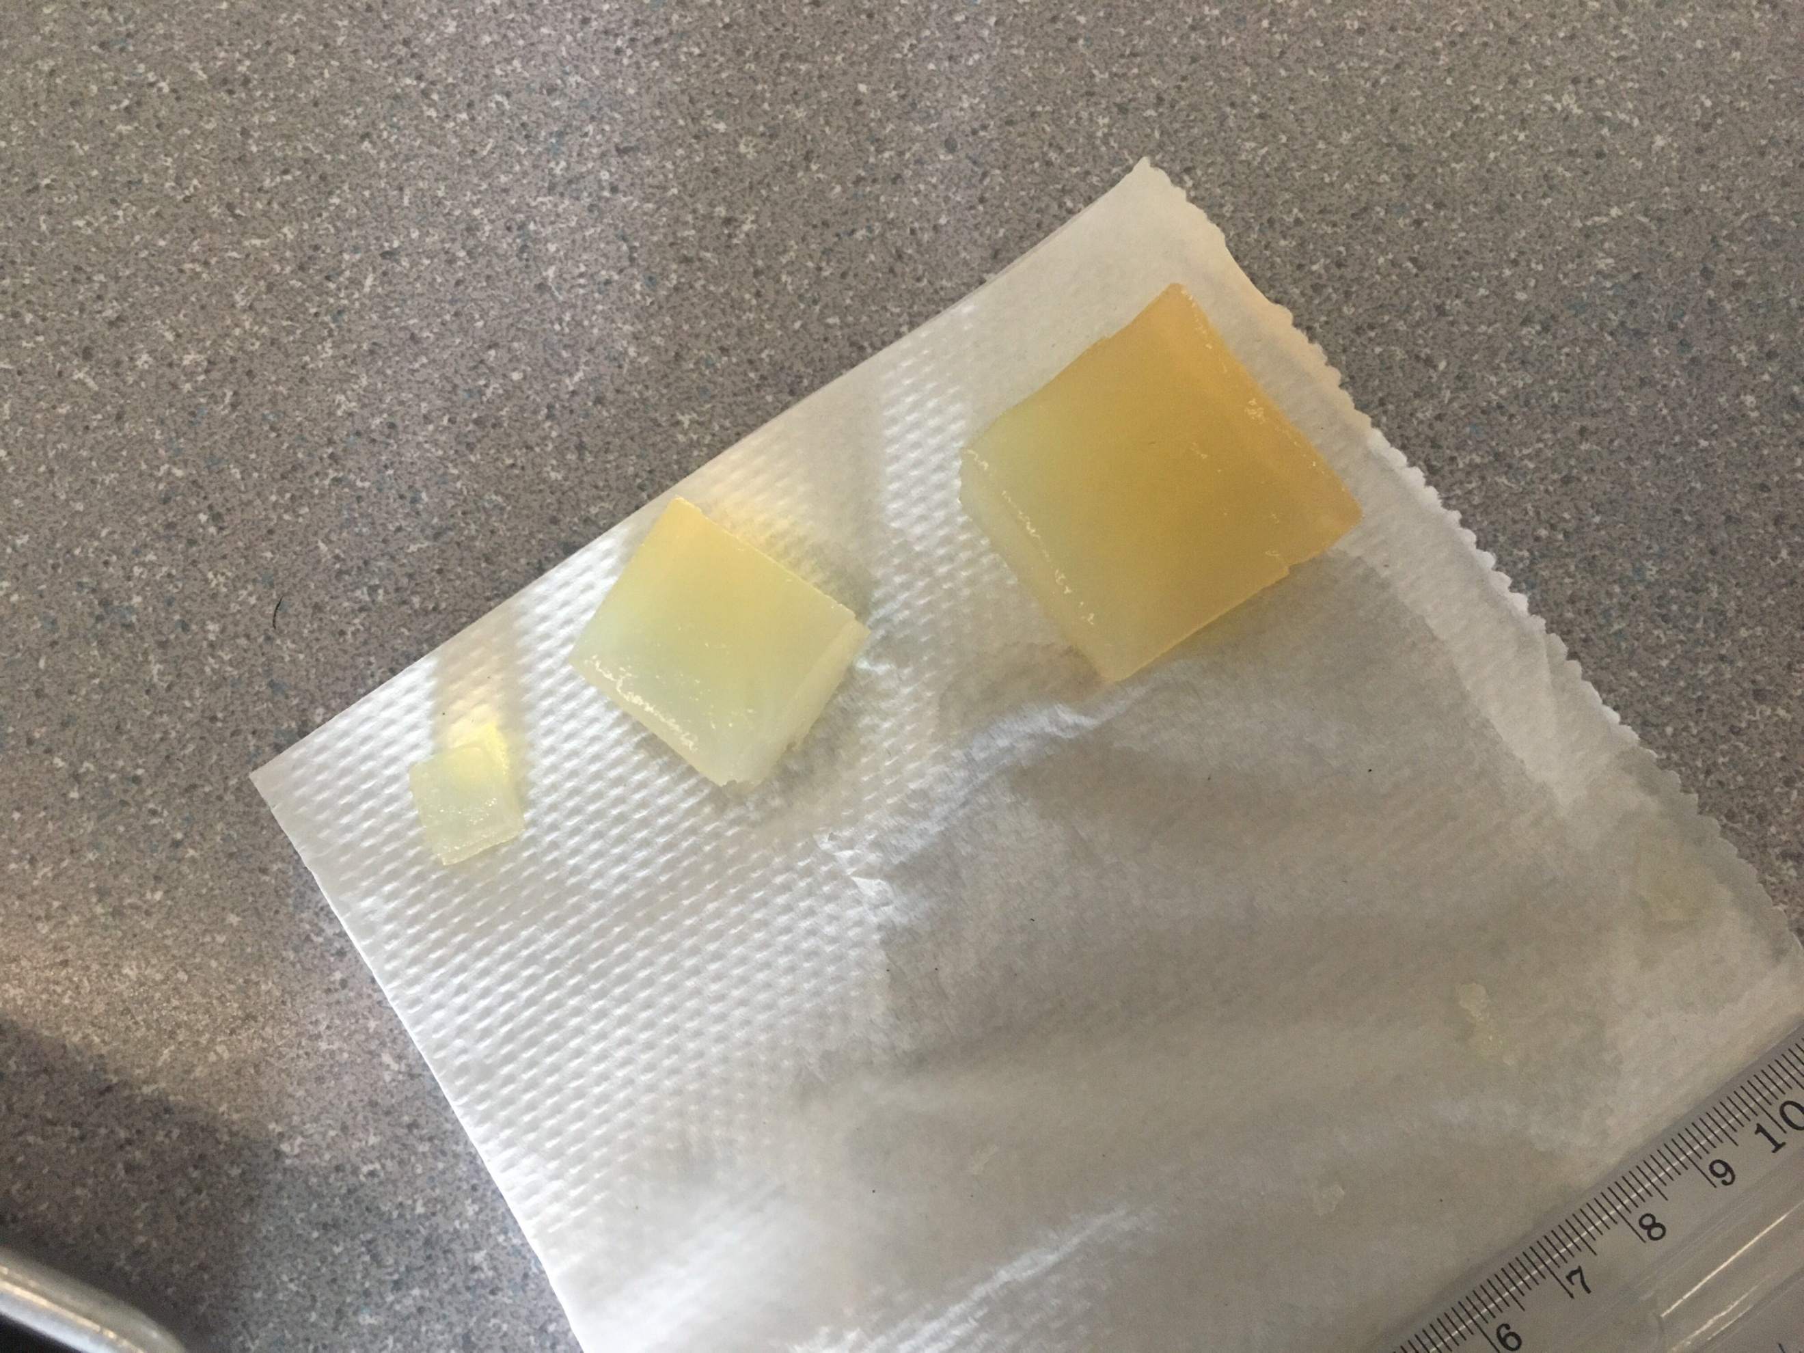
Agar cubes before placed in solution
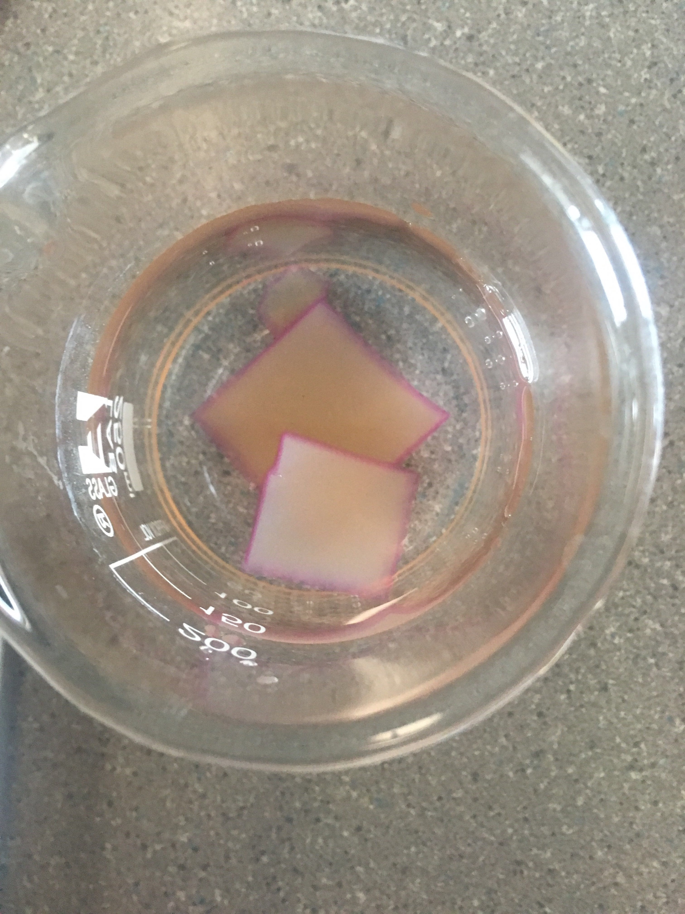

Agar cubes a few seconds after placed into solution
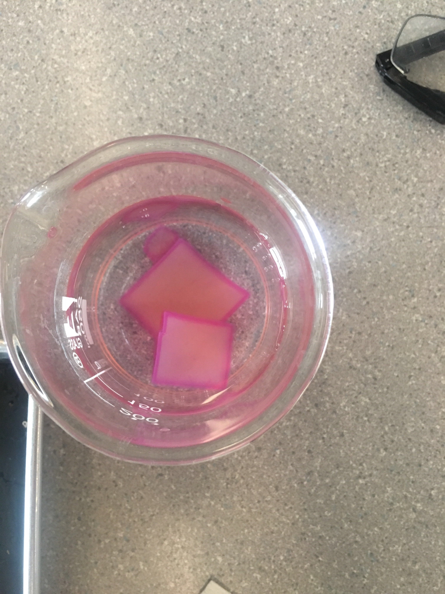

Agar cubes in solution for almost 10 minutes

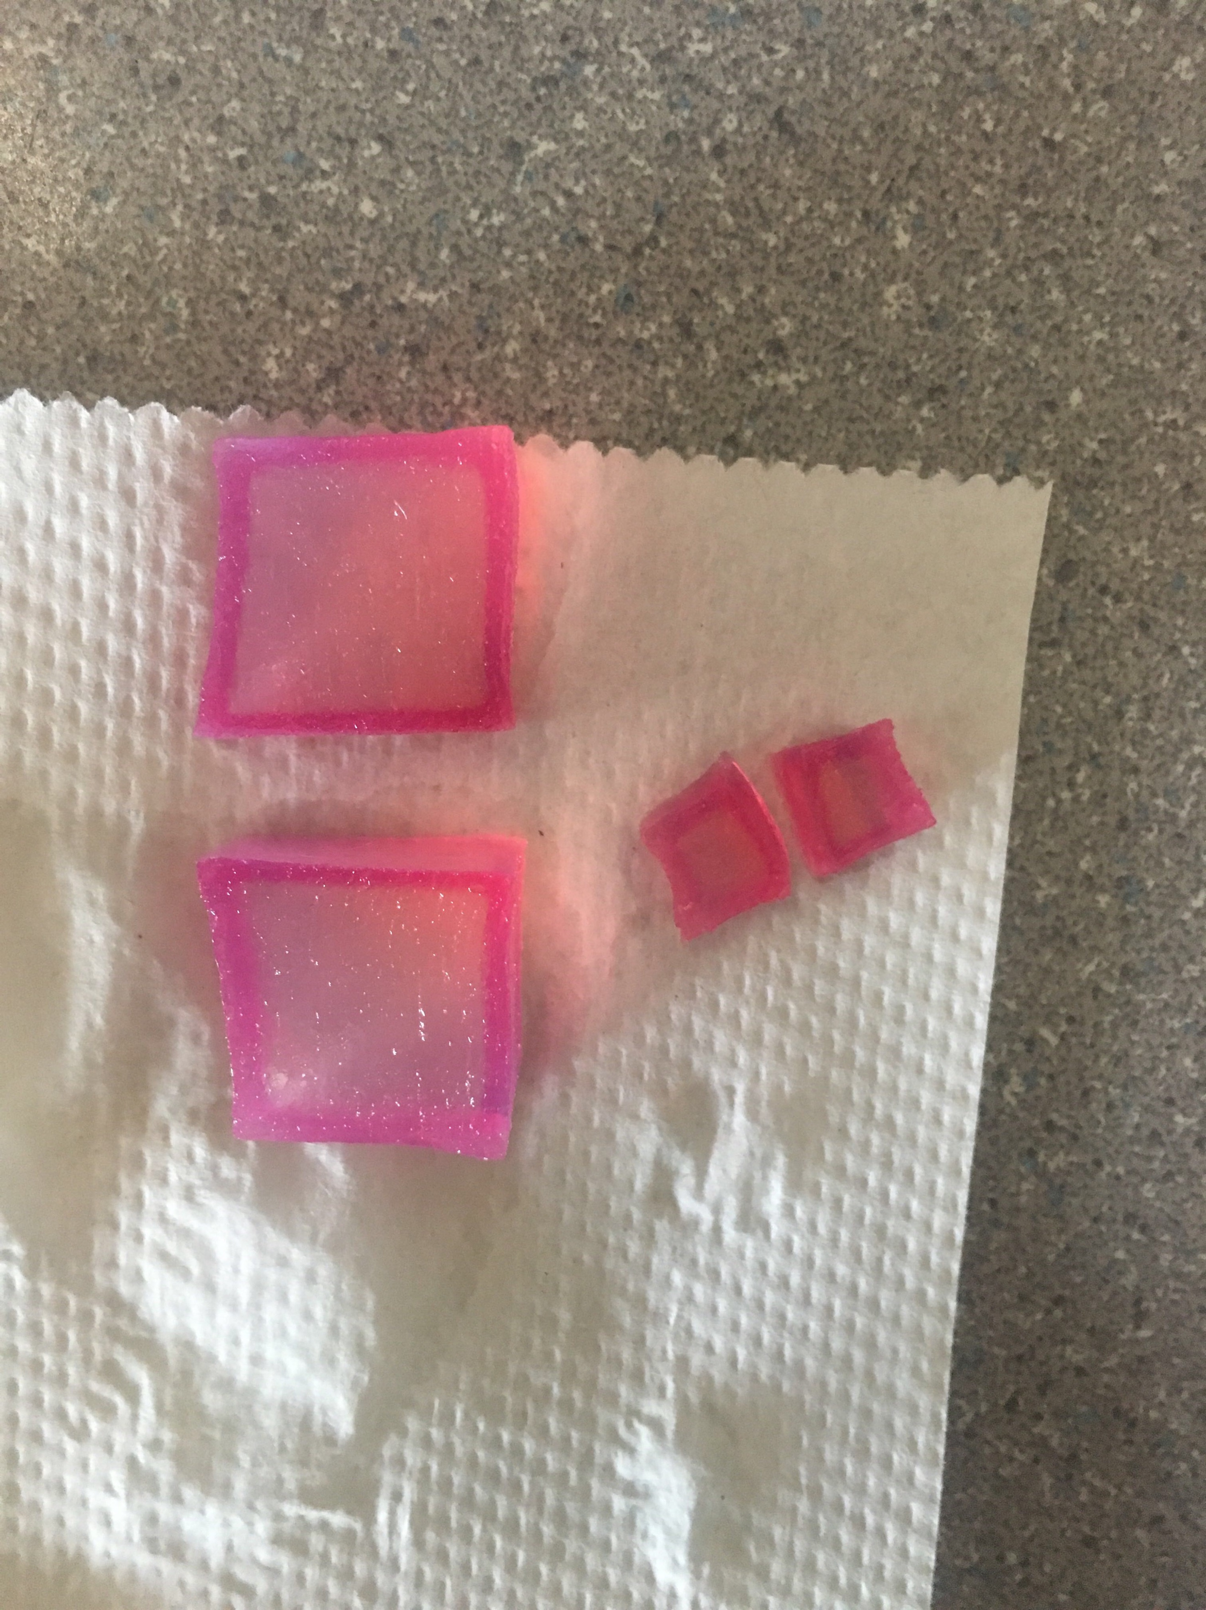

Agar cut in half.

Concluding Questions:

- In terms of maximizing diffusion, what was the most effective size cube that you tested?

In terms of maximum diffusion, the most effective size cube that was tested was the smallest cube. (1cm x 1cm x 1cm).

- Why was the size most effective at maximizing diffusion? What are the important factors that affect how materials diffuse into cells or tissues?

The smallest cube was the most effective due to it having the smallest volume, making it easier for diffusion to happen throughout the whole cube. Important factors that affect how materials diffuse into cells or tissues are concentration, temperature, type of material, size of cell and polarity.

- If a large surface area is helpful to cells, why do cells not grow to be very large?

Cells don’t grow to a large size because if the cell’s surface area increases, so will its volume causing diffusion to be inefficient. The process of diffusion will not occur through the inside of the whole cell. When a cell continues to grow, there is less membrane for the substances to diffuse through resulting in the centre of the cell not receiving the substances that it needs.

- You have three cubes, A, B and C. They have surface to volume ratios of 3:1, 5:2, and 4:1 respectively. Which of these cubes is going to be the most effective at maximizing diffusion, how do you know?

The cube that will be most effective at maximizing diffusion will be cube C (4:1), because it has a higher surface area to volume ratio. For every cubic unit of cytoplasm there is more cell membrane than the A and B cubes. this will ensure that the inside of the cube will be the most effective at diffusion allowing more materials to be able to enter the cytoplasm.

- How does your body adapt surface area to volume ratios to help exchange gases?

Our bodies have altered to have larger organs which are formed by small spheres which cover as much surface area as possible in order to efficiently exchange gases. Our bodies make sure the surface area to volume ratio is good and is established in the area where gas exchange happens.

- Why can’t certain cells, like bacteria, get to be the size of a small fish?

Cells like bacteria can’t be the size of a fish because they need to divide in order to keep a good surface area to volume ratio. Certain cells need to stay small for proper action. If the size of a small fish, their SA to V ration would be too small to ensure proper diffusion through the whole cell.

- What are the advantages of large organisms being multi-cellular?

The advantages of large organisms being multi-cellular is they have an ability to grow to a large size, due to the number of their cells increasing in the organism over time. Unicellular organisms only have one cell with one function, whereas multicellular organisms contain cells that have their own specific functions.

