
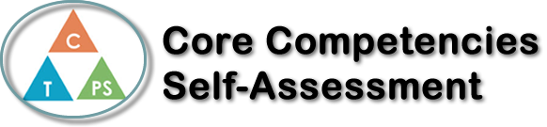
Name: Molly Schmidt | Date: November 22, 2017

  How does the artifact you selected demonstrate strengths & growth in the communication competency?  In what ways might you further develop your communication competency? | Self-Reflection  Describe how the artifact you selected shows your strengths & growth in specific core competencies. The prompt questions on the left - or other self-assessment activities you may have done - may guide your reflection process.  Compared to last year my personal awareness and responsibility has changed dramatically due to my growth as a person. This semester of math has showed me that good grades come with a great amount of responsibility. To achieve in a class, you must put in the effort to end with a good outcome. Math is a hard subject and Pre-calculus 11 for me personally, has been the hardest year so far. This year I have had to put in that extra step and set goals to create a source of motivation. I am taking ownership of my goals and learning by getting extra help from teachers, tutors, and my peers. When I don’t succeed, it will make me strive to try harder and do better. This semester so far has taught me how to develop my communication skills by taking charge to ask for help and be open with others about struggles with my work. I have experimented new thinking strategies from inspiration from my peers and teachers that I have still yet to use and master. I know if I take charge and figure out what next step I need to take to be closer to my final goal, then my year will be a success.  For example, I take responsibility in completing my blog post with organization and time to create something that can reflect on my learning and myself as a person. I have also gained motivation to result in success by seeing a tutor twice a week.


How does the artifact you selected demonstrate strengths & growth in the thinking competencies?

In what ways might you further develop your thinking competencies?


How does the artifact you selected demonstrate strengths & growth in the personal & social competencies?

In what ways might you further develop your personal & social competencies?

Publish Your Self Assessment
You will now attach and/or embed your self-assessment to the bottom of the blog post with the artifact you have chosen. You may choose to make this post private or public. After placing your artifact on a blog post, follow the instructions below.
- Categories - Self-Assessment
- Tags - Now tag your post using the tag that corresponds to the competency that you have written about. You can choose more than one. Please use lower case letters and be exact.
  - #creativethinkingcc
  - #communicationcc
  - #criticalthinkingcc
  - #socialresponsibilitycc
  - #personalidentitycc
  - #personalawarenesscc
- Use the Add Document button located at the top of your post page and embed your self-assessment at the bottom of your blog post.
- Publish

