Researcher
Name: Mikayla Berry Circle: 4
Meeting Date: May 16th, 2019 Reading Assignment: pg 200-240
Book: All the Light We Cannot See

Research I Found:
- Sea of Flames Stone
    - Not a historically accurate stone
    - Based off a gemstone that was thrown into the Thames River called the Delphi Sapphire
    - The Delphi Sapphire is also cursed and is said to not bring death but bring sorrow
    - It was donated to a museum after the previous owner experienced many misfortunes
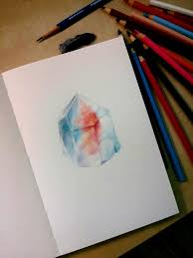
Sea of Flames Representation
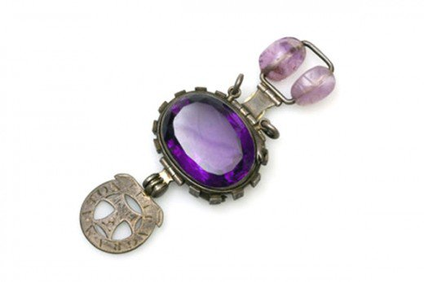
Delphi Sapphire

- Shulpforta School:
  - Opened separately from all other German Secondary Schools
  - Children who attended were meant to become future leaders of Germany
  - The school mentioned in the story was an actual institution from the World War 2 era
  - It was located in the Prussian Province of Saxony
