Researcher
Name: Mikayla Berry Circle: 1
Meeting Date: May 7th, 2019 Reading Assignment: pg 19-90
Book: All the Light We Cannot See

Research I Found:
- Bombing of Saint-Malo
  - In World War 2 the walled city was almost completely destroyed by American bombings and British Naval gunfire (late August-early December)
  - Beaches were heavily fortified against possible attacks and about 8000 Germans were in Saint-Malo when the attacks began
  - Town was rebuilt over a 12-year period
  - Attacks due to Allied forces gaining ground after a successful landing in France on D Day
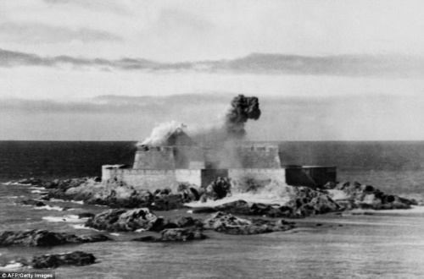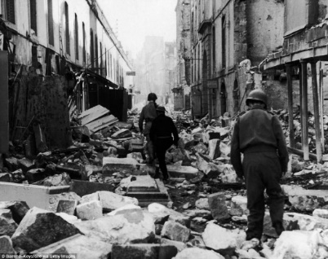

- National Museum of Natural History (France)
- Main museum located in Paris, France on the left bank of the River Seine
- Founded in 1793 during the French Revolution
- After receiving financial autonomy in 1907, there was a new phase of growth that helped to open facilities throughout France during the interwar years
- Research departments include: classification and evolution; regulation, development, and molecular diversity; aquatic environments and populations; ecology and biodiversity management; history of earth; men, nature, and societies; and prehistory
- Diffusion departments include: the galleries of the Jardin des Plantes (Marie-Laure’s favourite place); Botanical Parks and Zoos; and Museum of Man 