
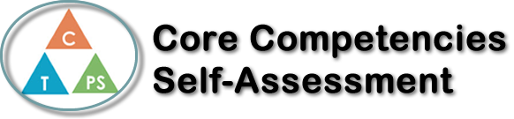
Name: Memphis Wilson | Date: 4/8/2022

  How does the artifact you selected demonstrate strengths & growth in the communication competency?  In what ways might you further develop your communication competency? | Self-Reflection  Describe how the artifact you selected shows your strengths & growth in specific core competencies. The prompt questions on the left - or other self-assessment activities you may have done - may guide your reflection process.  During the research for the project, I realised just how much doing French immersion benefits you. I had no idea that the impact of French immersion was so great compared to English. We didn’t do any myths in our project, so I got to focus more on the benefits which I started to notice more in some of my other classes. Overall, I am glad I took French immersion even it is very tough for me. French immersion has been a part of me since middle school and I originally took it just because I thought the trip to Quebec would be cool. The trip was nice, and I developed my French over there however now I don’t really see it that way. I debated quitting French numerous times over the years however I decided to stick with it and now I see that hopefully it will be worth it.

X

How does the artifact you selected demonstrate strengths & growth in the thinking competencies?

In what ways might you further develop your thinking competencies?

X

How does the artifact you selected demonstrate strengths & growth in the personal & social competencies?

In what ways might you further develop your personal & social competencies?

Publish Your Self Assessment
You will now attach and/or embed your self-assessment to the bottom of the blog post with the artifact you have chosen. You may choose to make this post private or public. After placing your artifact on a blog post, follow the instructions below.
- Categories - Self-Assessment
- Tags - Now tag your post using the tag that corresponds to the competency that you have written about. You can choose more than one. Please use lower case letters and be exact.
  - #creativethinkingcc
  - #communicationcc
  - #criticalthinkingcc
  - #socialresponsibilitycc
  - #personalidentitycc
  - #personalawarenesscc
- Use the Add Document button located at the top of your post page and embed your self-assessment at the bottom of your blog post.
- Publish

