- Mapa de la casa
Draw a blue print of a house.
You must have all the rooms and parts of the house as well as the furniture in the vocab section of this etapa.
Label all the rooms and the furniture. See vocab page for requirements.
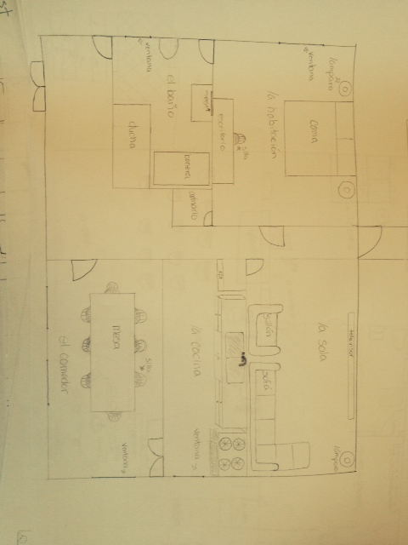

Los quehaceres
Describe what chores you are doing “ present progressive”.
1. You must have 6-8 chores that need to be done in the house.
2. You need to extend your sentence by adding the part of the house (bedroom, kitchen etc…) and any other vocabulary that would fit the context of your sentence.
Modelo : Estoy ordenando mis ropas en mi habitacion.
________________________________________________________________________________________________________________________________________________________________________________________________________________________________________________________________________
________________________________________________________________________________________________________________________________________________________________________________________________________________________________________________________________________
________________________________________________________________________________________________________________________________________________________________________________________________________________________________________________________________________
________________________________________________________________________________________________________________________________________________________________________________________________________________________________________________________________________
________________________________________________________________________________________________________________________________________________________________________________________________________________________________________________________________________
________________________________________________________________________________________________________________________________________________________________________________________________________________________________________________________________________
________________________________________________________________________________________________________________________________________________________________________________________________________________________________________________________________________

