DOCUMENT ONE

By 1941, there were over 23 000 Japanese-Canadians living in Canada, 22 000 in British Columbia. In early 1942, under the War Measures Act, all Japanese-Canadians living near the British Columbia coast were “invited” to move to the Okanagan Valley, where they would be settled in temporary camps known as “relocation centres”. In the wake of anti-Japanese marches in Vancouver, about 750 people moved voluntarily. Soon all Japanese-Canadians, regardless of how long they have been living in Canada, were forced to leave the coast.
Families were separated, and many were sent to isolated internment camps in the interior of British Columbia, where they were detained without trial until the end of the war. Some families chose to go, instead, to Alberta or Manitoba, where they laboured on beet farms. These locations were farther away from their homes, but at least families were permitted to stay together.
In January 1943, the Custodian of Enemy Property, a federal government official, was given the power to confiscate and sell Japanese-Canadian property. People who had been relocated inland lost everything: their houses, cars, shops, fishing boats, and other property. All their possessions were sold at fire-sale prices, and the owners received virtually nothing.

Cranny and Moles, Counterpoints, 2001, p. 126

DOCUMENT TWO

The uprooting of the Japanese families was just one small episode in perhaps the darkest chapter in the history of race relations in Canada. In the days and months following the raid on Pearl Harbor, the federal government designated as “enemy aliens” 22,000 people of Japanese heritage living in British Columbia – 75 percent of whom were either naturalized Canadians or born in Canada. By the fall of 1942, the government had evacuated them beyond a so-called protected area stretching 160 km inland from the Pacific Ocean along the entire B.C. coast. Officials confiscated their homes, businesses and farms, and even their cars, radios and cameras – despite RCMP and army assessments that no action was necessary. Maj. Gen. Kenneth Stewart, declared in 1941: “From the army point of view, I cannot see that Japanese-Canadians constitute the slightest menace to national security.” In fact, not a single Canadian of Japanese ancestry was ever charged with disloyalty to Canada. But in the spirit and panic of the time, Ottawa decided to limit any risk that they might constitute as Japanese forces began occupying island after island in the Pacific.

Quinn, Legacy of Shame
Maclean’s magazine, November 18, 1991

DOCUMENT THREE

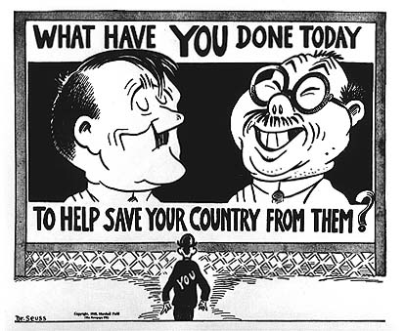
Theodor Seuss Geisel (Dr. Seuss), March 5, 1942, New York newspaper PM

DOCUMENT FOUR

The British Columbia delegation absolutely refused to accept the RCMP opinion that Japanese Canadians were loyal. Unanimously they declared that they did not trust persons of Japanese racial origin and that they considered the continuing presence of Japanese Canadians in B.C. a menace to public safety. Even if the RCMP were correct and the minority harmless, they argued, it made no difference. Indoctrinated by years of anti-Japanese propaganda, the people of B.C. could not possibly be convinced that Japanese Canadians were not a menace. Besides, one B.C. delegate conceded privately to Lieutenant General Maurice Pope, the war afforded a “heaven-sent opportunity to rid themselves of the Japanese economic menace for ever more.”
Sunahara, The Politics of Racism, 1981

DOCUMENT FIVE

Vancouver businessman Frank Bernard says of the Japanese-Canadians: “I believe 95 per cent of them were loyal to Canada under normal circumstances, but who knows how many of them might have turned had the Japanese invaded the west coast, as was the real fear at that time. The other five per cent were enemies of this country. In each camp, there were traitors to Canada, more among the foreign-born Japanese. But it was impossible to tell who was loyal and who was disloyal the fate of Canada could have been affected by one traitor, especially in the event of an invasion. There was no other alternative to ensure security of Canada’s coast waters. Under similar conditions today, the decision undoubtedly would have to be the same.”
Boyd, Vancouver Sun, 1984

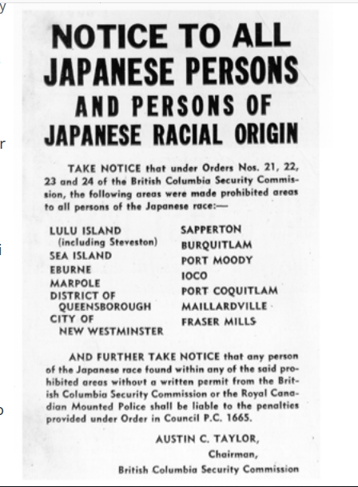

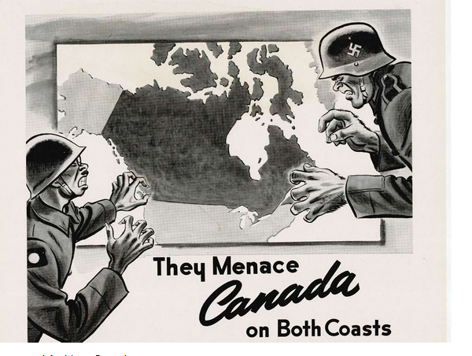

DOCUMENT SIX

Put All Under Guard

Sir: While the authorities are on the job of rounding up the Japanese fishermen, what about rounding up the Jap market gardeners, truck drivers, etc., scattered around in the Fraser Valley? They are just as liable to fifth column work as any other enemy aliens.
I notice along the main highway going to Mission and Harrison Hot Springs there is quite a good percentage of Japanese on the road with trucks and cars, loaded with passengers with their suitcases attached on the roofs of their vehicles as though they were going somewhere, I wonder where they are all going?
What about all the Italians working on the railroad tracks? It would be easy work for them to plant some fireworks for the incoming or outgoing train.
I say, put all enemy aliens under guard. Take a pattern from Australasia.

OLD-TIMER
Letter to the editor of the Vancouver Province, January 6, 1942

DOCUMENT SEVEN

The photograph shows Japanese fishing boats seized by the government and corralled at Annieville Dyke on the Fraser River. Despite earlier government promises to the contrary, the Custodian of Enemy Alien Property sold the confiscated property. The proceeds were used to pay auctioneers and realtors, and to cover storage and handling fees. The remainder paid for small allowances given to those in internment camps. Unlike prisoners of war of enemy nations who were protected by the Geneva Convention, Japanese Canadians were forced to pay for their own internment.
Photograph courtesy of Vancouver Public Library
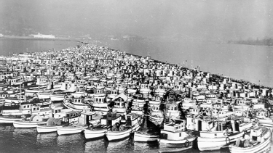
Internment and Redress: The Japanese Canadian Experience, 2002

DOCUMENT EIGHT
“…the War-time Measures Act, granted the Canadian government the authority to do everything necessary “for the security, defense, peace, order, and welfare of Canada” during a time of war.
Cranny and Moles, Counterpoints, 2001, p. 27

DOCUMENT NINE
“Asiatics could not be assimilated (absorbed into society so that cultural differences disappear) because of their colour, languages, clothes, religions, foods and customs.”
J. Arthur Lower, Canada and the World, December 1977

DOCUMENT TEN
"Born in Canada, brought up on big-band jazz, Fred Astaire and the novels of Rider Haggard, I had perceived myself to be as Canadian as the beaver. I hated rice. I had committed no crime. I was never charged, tried or convicted of anything. Yet I was fingerprinted and interned."
Ken Adachi, Toronto Star, Sept. 24, 1988

DOCUMENT ELEVEN
Acknowledgement
As a people, Canadians commit themselves to the creation of a society that ensures equality and justice for all, regardless of race or ethnic origin.
During and after World War II, Canadians of Japanese ancestry, the majority of whom were citizens, suffered unprecedented actions taken by the Government of Canada against their community.
Despite perceived military necessities at the time, the forced removal and internment of Japanese Canadians during World War II and their deportation and expulsion following the war, was unjust. In retrospect, government policies of disenfranchisement, detention, confiscation and sale of private and community property, expulsion, deportation and restriction of movement, which continued after the war, were influenced by discriminatory attitudes. Japanese Canadians who were interned had their property liquidated and the proceeds of sale were used to pay for their own internment.
The acknowledgement of these injustices serves notice to all Canadians that the excesses of the past are condemned and that the principles of justice and equality in Canada are reaffirmed.
Therefore, the Government of Canada, on behalf of all Canadians, does hereby:
- acknowledge that the treatment of Japanese Canadians during and after World War II was unjust and violated principles of human rights as they are understood today;
- pledge to ensure, to the full extent that its powers allow, that such events will not happen again; and
- recognize, with great respect, the fortitude and determination of Japanese Canadians who, despite great stress and hardship, retain their commitment and loyalty to Canada and contribute so richly to the development of the Canadian nation.
Brian Mulroney
Prime Minister of Canada
September 22, 1988

DOCUMENT TWELVE
“It is the government’s plan to get these people out of B.C. as fast as possible. It is my personal intention, as long as I remain in public life, to see they never come back here. Let our slogan be for British Columbia: ‘No Japs from the Rockies to the seas.'"
Ian Mackenzie, MP, CBC, 1941

DOCUMENT THIRTEEN
Woman recalls life in “traumatic era”
“A portion of Canada’s history which is considered by some as shameful is the wartime relocation of the Japanese from the B.C. coast to the interior. I would like to present a different perspective, the impressions of a frightened 14-year-old. From early memories, the Japanese had been classmates and friends. After Pearl Harbor, there was a marked changed of attitude in many Japanese. Remarks such as “We’ll soon be running things” were alarming. This, with news that Japanese subs had been seen off the coast, left many of us with feelings of dread. Many of us who lived through this traumatic era consider the relocation justified, and that no compensation should have been considered.”
Geraldine Wray, Richmond, BC

