Electricity Project
Hydroelectric Generation (Lake Buntzen): Plants takes the energy of water that are falling to generate electricity. A generator called turbine (it connects to an electric generator to generate electric power. Most of the world’s electricity are using this and it is really useful.) converts all the falling water into a mechanical energy.
Pro:
- Useful
- Quickly to create electricity
- Ecofriendly
Con:
- Non ecofriendly
- Dangerous
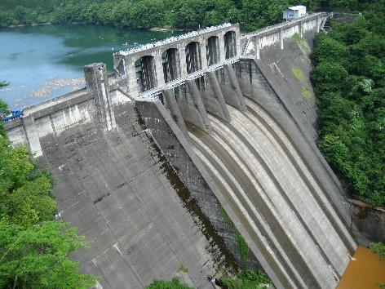
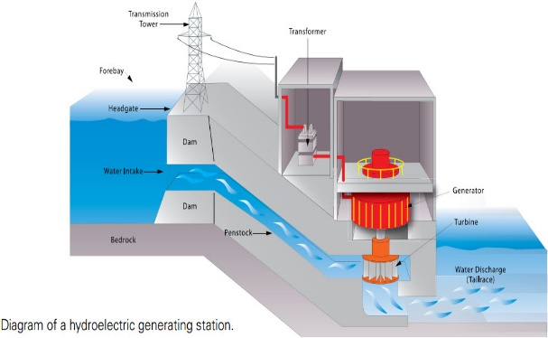

Thermal Generation (Burrard Thermal): It usually uses coal, oil or gas to produce heat-chemical to make heat energy. This is used to change water to steam, make hot water, and make heat to cook. The generator helps to produce electricity.
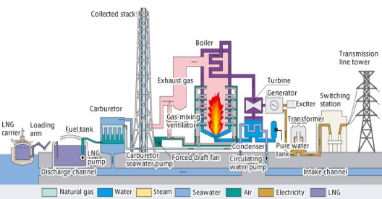
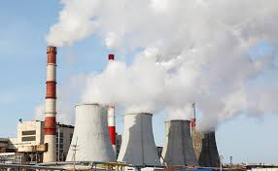

Pro:
- Useful
- Helpful

Con:
- Not ecofriendly
- Dangerous
- Can destroy the world.

How electricity is sent to communities:
- The current sends the electricity through transformers to increase the V to push the electricity further.
- The electrical charge is sent through from the transmission line that are around the country.
- It arrives to the business and the voltage are lowered to be able to send it to small power lines.
- The electricity are move around the neighborhood, then goes to the power safe in our homes.
- The electricity goes to your basement or garage to all the wires
