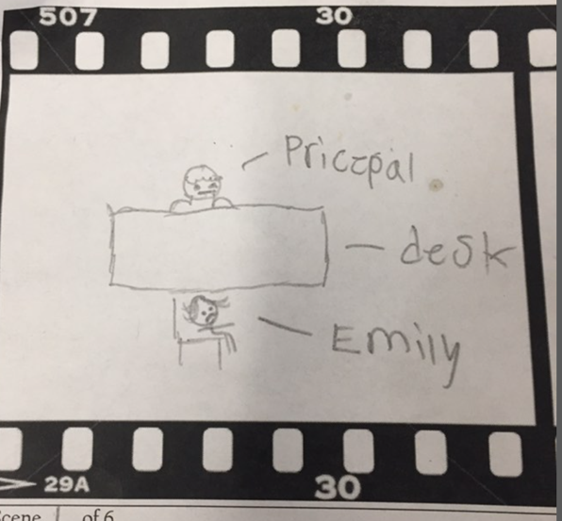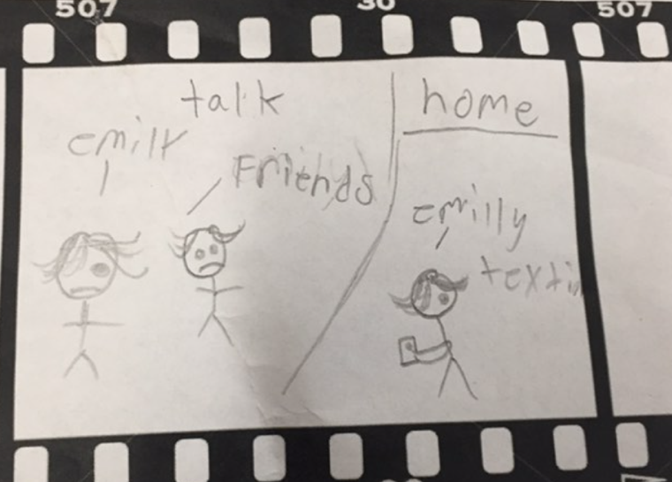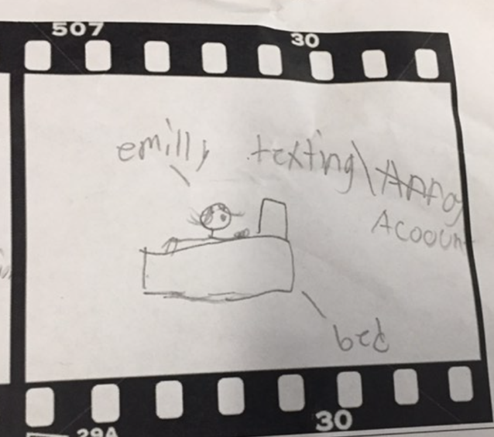
Scene ___1_ of 6  Description: Girl named who was crying and she went to the office to complain saying inappropriate photos of her were posted on Instagram account and takes place in a high school in California called California high school where there have been several complaints of this incident and trying to catch this guy  Audio: sad ballad piano  Dialogue: she starts stuttering and is upset talking to the principal and starts to cry and explain what happened the principal says “we have tried to stop this cyberbully but he is always on different and new account platforms but one day we will catch him don’t” she shutters and says thank you and ends up leaving the office  Effects: lunch time text and cannot handle it, so she leaves the office and goes outside to talk with her fiends so make her feel better  Transition: she gets depressed and cannot control herself, so she decides to get advice from her friend  LS / MS / CU: camera shot from the bottom | Scene __2__ of 6  Description: she goes outside to talk to her friends and they start talking and saying this is not the first time he blackmails people they all support her and comfort her but then after school she receives a message on Instagram and it’s a made up account based on a truth or dare.  Audio: sad ballad piano  Dialogue: she goes back to her house and just getting depressed in her own room. she thinks about explaining the situation to her parents, but she ends up not doing it and receives a text message from anonymous person in da school and she starts to worry.  Effects: 8 pm in Emily’s bed text at the bottom of the screen  Transitions: she receives an anonymous text on Instagram with 0 follower and 1 following which is Emily she opens the message and the anonymous say hi Emily and says her last name and says you  LS / MS / CU: close up shot because you can see the phone message and a bit of Emily. | Scene __3__ of 6  Description: she starts the conversation with anonymous account by opening up the message from Instagram dm and having conversation about her embarrassing pictures that seems to be inappropriate to share with another.  Audio: hard sound (nervous: drum)  Dialogue: she feels nervous and scared about it so she decides to do what he forces him to do to not make him angry which will cause her the trouble  Effects: Text or picture  Transition: she sends picture so than the anonymous takes photo and then leaves and deletes account.  LS / MS / CU: film it from the back and getting closer

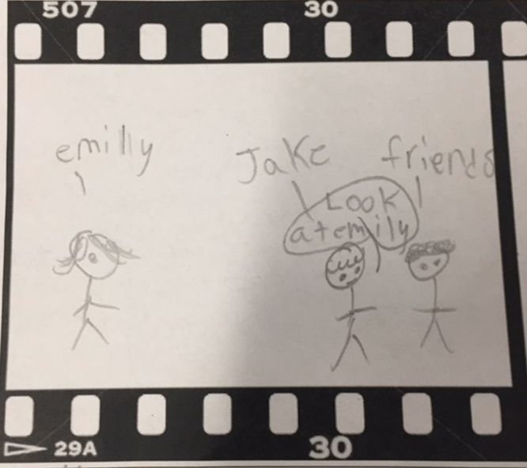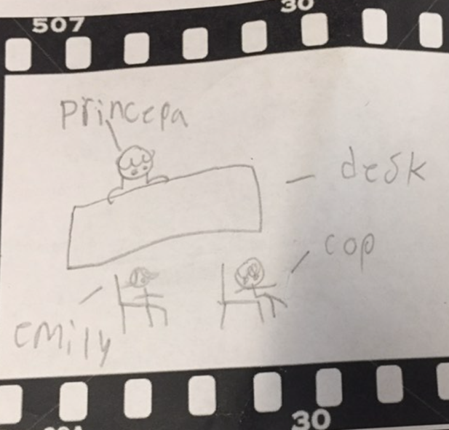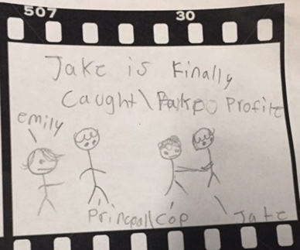

Scene __4__ of 6  Description: so Emily goes to school the next day and she was upset because she keeps texting him so than she is walking with her friend at lunch and over hears a conversation with a boy named Jake saying I have Emily’s embarrassing pictures so she hears the conversation and was shocked but she was mad it was him so she goes home and emails the school and contacts the police and talks and is going to talk to principal and office  Audio: sad violin  Dialogue: she goes home after school and texts the teacher saying she knows who has been blackmailing people in the school and the principal replies with we will talk immediately tomorrow  Effects: NO effect  Transition: the next day she goes to school she meets with the principal to talk about the situation and issue and police are called in so the principal; goes to jakes’s class and askes to see phones and he gets busted for his action  LS / MS / CU::film it from the back to show the background | Scene __5__ of 6  Description: She finds out that Jay is the one who has been threatening and blackmailed her on Instagram, on many social media accounts to send a picture.  Audio: sad piano  Dialogue: She is now at the end of her rope and unable to get help from school, so she finally decided to tell the police about her situation.  Effects: drums pounding because he is about to get caught  Transition: Jakes gets caught and he has to talk to the cops and principal  LS / MS / CU: long shot because it shows officer and principal and Emily. | Scene __6__ of 6  Description: Jake gets asked to show his phone and turns out he has Emily embarrassing photo and has the text from her own different social media platforms like Instagram, snapchat, Facebook, and when he gets confronted he was put in cuffs but he does say sorry and regret what he was doing he says sorry to Emily but she isn’t happy but his will come back to haunt him in the future  Audio: non  Dialogue: NON because it is end of the scene  Effects: No effect  Transition: NON because it is end of the scene  LS / MS / CU: film it around him

