
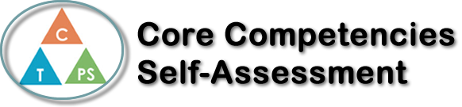
Name: Maria Benitez | Date: December 15, 2017

  How does the artifact you selected demonstrate strengths & growth in the communication competency?  In what ways might you further develop your communication competency? | Self-Reflection  Describe how the artifact you selected shows your strengths & growth in specific core competencies. The prompt questions on the left - or other self-assessment activities you may have done - may guide your reflection process.  For the project "Une bouteille dans la mer de Gaza", I had strengths in critical thinking, creative thinking, social responsibility, and communication. To find out more information about my project, I looked up websites and videos about the book and found some extra information and details to add in my story. I used creative thinking to find words that are more advanced and detailed in French, that way my vocabulary would be richer, detailed and more specific. Also, for the story, I had to devise an intriguing scenario for Tal and Naim to meet, also I had to outline character and setting details before I could start writing my story.  Another strength that I had during this project, was communication. When doing this project, I asked questions to my family and friends to get some feedback on my story, to read it, and help me make some changes if necessary.

X

How does the artifact you selected demonstrate strengths & growth in the thinking competencies?

In what ways might you further develop your thinking competencies?


How does the artifact you selected demonstrate strengths & growth in the personal & social competencies?

In what ways might you further develop your personal & social competencies?

Publish Your Self Assessment
You will now attach and/or embed your self-assessment to the bottom of the blog post with the artifact you have chosen. You may choose to make this post private or public. After placing your artifact on a blog post, follow the instructions below.
- Categories - Self-Assessment
- Tags - Now tag your post using the tag that corresponds to the competency that you have written about. You can choose more than one. Please use lower case letters and be exact.
  - #creativethinkingcc
  - #communicationcc
  - #criticalthinkingcc
  - #socialresponsibilitycc
  - #personalidentitycc
  - #personalawarenesscc
- Use the Add Document button located at the top of your post page and embed your self-assessment at the bottom of your blog post.
- Publish

