
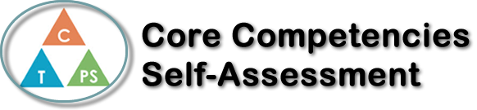
Name: Maddy Birtch | Date: May 9th, 2019

  How does the artifact you selected demonstrate strengths & growth in the communication competency?  In what ways might you further develop your communication competency? | Self-Reflection  Describe how the artifact you selected shows your strengths & growth in specific core competencies. The prompt questions on the left - or other self-assessment activities you may have done - may guide your reflection process.  The assignment I chose to best represent my growth in French 11 was a review booklet. The requirements were to complete a booklet of review from our past French units, lessons 1-6. The booklet was able to be completed by using the past worksheets, meaning it was open book, but still a tests to your knowledge. I had realized right from the first question that I didn’t retain a majority of the information from the first few units, ultimately illustrating to me how a language must be practiced frequently if you are wanting it to stick in your mind forever. Especially French being my second language, a lot of these topics I don’t review of used daily expect for the hour class I have 5 days a week. Other than the vast amount of reviewing I had to do, topics emerged that I actually could remember, these were ones I used more often, like verb conjugation, obligataire permis and interdit. These are all topics we spent extra time on, repetition of them causing my memory to be less foggy when trying to recall what to do. From this review package my thinking competencies were improved from the ability to remember and retain information and how to do it effectively.

x

How does the artifact you selected demonstrate strengths & growth in the thinking competencies?

In what ways might you further develop your thinking competencies?


How does the artifact you selected demonstrate strengths & growth in the personal & social competencies?

In what ways might you further develop your personal & social competencies?

Publish Your Self Assessment
You will now attach and/or embed your self-assessment to the bottom of the blog post with the artifact you have chosen. You may choose to make this post private or public. After placing your artifact on a blog post, follow the instructions below.
- Categories - Self-Assessment
- Tags - Now tag your post using the tag that corresponds to the competency that you have written about. You can choose more than one. Please use lower case letters and be exact.
  - #creativethinkingcc
  - #communicationcc
  - #criticalthinkingcc
  - #socialresponsibilitycc
  - #personalidentitycc
  - #personalawarenesscc
- Use the Add Document button located at the top of your post page and embed your self-assessment at the bottom of your blog post.
- Publish

