
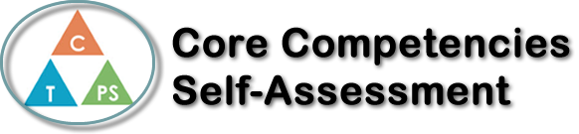
Name: Maddex Marshall | Date: 1/28/2021

  X  How does the artifact you selected demonstrate strengths & growth in the communication competency?  In what ways might you further develop your communication competency? | For my artifact I chose my mock interview because it demonstrates an improvement I have made in my profession communication. I have always had troubles with profession conversation as I would tend to mess up words/stutter or I would use improper language. I feel that my mock interview shows off my quick thinking when asked a question and I was really proud that I did not stumble on my words as much as I normally would. I think that if I practice speaking and saying hard and intricate words, I can improve even more on my speech and not have to worry about stumbling on my words as much.


How does the artifact you selected demonstrate strengths & growth in the thinking competencies?

In what ways might you further develop your thinking competencies?


How does the artifact you selected demonstrate strengths & growth in the personal & social competencies?

In what ways might you further develop your personal & social competencies?

Publish Your Self Assessment
You will now attach and/or embed your self-assessment to the bottom of the blog post with the artifact you have chosen. You may choose to make this post private or public. After placing your artifact on a blog post, follow the instructions below.
- Categories - Self-Assessment
- Tags - Now tag your post using the tag that corresponds to the competency that you have written about. You can choose more than one. Please use lower case letters and be exact.
  - #creativethinkingcc
  - #communicationcc
  - #criticalthinkingcc
  - #socialresponsibilitycc
  - #personalidentitycc
  - #personalawarenesscc
- Use the Add Document button located at the top of your post page and embed your self-assessment at the bottom of your blog post.
- Publish

