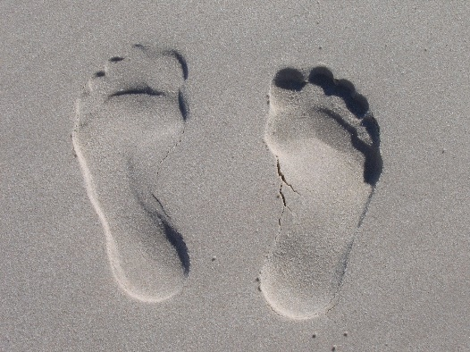

- My digital footprint could affect my future in many ways. Some of the examples are like if I were to post a picture of me doing something that I should not be it could be the reason I am not accepted to a college or university that I applied to. Another way it could affect me is that it could stop me from getting a job or a promotion at a job that I have.
- One: don’t post everything I do in my free time
Two: If I have nothing good to say online, don’t say it
Three: Don’t cyber bully others
- The most important thing that I learned is that don’t post everything I do because not everyone needs to see what I do in my free time and some people might find it unflattering.

