The new York moon
Teen found dead after being stabbed in alley!
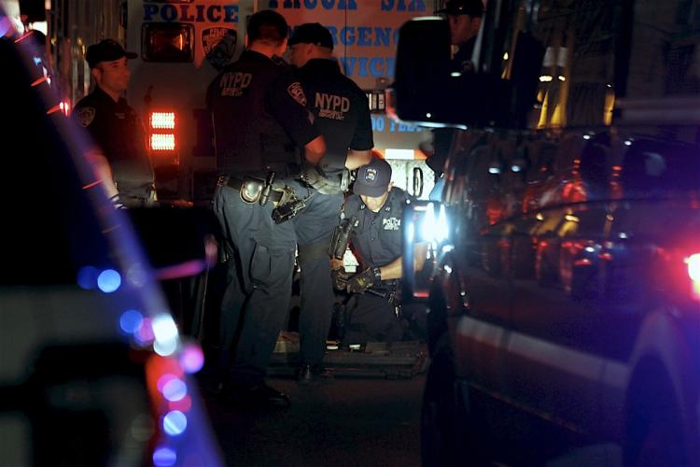
1 Teen was left dead after vicious stabbing last night.
By: Maddex Marshall March 9, 1954
Last night at about 11:30 a teen was stabbed to death in a New York city alley

New York---Gang members from a local gang stabbed a rival member last night. Andy, a sixteen-year-old kid from Manhattan was found dead in an alley face down after being stabbed in the abdominal area with a switch blade.
“This is yet another kid apart of a gang to die this week. Things like this should not be happening to such young kids.” Said commissioner John Kelly this morning in a press conference.
It was reported that surveillance footage shows multiple people walking by and walking right past him as he bled to death.
There was a witness who saw Andy minutes before his passing, “I really regret not doing anything to help that poor boy, I was drunk and stupid and I will have to live with that for the rest of my life. My girlfriend and I should have done something and looking back at the video, I don’t even recognize myself.” Said Freddie Smith.
Police don’t have anyone in custody at the moment, but they are confident they will soon.
I think this teaches us that being in a gang can be very dangerous and it is best to stay as far away from it as possible.

