Darwin’s theory of natural selection

In the year 1831, Darwin took his 5 departure from England on the HMS beagle throughout South America to examine the waters, the nature, and the wildlife species. He visited multiple places, but the place that stood out to him the most and the place in which his research has been most famous for were the Galapagos islands. These islands were home to many species such as finches, iguanas, tortoises etc. The main types of animals that Darwin had took notice to and began to examine were the finches and the tortoises. These animals were the ones that ended up being the ones he used for his theory.

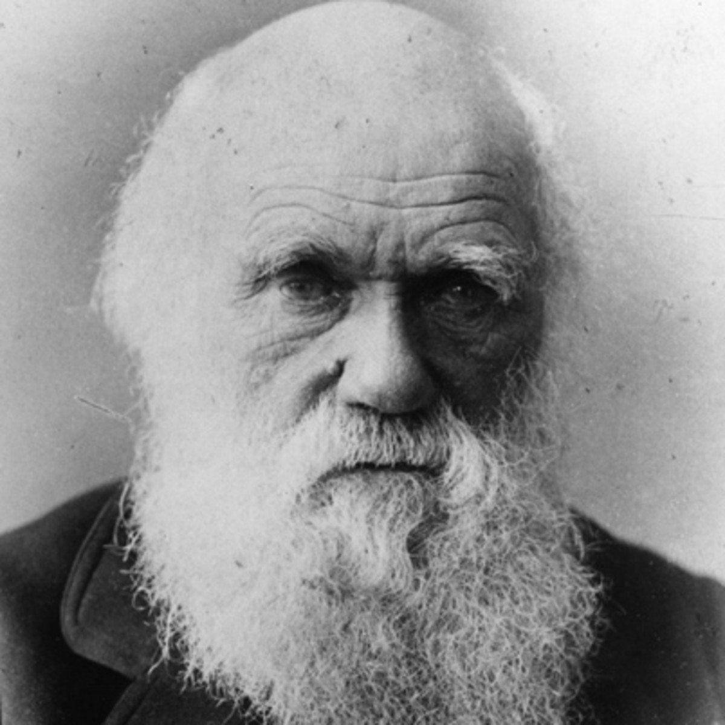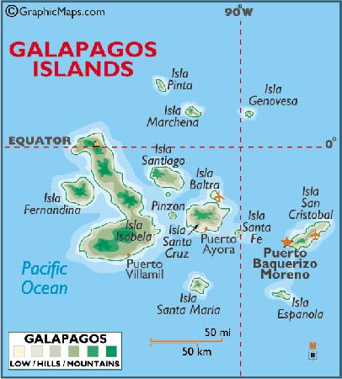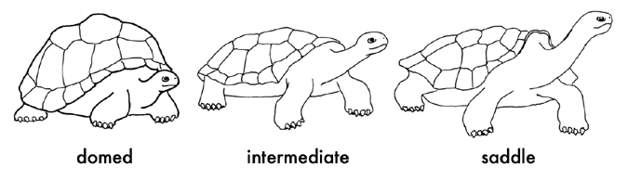
The theory before Darwin began to put his into place was the theory of transformation by Jean-Baptiste Lamarck and his idea was that in order for a species to evolve, three things must happen. Law of use and disuse, Law of inheritance of acquired traits, and a desire to change. Darwin proved this to be false. His theory stated that Phenotypic variation exists among individuals and the variation is heritable. Those individuals with heritable traits better suited to the environment will survive. When he talks about fitness, he doesn’t mean how strong you are or how much you can lift, he is talking about the organism’s way of adapting to their specific environment. An example we can use is from the activity online about white coloured moths and dark coloured moths. As the environment around these moths changed into an industrial environment, the darker coloured moths were surviving more and more as where the white coloured moths were being killed off earlier leaving them unable to reproduce as much. The darker coloured moths were better suited to their environment because their color of skin matched their environment leaving them to be less and less hunted by prey. As for the Galapagos animals, it’s very similar. Different finches had different sized beaks based on how they were to obtain their food. If food in a certain area was in a hole and a longer beak was needed to reach in the whole to eat it, then the finches with the longer beaks would survive while the others died off. Vice versa for opposite situations with shorter beaks. Since more of the ones unfit to survive were dying off, the only ones being reproduced were the descendants of those who had those fit characteristics.
However, even though Darwin came to this conclusion based off of specific research and evidence from the islands, the idea of DNA had nothing to do with his opinion. A century later, the ideas of DNA, embryology, technological advancements and brand new scientific discoveries proved his idea even more true and his theory became more widely accepted by people around the world.
As mentioned in previous documentaries, one way to use DNA as a comparison is when you look at the genetic similarities. When you look at different species like a chimpanzee and human for example, the majority of their genes are exactly identical (99%). Small changes of the genetic code of the species made an enormous impact on the way this species evolved and continues to shape how we evolve today. It shows how they aren’t very different from each other and at one point they should have been exactly the same. Also, when you look at embryology, you tend to see that many species look almost exactly the same and actually have the same body parts in that stage. (As shown in the photo below.)

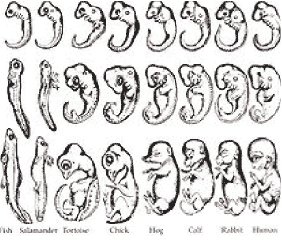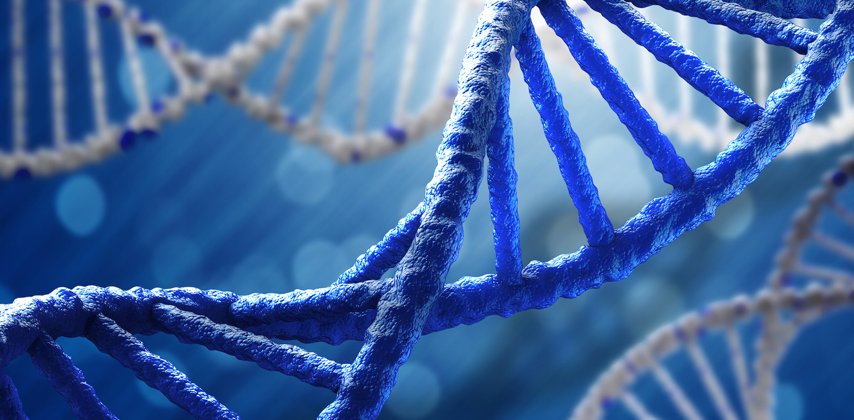

One example is with fish and human. During both of their embryo stages, both have a gill looking feature that goes with them, but as they grow older, for the fish it turns into the gills as for the humans it turns into the cartilage in your ear. You can also call this an example of a vestigial organ.
None the less, all of the evidence shown in the almost exact gene display of human and chimpanzee (and other species) and the very common looking embryos in different animals all play a role into supporting Darwin’s original theory of evolution. The quality and accuracy of the research only makes it easier for those who previously did not believe in it, to believe in it with evidence behind it. The research capacities and development will only get better as time goes on allowing the quality of research and our knowledge on this topic to get better in the process.

References
https://www.biography.com/people/charles-darwin-9266433
https://www.tripadvisor.co.uk/LocationPhotoDirectLink-g294310-d679560-i19472522-Darwin_Wolf_Islands-Galapagos_Islands.html
https://classosteichthyes.weebly.com/embryology.html
https://phys.org/news/2017-08-dark-dnathe-phenomenon-evolution.html

