Name: Luise Matias
Block: C
House Hunting Assignment
CLE 10
_________________________________________________________________________________________________

PART ONE: Using Craiglist-Rent.com or any other appropriate site, you are to find a housing option suitable to your needs once out of high school. Consider what city you are planning to live in.

Budget for Rent: $750 monthly
Housing Type and Address | Rent Amount | Security Deposit | Utilities | Single, Double or Triple | Lease | Features & Restrictions
Type: Apartment.  1325 Rolston St. Downtown, Vancouver BC | $700.00  (divided by 2= $350.00 monthly) | $700 monthly (divided by 2 = $350 monthly per person) |  | Double | No lease | Cats and dogs are ok  Furnished  160 SF balcony  2 bedroom/ 2 bathroom  840ft²
Link to listing and one picture:
https://vancouver.craigslist.org/van/vac/d/vancouver-rolston-street-apartments-for/6792404532.html
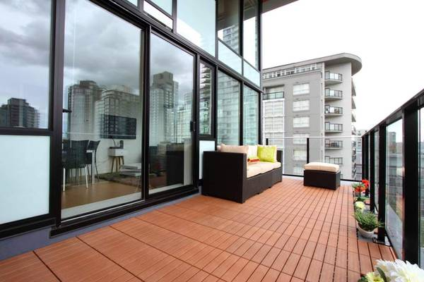
Housing Type and Address | Rent Amount | Security Deposit | Utilities | Single, Double or Triple | Lease | Features & Restrictions
Type: Apartment  49th Ave E Vancouver BC | $1360 divided by 2= $680 | $1360 divided by 2= $680 | Included | Double | No lease | Furnished  Laundry  Street parking  No partying  No pets  2 bedrooms/ 1 bathroom  Street parking
Link to listing and one picture:

https://vancouver.craigslist.org/van/apa/d/vancouver-furnished-2-bedrooms/6794272493.html

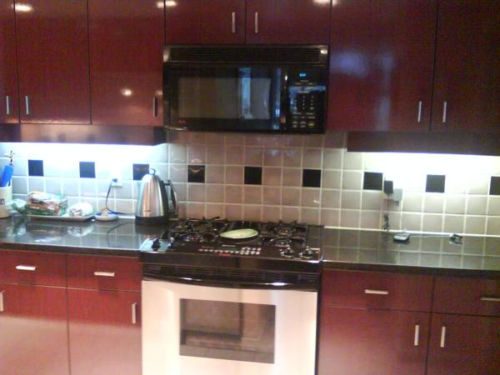

Housing Type and Address | Rent Amount | Security Deposit | Utilities | Single, Double or Triple | Lease | Features & Restrictions
Type: Basement(roommate)  Very close to Fraser St and Langara College.  South Vancouver BC | $750 | $750 | Included | Double | No lease | 5 min walk to Number 8, 3 and 49 bus stops  No pets  No smoker  No drugs  No parties  Furnished  Street parking
Link to listing and one picture:

https://vancouver.craigslist.org/van/apa/d/vancouver-roommate-wanted-or-student/6793583349.html

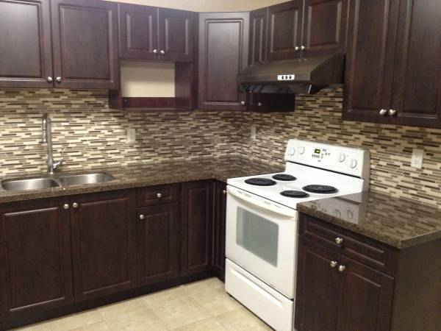

PART TWO: Housing Choice:

After reviewing your three housing options from above, which would you be more inclined to rent and why? Explain your reasoning with at least 3 specific reasons why you made that decision.
After reviewing my three options, probably I would choose the first, the one located in downtown Vancouver, because between my options this is one has a very good location, near UBC, university that I intend to go. Also, it has everything that I need, accept pets, street parking, it has a rent monthly affordable, I would not need to buy furniture because it is already furnished, that’s why would be a great choice. The other options are good as well, but this one I think it is the newest and with a good price for its location.

Example information:

Housing Type & Address: Apartment #45-888 Citadel Dr. Port Coquitlam, BC
Rent: $1200 total (Divided by 2 = $600 per person/month)
Security Deposit: $1200 (Divided by 2 = $600/person)
Budget for rent: $1300
Leftover money rent: $100
Single/Double: Double
Lease: 6 months
Utilities: Not included
Location:
Housing Features: - Two Bedrooms
- Two Bathrooms
- In-suite laundry and dryer
- No pets
- Granite countertops
- free parking spot underground
Link: and picture of the listing

