
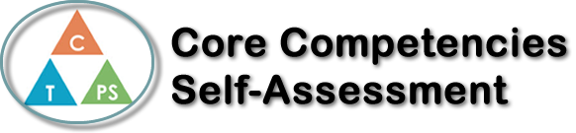
Name: Lina Pan | Date: June 19th, 2020

  How does the artifact you selected demonstrate strengths & growth in the communication competency?  In what ways might you further develop your communication competency? | Self-Reflection  Describe how the artifact you selected shows your strengths & growth in specific core competencies. The prompt questions on the left - or other self-assessment activities you may have done - may guide your reflection process.  I have completed one of the most difficult courses of my high school career. First, Calculus 12 enhanced and developed my communication skills through a mutually supportive environment with peers. Secondly, it was sometimes difficult to keep myself on task and stay motivated through online learning. Calculus has been difficult since the beginning of the semester and when I don't understand it, it's hard to keep working. After spending a lot of time trying and solving problems correctly, it was frustrating every time I got the wrong answer. In the end, I would seek help for questions I didn't understand, demonstrating my personal growth and social skills. Even though I didn't ask the instructor many questions, I was able to get in touch with my classmates. Because the course was online, I often missed class later in the day when I lost track of time. This is something that I felt the video recording was necessary to provide a platform for me to consolidate and review afterwards. But overall, Calculus 12 was still a challenging course, and sometimes I even wanted to give up and stop taking it, but I wanted to Improve my grades, I knew the only way to do that was to continue working on the problem without giving up. And simply I stuck with it, and while my grades may not have been the best, I feel that for calculus I have achieved a good achievement


How does the artifact you selected demonstrate strengths & growth in the thinking competencies?

In what ways might you further develop your thinking competencies?


How does the artifact you selected demonstrate strengths & growth in the personal & social competencies?

In what ways might you further develop your personal & social competencies?

Publish Your Self Assessment
You will now attach and/or embed your self-assessment to the bottom of the blog post with the artifact you have chosen. You may choose to make this post private or public. After placing your artifact on a blog post, follow the instructions below.
- Categories - Self-Assessment
- Tags - Now tag your post using the tag that corresponds to the competency that you have written about. You can choose more than one. Please use lower case letters and be exact.
  - #creativethinkingcc
  - #communicationcc
  - #criticalthinkingcc
  - #socialresponsibilitycc
  - #personalidentitycc
  - #personalawarenesscc
- Use the Add Document button located at the top of your post page and embed your self-assessment at the bottom of your blog post.
- Publish

