
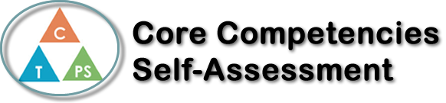
Name: Lina Pan | Date: Dec.23, 2019

  ☑️  How does the artifact you selected demonstrate strengths & growth in the communication competency?  In what ways might you further develop your communication competency? | Self-Reflection  Describe how the artifact you selected shows your strengths & growth in specific core competencies. The prompt questions on the left - or other self-assessment activities you may have done - may guide your reflection process.  I believe in thermos challenge; communication was a major component of this project. As individuals, everyone in our group has strong ideas and opinions when developing projects. This forced us to work together and brainstorm as a team in order to create the best product possible. Another piece of communication found during this process was seeking help from others. This process took a lot of trial and error tactics which is one of the reasons why I believe the Critical and Creative Thinking core competencies were also present.  Many times, throughout the project we feel stuck. Ms. Jackson and classmates took the time to help us and make suggestions for improvement. Although our thermos has repeatedly failed to be as frustrating as we wished, it has allowed us to delve into critical thinking skills to change or add many of the design components of a thermos.  Finally, this process helped us interact with many members of the school (representing core competencies in social responsibility). Even though we didn't seem to find a solution, with the new spiritual reforms to transform and improve, we finally created a product that we are all proud of. This process is not easy, but I am very grateful for the knowledge and friendship I have gained.

☑️

How does the artifact you selected demonstrate strengths & growth in the thinking competencies?

In what ways might you further develop your thinking competencies?


How does the artifact you selected demonstrate strengths & growth in the personal & social competencies?

In what ways might you further develop your personal & social competencies?

Publish Your Self Assessment
You will now attach and/or embed your self-assessment to the bottom of the blog post with the artifact you have chosen. You may choose to make this post private or public. After placing your artifact on a blog post, follow the instructions below.
- Categories - Self-Assessment
- Tags - Now tag your post using the tag that corresponds to the competency that you have written about. You can choose more than one. Please use lower case letters and be exact.
  - #creativethinkingcc
  - #communicationcc
  - #criticalthinkingcc
  - #socialresponsibilitycc
  - #personalidentitycc
  - #personalawarenesscc
- Use the Add Document button located at the top of your post page and embed your self-assessment at the bottom of your blog post.
- Publish

