
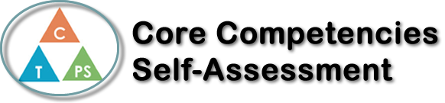
Name: Liam Campbell | Date:

  How does the artifact you selected demonstrate strengths & growth in the communication competency?  In what ways might you further develop your communication competency? | Self-Reflection  Describe how the artifact you selected shows your strengths & growth in specific core competencies. The prompt questions on the left - or other self-assessment activities you may have done - may guide your reflection process.  I have improved on critical thinking, as I learned how to quickly discover new things and learn how to do things quickly, For example, my 1234 puzzle. I quickly discovered many of the equations without really thinking that hard, and just doing it. Another example is the philosophy questions I made in class. I quickly threw made questions up, which made other questions, and I answered them as best as I could.

V

How does the artifact you selected demonstrate strengths & growth in the thinking competencies?

In what ways might you further develop your thinking competencies?


How does the artifact you selected demonstrate strengths & growth in the personal & social competencies?

In what ways might you further develop your personal & social competencies?

Publish Your Self Assessment
You will now attach and/or embed your self-assessment to the bottom of the blog post with the artifact you have chosen. You may choose to make this post private or public. After placing your artifact on a blog post, follow the instructions below.
- Categories - Self-Assessment
- Tags - Now tag your post using the tag that corresponds to the competency that you have written about. You can choose more than one. Please use lower case letters and be exact.
  - #creativethinkingcc
  - #communicationcc
  - #criticalthinkingcc
  - #socialresponsibilitycc
  - #personalidentitycc
  - #personalawarenesscc
- Use the Add Document button located at the top of your post page and embed your self-assessment at the bottom of your blog post.
- Publish

