**SMART GOAL: Personal**

(Specific, Measurable, Achievable, Realistic, Timely)

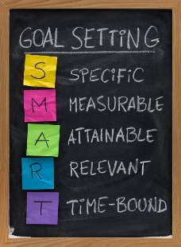 **GOAL STATEMENT:**

To get into honors math and science next year

**WHAT DO I NEED TO REACH THIS GOAL? (The steps you**

**must take in order, and the date you wish the step to be**

**completed by.)**

-stay really focused in class and always be paying attention and possibly taking notes

-complete all homework for due date and do extra work or questions

-study hard for tests to improve my mark

-make sure my studying is effective and shows good results on the test

- do all of these to get into honors and to stay in honors with good marks still

**HOW ARE YOU GOING TO MEASURE THE PROGRESS TOWARDS**

**YOUR GOAL?**

By doing all of the points and getting into honors

**OBSTACLES YOU MIGHT SOLUTIONS**

**FACE**

-study really hard and get a better mark on the next test that makes up for the previous

-work even harder and get in the next year

-remember what motivated me to get into honors so I regain motivation

-Getting aa bad test mark

-I don’t make it into honors

-I start to give up on my goal

**WHO ARE YOU GOING TO SHARE YOUR GOAL WITH?**

My family and friends

**HOW WILL YOU CELEBRATE YOUR GOAL?**

Have a really nice meal and maybe buy a new laptop

**NEVER GIVE UP!**