The book of life

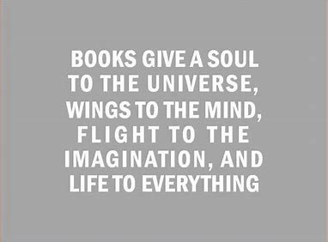

What aspect of the world/society do you want to learn more about?
Our lives are like a story, a book of our own creation. All exclusively designed for us, cataloging our brightest and most vivid highlights of our existence. This is your story, and how you choose to grasp the pen and take hold of the paper is entirely on you.
“life is the art of drawing….without an eraser”
But there are some of us who grasp the pen a little harder. Some of us who really want to leave a mark upon this earth. Some who by fate are destined for change.
Our earth is dying. We can no longer stand here and wait for the next person to come along and clean up the mess you swore an oath to fix. We can no longer hide our faces in our phones and pretend to be blind to the world burning under our feet. It’s getting to hot, and its time to wake up.
Coming from a person living on this planet. I want to learn how to help. How to save earth from the prying hands of destined destruction. How to make our oceans flow with pure water again, how to grow lush forests for miles without a single fire. I want to be part of this awakening; I want to take off the blindfold. I am ready.

What are you passionate about, what do you stand for?
I have a personal passion for speaking up about what’s right. Our society has become so blind and careless towards this small speck in a galaxy we call home. And I believe its time for people to see what’s really happening.
There is not going to be another generation to come along and clean up this mess, its here right now, this duty belongs to us and we cannot ignore it any further.

Do you believe that you should have a say in how society works?
I believe not just me, but the youth of society need to take a stand and really start to have a say in how society works. We are the youngest generation and we are the future. If we want to save this planet and be destined for great things, we all need to step up.
As young kids we shouldn’t have to deal with the anxiety that todays youth faces about our planet. But we have to, we have to fix this, so the new generations don’t have to. If we don’t fix this who will?
I believe if we had more of a say in how society works, we could accomplish a lot more. If younger and older generations worked together instead of hating one another we could turn this around. The youth of society have billions of ideas on conservation and environmentalism, that older generations refuse to acknowledge. We could fix this.

If you could interview one person in the world, who would it be and why?
What makes us driven? What makes the few people in the word strive for achievement? That’s what I would like to find out. How one person who has so much thrown at them their entire life, a constant whirlwind of turbulence and never-ending sorrow. But yet they saw the light at the end of the tunnel, they fought to reach that light with every once of courage their body

could muster. One of these people is J.K Rowling or more commonly known as the author to one of the number one selling series in the world, Harry Potter.
Rowling Is a very inspiring person for not just me, but youth all around the world. She inspires me not only with her unique writing abilities but in how she created a whole new world full of magic and stories that all began during a lonely train ride across London, scribbled on an old napkin.
I want to learn how someone who has been through so much hardship in life but still persevered every day, took a leap of faith and took that old napkin and turned it into one of the most heartfelt, magical, and inspiring series of all time.

what stories, videos, content on the internet inspires you/makes you want to read?
I often reflect a lot on times in society that I was not a part of, times where people enjoyed the company of others around the glowing halo of a warm fire on a hazy summer night, sharing stories of magical lands, and adventures far, far away.
Sometimes I close my eyes and wonder what it would be like to live in a time like that. How different things would be…that’s when I turn to books.
To me books are time capsules preserving a time so old in a world that is so modern. Behind each book there is or was an author who poured their heart and soul into their very pages. When online I often seek out old quotes, or art people have done based on books they enjoy. And they inspire me to keep reading, and never stop. Every book is a new lesson, a new story, and a new adventure.

