Interior Design-Community Connection
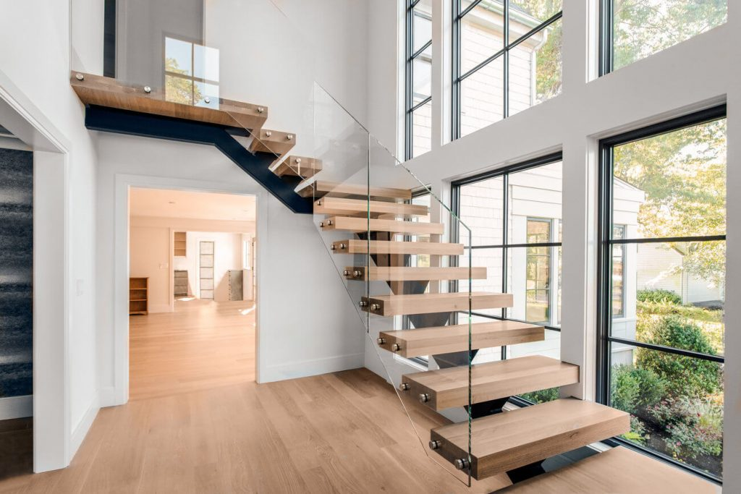
  - Who did you interview, what does their job entail, and why did you interview them?
I interviewed Rebecca; an amazing Interior designer located in Vancouver. Her job entails transforming a space/s in her client’s homes, that “lets their personalities shine or how proud it makes them to invite their friends over. That gives me a huge sense of pride knowing my design was successful and made a huge impact on their lives.” -Rebecca
Not only does it look great but it’s more functional and she loves seeing how a well-designed space can not only look great, but more importantly, transform the people that live in it! I chose to interview Rebecca because she shares the same passion as me as I may want to get into Interior Design in the future. I also liked that she was a local interior designer so I could relate to her more in that sense as I could see what things she did locally and courses she took etc.

Questions I asked:

#1 Why are you so passionate about your job?

“Because every day is different and I love seeing how a well-designed space can not only look great but more importantly transform the people that live in it! When a family has a home that functions well, their daily routine becomes easier. When you open a space for a family who loves to entertain and see how the new layout helps their personalities shine, or how proud it makes them to invite their friends over, that gives me a huge sense of pride knowing my design was successful and made an impact on their lives. That and if I get a hug and a "I couldn't have done this without you" at the end of the project, it makes all the hard work worth it.”

#2 What obstacles have you faced to get to where you are today?

“My biggest obstacle was when I was started my career, I was young and I looked young. This industry is becoming better, but for many years it mainly consisted of men so if I'm honest gaining people's trust and having the confidence to tell display to them that I had the knowledge required to help them design their home was my first challenge. That said, I am very thankful that I chose to work for a company and learn through them rather than jumping in and starting my own business right after school. This industry takes a bit to make contacts, but when you do establish contacts it is a great network full of people willing to help you. Confidence simply takes time, after a couple years I was no longer insecure about my age or how young I looked because I knew that I worked hard and I was able to help the clients that I worked with. My second was that understanding that you WILL make mistakes, there will be delays, discontinued products, disagreements between your clients (i.e.: a husband and wife that have opposite design styles and it's your job to establish a happy medium for both of them) etc. and that's all part of the job and you will most definitely learn from them. (Every designer has many stories about their first couple projects... lol) What will make you successful is how you deal with them and how you maintain your clients trust while you correct that mistake.”

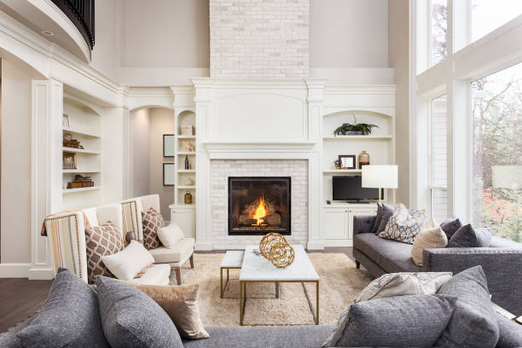

#3 What advice would you pass onto someone that is interested in doing what you do?

|” Interior Design is not just decorating. You don't just pick out pillows and paint (that's a decorator or a stylist) as an interior designer you are also responsible for technical details and the successful designers are truly interested in figuring out how things work. If you dream about transforming spaces, get lost in Pinterest, don't mind sitting at a desk and working on a computer program and love a good before and after photo that inspiration will fuel you and you will love your job. There are many different avenues of interior design and you don't have to know exactly what you want to do, but going to college will help you determine which route is right for you. If you have this inner drive for transforming spaces interior design is probably right for you! Just don't expect it to be easy. There are fun, easy days but there is alot of problem solving that goes along with it. Prepare to work for your success. :)”

#4 Would you be open to further contact with Riverside students if so, how can someone contact you?

“I am always happy to answer messages on Instagram it just might take a couple of days to respond.”

#5 What is your favourite thing about your job?

“Oh, so much! But mainly that no client is the same, no day is the same, no project is the same so it keeps things interesting. I could never go back to a repetitive job that was the same every day. It would be so boring. . lol.. Also, there are so many great people in this industry! So many people that want to see you succeed. It is still competitive but there are people like me that believe in community over competition. :)

I also love teaching and basically all I do all day is educate clients on different materials and applications and the benefits/ disadvantages of each so they can make an informed decision. In school I was terrible at presentations but it got easier and now I love presenting (in small groups) to clients because they are coming to you for your advice as the professional. It's a big responsibility but also a great feeling to know your education and hard work is valued.”

#6 What steps did you take to get to where you are today?

“In high school I took a decorating class and loved it. (I was living in a small town called Fort St John and there was no such thing as interior design there so I truly didn't know it was an actual job)

I applied to BCIT, NAIT(Edmonton) and the Art Institute and got accepted to all.

Chose BCIT because it was the only college recognized internationally and at the time, I thought I might want to move to Australia.

Started my Management Certificate for Interior Design and quickly realized interior design wasn't interior decorating and it was a lot harder work than I expected. Still loved it.

Went on to complete my diploma in interior design technology.

At the portfolio review (happens at the end of the diploma program) family and industry professionals were invited and I won't talk about the whole story but it ends with me being one of the very few students that were hired right after school without having to apply to multiple.”

What I learnt from this interview is that there is a lot of hard work, planning, creativity, and skills that goes into designing spaces in homes but it’s all worth it when you see the end result, before and after, and your clients reactions of how great you designed their home. It makes you proud of all of your hard work. I also didn’t realize that interior designers don’t just decorate, but they are responsible for the technical side of things as well. This connects to my interests as I’ve always been interested in Interior Design. I helped my Dad a lot with the design of his new house and how to decorate it to something that fits our family and that is aesthetic as well. It is one of my options of what I want to get into in the future. I really did learn a lot through this project and my connection with Rebecca.

Here is a link to some of Rebecca’s Interior Design work: https://www.houzz.com/professionals/interior-designers-and-decorators/interior-designs-by-becky-runacres-pfvwus-pf~184709558

Citations:
https://www.pinterest.ca/pin/139963500900794308/
https://www.keuka-studios.com/how-much-do-custom-floating-stairs-cost/
https://www.pinterest.ca/pultehomes/dream-bedrooms/
https://www.istockphoto.com/ca/photos/home-interior?sort=mostpopular&mediatype=photography&phrase=home%20interior

