Diffusion in agar cubes- lab
- In terms of maximizing diffusion, what was the most effective size cube that you tested?
The smallest cube was most effective and had the largest percent of diffusion.
- Why was that the most effective at maximizing diffusion? What are the important factors that affect how materials diffuse into cells or tissues?
The smallest cube had the largest surface area to volume ratio, which allowed the base to cover more space on the cube compared to the dimensions and proportions to a larger cube.
- If a large surface area is helpful to cells, why do cells not grow to be very large?
The greatest benefit of having a large surface area is present when the volume of the object is smaller. Having a large cell would increase surface area, but the increased volume that comes along with it would diminish the positive effect of the surface area.
- Cubes A B and C have surface to volume ratios of 3:1, 5:2, and 4:1 respectively. Which of these cubes is going to be the most effective at maximizing diffusion, how do you know this?
Cube C would be the most effective at maximizing diffusion because the larger the surface area to volume ratio is, the more efficiently diffusion will occur. When there is a larger amount of surface area, the more space there is for whatever is penetrating the cell, in this case of the base and the agar cube, the base was able to “cover more ground” in proportion to the size of the cube.
- How does your body adapt surface area- to – volume ratios to help exchange gases?
The larger the surface area to volume ratio, the more surface area there is for the cell membrane to “breathe.” This allows more gas exchange within each cell
- Why can’t certain cells, like bacteria, get to be the size of a small fish?
The larger a cell is, the more of its resources would be required to transport things within the cell, and the larger the cell is the more difficult it is to maintain (with amounts of waste produced, etc.). A large bacterium wouldn’t be able to grow to the size of a small fish because if it were to grow that big, its surface area to volume ratio would be thrown off from what would be advantageous.
- What are the advantages of large organisms being multicellular
Each cell has the rational advantage and having these repeated is beneficial to the organism as a whole. With each cell working simultaneously on their own to gain their own benefits as well as working together in the grand scheme of the organism, it functions much better to have smaller cells that are very numerous.

The process:
- Here are the photos of our agar cubes from about halfway (5 minutes) through their time in the base. The pink is only prominent on the outside surfaces of the cubes at this time
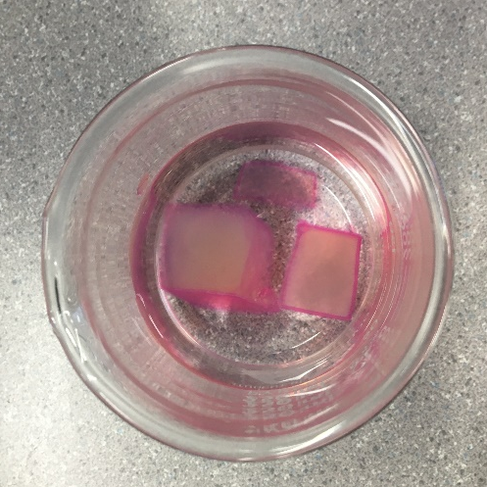

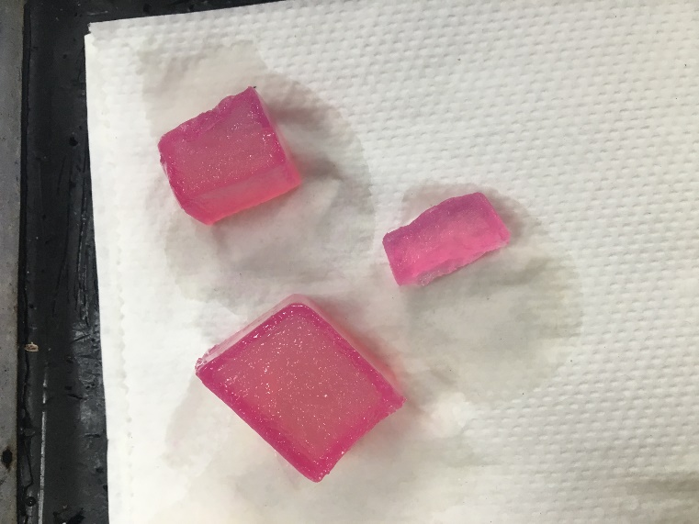
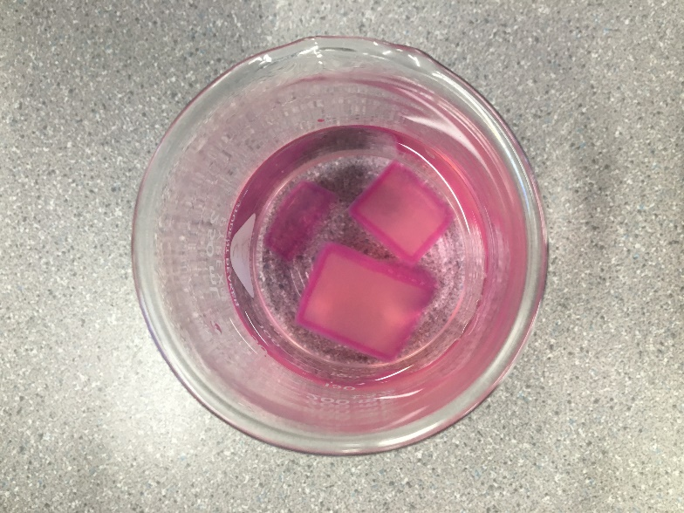
- Here are our cubes just before and after removing them from the base. By the end of the 10 minutes that each different sized cube was penetrated differently with the pink colouring. The smaller the cube, the higher percentage of diffusion (as shown in the data table below)
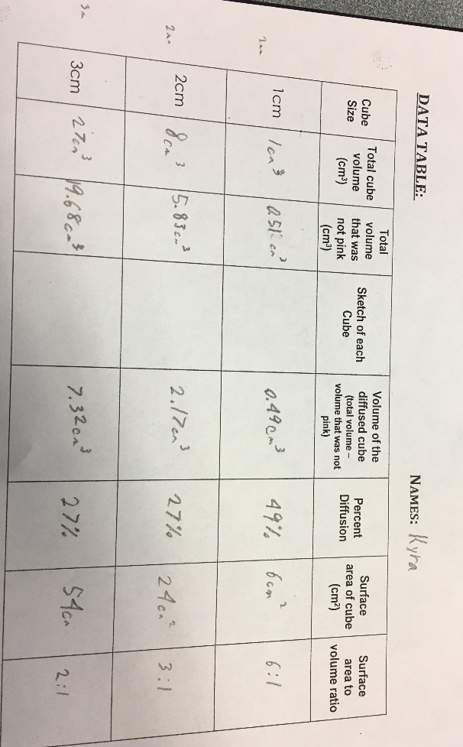

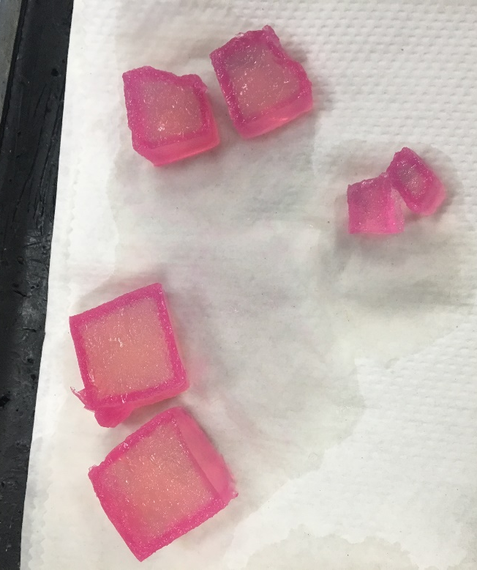
- In this last photo, our cubes are cut in half, so you can see the penetration of the pink colour towards the center of the cube.

